10.1-Stock-Index-Futures-Period-Plots-to-File-Test.R

frmhelp

2021-03-24

# 10.1 Stock Index Futures Period Plot to File Test.R  
# rmarkdown::render("10.1 Stock Index Futures Period Plots to File Test.R", "word_document")  
#  
# NOTE: Coded for rmarkdown ONLY  
# DO NOT run dev.off()  
# You may not have installed 'Times New Roman'  
# Comment out par(family= ... ) if program fails to run  
#  
rm(list = ls()) # Take out the Environment "trash"  
cat("\014") # Clear Console, making error checking easier.

# while (!is.null(dev.list())) dev.off() # Clear old plots  
# Times New Roman is not available in PostScript  
par(family = 'Times New Roman') # Globally set fonts for graphs  
# Technical plot manipulations require resetting back to default  
defaultpar <- par() # plot global parameters  
Packages <- c("openxlsx", "zoo", "date", "moments", "stats",  
 "PerformanceAnalytics", "RColorBrewer", "SDMTools", "weights",  
 "xts", "rootSolve", "Weighted.Desc.Stat") # Libraries  
if(length(setdiff(Packages, rownames(installed.packages()))) > 0) {  
 install.packages(setdiff(Packages, rownames(installed.packages())))  
} # Make sure libraries are installed on this computer  
lapply(Packages, library, character.only=TRUE) # Load and attach libraries

## [[1]]  
## [1] "Weighted.Desc.Stat" "rootSolve"   
## [3] "weights" "mice"   
## [5] "gdata" "Hmisc"   
## [7] "ggplot2" "Formula"   
## [9] "survival" "lattice"   
## [11] "SDMTools" "RColorBrewer"   
## [13] "PerformanceAnalytics" "xts"   
## [15] "moments" "date"   
## [17] "zoo" "openxlsx"   
## [19] "stats" "graphics"   
## [21] "grDevices" "utils"   
## [23] "datasets" "methods"   
## [25] "base"   
##   
## [[2]]  
## [1] "Weighted.Desc.Stat" "rootSolve"   
## [3] "weights" "mice"   
## [5] "gdata" "Hmisc"   
## [7] "ggplot2" "Formula"   
## [9] "survival" "lattice"   
## [11] "SDMTools" "RColorBrewer"   
## [13] "PerformanceAnalytics" "xts"   
## [15] "moments" "date"   
## [17] "zoo" "openxlsx"   
## [19] "stats" "graphics"   
## [21] "grDevices" "utils"   
## [23] "datasets" "methods"   
## [25] "base"   
##   
## [[3]]  
## [1] "Weighted.Desc.Stat" "rootSolve"   
## [3] "weights" "mice"   
## [5] "gdata" "Hmisc"   
## [7] "ggplot2" "Formula"   
## [9] "survival" "lattice"   
## [11] "SDMTools" "RColorBrewer"   
## [13] "PerformanceAnalytics" "xts"   
## [15] "moments" "date"   
## [17] "zoo" "openxlsx"   
## [19] "stats" "graphics"   
## [21] "grDevices" "utils"   
## [23] "datasets" "methods"   
## [25] "base"   
##   
## [[4]]  
## [1] "Weighted.Desc.Stat" "rootSolve"   
## [3] "weights" "mice"   
## [5] "gdata" "Hmisc"   
## [7] "ggplot2" "Formula"   
## [9] "survival" "lattice"   
## [11] "SDMTools" "RColorBrewer"   
## [13] "PerformanceAnalytics" "xts"   
## [15] "moments" "date"   
## [17] "zoo" "openxlsx"   
## [19] "stats" "graphics"   
## [21] "grDevices" "utils"   
## [23] "datasets" "methods"   
## [25] "base"   
##   
## [[5]]  
## [1] "Weighted.Desc.Stat" "rootSolve"   
## [3] "weights" "mice"   
## [5] "gdata" "Hmisc"   
## [7] "ggplot2" "Formula"   
## [9] "survival" "lattice"   
## [11] "SDMTools" "RColorBrewer"   
## [13] "PerformanceAnalytics" "xts"   
## [15] "moments" "date"   
## [17] "zoo" "openxlsx"   
## [19] "stats" "graphics"   
## [21] "grDevices" "utils"   
## [23] "datasets" "methods"   
## [25] "base"   
##   
## [[6]]  
## [1] "Weighted.Desc.Stat" "rootSolve"   
## [3] "weights" "mice"   
## [5] "gdata" "Hmisc"   
## [7] "ggplot2" "Formula"   
## [9] "survival" "lattice"   
## [11] "SDMTools" "RColorBrewer"   
## [13] "PerformanceAnalytics" "xts"   
## [15] "moments" "date"   
## [17] "zoo" "openxlsx"   
## [19] "stats" "graphics"   
## [21] "grDevices" "utils"   
## [23] "datasets" "methods"   
## [25] "base"   
##   
## [[7]]  
## [1] "Weighted.Desc.Stat" "rootSolve"   
## [3] "weights" "mice"   
## [5] "gdata" "Hmisc"   
## [7] "ggplot2" "Formula"   
## [9] "survival" "lattice"   
## [11] "SDMTools" "RColorBrewer"   
## [13] "PerformanceAnalytics" "xts"   
## [15] "moments" "date"   
## [17] "zoo" "openxlsx"   
## [19] "stats" "graphics"   
## [21] "grDevices" "utils"   
## [23] "datasets" "methods"   
## [25] "base"   
##   
## [[8]]  
## [1] "Weighted.Desc.Stat" "rootSolve"   
## [3] "weights" "mice"   
## [5] "gdata" "Hmisc"   
## [7] "ggplot2" "Formula"   
## [9] "survival" "lattice"   
## [11] "SDMTools" "RColorBrewer"   
## [13] "PerformanceAnalytics" "xts"   
## [15] "moments" "date"   
## [17] "zoo" "openxlsx"   
## [19] "stats" "graphics"   
## [21] "grDevices" "utils"   
## [23] "datasets" "methods"   
## [25] "base"   
##   
## [[9]]  
## [1] "Weighted.Desc.Stat" "rootSolve"   
## [3] "weights" "mice"   
## [5] "gdata" "Hmisc"   
## [7] "ggplot2" "Formula"   
## [9] "survival" "lattice"   
## [11] "SDMTools" "RColorBrewer"   
## [13] "PerformanceAnalytics" "xts"   
## [15] "moments" "date"   
## [17] "zoo" "openxlsx"   
## [19] "stats" "graphics"   
## [21] "grDevices" "utils"   
## [23] "datasets" "methods"   
## [25] "base"   
##   
## [[10]]  
## [1] "Weighted.Desc.Stat" "rootSolve"   
## [3] "weights" "mice"   
## [5] "gdata" "Hmisc"   
## [7] "ggplot2" "Formula"   
## [9] "survival" "lattice"   
## [11] "SDMTools" "RColorBrewer"   
## [13] "PerformanceAnalytics" "xts"   
## [15] "moments" "date"   
## [17] "zoo" "openxlsx"   
## [19] "stats" "graphics"   
## [21] "grDevices" "utils"   
## [23] "datasets" "methods"   
## [25] "base"   
##   
## [[11]]  
## [1] "Weighted.Desc.Stat" "rootSolve"   
## [3] "weights" "mice"   
## [5] "gdata" "Hmisc"   
## [7] "ggplot2" "Formula"   
## [9] "survival" "lattice"   
## [11] "SDMTools" "RColorBrewer"   
## [13] "PerformanceAnalytics" "xts"   
## [15] "moments" "date"   
## [17] "zoo" "openxlsx"   
## [19] "stats" "graphics"   
## [21] "grDevices" "utils"   
## [23] "datasets" "methods"   
## [25] "base"   
##   
## [[12]]  
## [1] "Weighted.Desc.Stat" "rootSolve"   
## [3] "weights" "mice"   
## [5] "gdata" "Hmisc"   
## [7] "ggplot2" "Formula"   
## [9] "survival" "lattice"   
## [11] "SDMTools" "RColorBrewer"   
## [13] "PerformanceAnalytics" "xts"   
## [15] "moments" "date"   
## [17] "zoo" "openxlsx"   
## [19] "stats" "graphics"   
## [21] "grDevices" "utils"   
## [23] "datasets" "methods"   
## [25] "base"

rm(Packages)  
#  
# Parameters  
#  
# File = 'SPX LSC.xlsx'  
File = 'MiniSPX LSC.xlsx'  
mTitle1 <- 'US S&P 500 (Mini)'  
Title1 = as.character('S&P 500')  
# File = 'NGComb LSC.xlsx'  
# mTitle1 <- 'Natural Gas'  
# Title1 = as.character('NG')  
StartDate = 20190323 # 19870402 US SPX, 20100319 China (?)  
EndDate = 20210323  
# sTitle = expression(paste("06/01/1993 through 12/31/2019"))  
#  
# Plots (Pseudo possible, fix limits--better for analysis)  
# Produces one plot for every day  
# Open all *.jpg files and print to PDF  
# Open PDF and scroll through in full screen mode  
#   
PlotPseudoPrices <- TRUE # TRUE: Plot both prices and pseudo prices  
FixedLimits <- TRUE # Used for daily plots  
# withAutoprint allows graphs in files  
withAutoprint({  
 Temp <- read.xlsx(File)  
 Temp <- Temp[Temp$Date <= EndDate,]  
 Temp <- Temp[Temp$Date >= StartDate,]  
 FileLength <- length(Temp$Date)  
 TempData = data.frame(matrix(vector(), FileLength, 57, dimnames=list(c(),   
 c("Date", "Date1", "Month", "Day", "Year",  
 "PsC1", "PsC2", "PsC3", "PsC4", "PsC5", "PsC6", "PsC7",   
 "PsC8", "PsC9", "PsC10", "PsC11", "PsC12", "PsC13",  
 "PsMat1", "PsMat2", "PsMat3", "PsMat4", "PsMat5", "PsMat6", "PsMat7",   
 "PsMat8", "PsMat9", "PsMat10", "PsMat11", "PsMat12", "PsMat13",  
 "C1", "C2", "C3", "C4", "C5", "C6", "C7",   
 "C8", "C9", "C10", "C11", "C12", "C13",  
 "Mat1", "Mat2", "Mat3", "Mat4", "Mat5", "Mat6", "Mat7",   
 "Mat8", "Mat9", "Mat10", "Mat11", "Mat12", "Mat13"  
 ))), stringsAsFactors=F  
 )  
 TempData$Date <- Temp$Date  
 TempData$Date1 <- Temp$Date1  
 TempData$Month <- Temp$Month  
 TempData$Day <- Temp$Day  
 TempData$Year <- Temp$Year  
 TempData$Date <- as.Date(mdy.date(month = TempData$Month,   
 day = TempData$Day, year = TempData$Year))  
 TempData$Mat1 <- Temp$Mat1 * 12 # Convert years to months  
 TempData$Mat2 <- Temp$Mat2 * 12  
 TempData$Mat3 <- Temp$Mat3 * 12  
 TempData$Mat4 <- Temp$Mat4 * 12  
 TempData$Mat5 <- Temp$Mat5 * 12  
 TempData$Mat6 <- Temp$Mat6 * 12  
 TempData$Mat7 <- Temp$Mat7 * 12  
 TempData$Mat8 <- Temp$Mat8 * 12  
 TempData$Mat9 <- Temp$Mat9 * 12  
 TempData$Mat10 <- Temp$Mat10 * 12  
 TempData$Mat11 <- Temp$Mat11 * 12  
 TempData$Mat12 <- Temp$Mat12 * 12  
 TempData$C1 <- Temp$C1 # Actual nearby prices  
 TempData$C2 <- Temp$C2  
 TempData$C3 <- Temp$C3  
 TempData$C4 <- Temp$C4  
 TempData$C5 <- Temp$C5  
 TempData$C6 <- Temp$C6  
 TempData$C7 <- Temp$C7  
 TempData$C8 <- Temp$C8  
 TempData$C9 <- Temp$C9  
 TempData$C10 <- Temp$C10  
 TempData$C11 <- Temp$C11  
 TempData$C12 <- Temp$C12  
 TempData$PsMat1 <- 0 # Pseudo months, nearby is spot for pseudo  
 TempData$PsMat2 <- 1   
 TempData$PsMat3 <- 2   
 TempData$PsMat4 <- 3   
 TempData$PsMat5 <- 4   
 TempData$PsMat6 <- 5   
 TempData$PsMat7 <- 6   
 TempData$PsMat8 <- 7   
 TempData$PsMat9 <- 8   
 TempData$PsMat10 <- 9   
 TempData$PsMat11 <- 10   
 TempData$PsMat12 <- 11   
 TempData$PsMat13 <- 12   
 TempData$PsC1 <- Temp$PsC1 # Estimated pseudo prices  
 TempData$PsC2 <- Temp$PsC2  
 TempData$PsC3 <- Temp$PsC3  
 TempData$PsC4 <- Temp$PsC4  
 TempData$PsC5 <- Temp$PsC5  
 TempData$PsC6 <- Temp$PsC6  
 TempData$PsC7 <- Temp$PsC7  
 TempData$PsC8 <- Temp$PsC8  
 TempData$PsC9 <- Temp$PsC9  
 TempData$PsC10 <- Temp$PsC10  
 TempData$PsC11 <- Temp$PsC11  
 TempData$PsC12 <- Temp$PsC12  
 TempData$PsC13 <- Temp$PsC13  
 # Need maximum and minimum of PsC1-12 and C1-12 for charts  
 if(PlotPseudoPrices){  
 UpperLimit <- max(TempData$C1, TempData$C2, TempData$C3, TempData$C4,   
 TempData$C5, TempData$C6, TempData$C7, TempData$C8,   
 TempData$C9, TempData$C10, TempData$C11, TempData$C12,   
 TempData$PsC1, TempData$PsC2, TempData$PsC3, TempData$PsC4,   
 TempData$PsC5, TempData$PsC6, TempData$PsC7, TempData$PsC8,   
 TempData$PsC9, TempData$PsC10, TempData$PsC11, TempData$PsC12,  
 TempData$PsC13, na.rm = TRUE  
 )  
 LowerLimit <- min(TempData$C1, TempData$C2, TempData$C3, TempData$C4,   
 TempData$C5, TempData$C6, TempData$C7, TempData$C8,   
 TempData$C9, TempData$C10, TempData$C11, TempData$C12,   
 TempData$PsC1, TempData$PsC2, TempData$PsC3, TempData$PsC4,   
 TempData$PsC5, TempData$PsC6, TempData$PsC7, TempData$PsC8,   
 TempData$PsC9, TempData$PsC10, TempData$PsC11, TempData$PsC12,  
 TempData$PsC13, na.rm = TRUE  
 )  
 } else {  
 UpperLimit <- max(TempData$C1, TempData$C2, TempData$C3, TempData$C4,   
 TempData$C5, TempData$C6, TempData$C7, TempData$C8,   
 TempData$C9, TempData$C10, TempData$C11, TempData$C12,   
 na.rm = TRUE  
 )  
 LowerLimit <- min(TempData$C1, TempData$C2, TempData$C3, TempData$C4,   
 TempData$C5, TempData$C6, TempData$C7, TempData$C8,   
 TempData$C9, TempData$C10, TempData$C11, TempData$C12,   
 na.rm = TRUE  
 )  
 }  
 PlotFileLength <- 13   
 PlotTempData = data.frame(matrix(vector(), PlotFileLength, 9,   
 dimnames=list(c(), c("Date", "Date1", "Month", "Day", "Year", "PsC",   
 "PsMat", "C", "Mat"))), stringsAsFactors=F)  
# Convert time series into cross-sectional data (on for each graph)  
 for (j in 1:FileLength){  
 k = 0 # Observation 1  
 PlotTempData$Date[k+1] <- TempData$Date[j]  
 PlotTempData$Date1[k+1] <- TempData$Date1[j]  
 PlotTempData$Month[k+1] <- TempData$Month[j]  
 PlotTempData$Day[k+1] <- TempData$Day[j]  
 PlotTempData$Year[k+1] <- TempData$Year[j]  
 PlotTempData$Mat[k+1] <- TempData$Mat1[j]  
 PlotTempData$C[k+1] <- TempData$C1[j]  
 PlotTempData$PsMat[k+1] <- TempData$PsMat1[j]  
 PlotTempData$PsC[k+1] <- TempData$PsC1[j]  
 k = k + 1 # Observation 2  
 PlotTempData$Date[k+1] <- TempData$Date[j]  
 PlotTempData$Date1[k+1] <- TempData$Date1[j]  
 PlotTempData$Month[k+1] <- TempData$Month[j]  
 PlotTempData$Day[k+1] <- TempData$Day[j]  
 PlotTempData$Year[k+1] <- TempData$Year[j]  
 PlotTempData$Mat[k+1] <- TempData$Mat2[j]  
 PlotTempData$C[k+1] <- TempData$C2[j]  
 PlotTempData$PsMat[k+1] <- TempData$PsMat2[j]  
 PlotTempData$PsC[k+1] <- TempData$PsC2[j]  
 k = k + 1 # Observation 3  
 PlotTempData$Date[k+1] <- TempData$Date[j]  
 PlotTempData$Date1[k+1] <- TempData$Date1[j]  
 PlotTempData$Month[k+1] <- TempData$Month[j]  
 PlotTempData$Day[k+1] <- TempData$Day[j]  
 PlotTempData$Year[k+1] <- TempData$Year[j]  
 PlotTempData$Mat[k+1] <- TempData$Mat3[j]  
 PlotTempData$C[k+1] <- TempData$C3[j]  
 PlotTempData$PsMat[k+1] <- TempData$PsMat3[j]  
 PlotTempData$PsC[k+1] <- TempData$PsC3[j]  
 k = k + 1 # Observation 4  
 PlotTempData$Date[k+1] <- TempData$Date[j]  
 PlotTempData$Date1[k+1] <- TempData$Date1[j]  
 PlotTempData$Month[k+1] <- TempData$Month[j]  
 PlotTempData$Day[k+1] <- TempData$Day[j]  
 PlotTempData$Year[k+1] <- TempData$Year[j]  
 PlotTempData$Mat[k+1] <- TempData$Mat4[j]  
 PlotTempData$C[k+1] <- TempData$C4[j]  
 PlotTempData$PsMat[k+1] <- TempData$PsMat4[j]  
 PlotTempData$PsC[k+1] <- TempData$PsC4[j]  
 k = k + 1 # Observation 5  
 PlotTempData$Date[k+1] <- TempData$Date[j]  
 PlotTempData$Date1[k+1] <- TempData$Date1[j]  
 PlotTempData$Month[k+1] <- TempData$Month[j]  
 PlotTempData$Day[k+1] <- TempData$Day[j]  
 PlotTempData$Year[k+1] <- TempData$Year[j]  
 PlotTempData$Mat[k+1] <- TempData$Mat5[j]  
 PlotTempData$C[k+1] <- TempData$C5[j]  
 PlotTempData$PsMat[k+1] <- TempData$PsMat5[j]  
 PlotTempData$PsC[k+1] <- TempData$PsC5[j]  
 k = k + 1 # Observation 6  
 PlotTempData$Date[k+1] <- TempData$Date[j]  
 PlotTempData$Date1[k+1] <- TempData$Date1[j]  
 PlotTempData$Month[k+1] <- TempData$Month[j]  
 PlotTempData$Day[k+1] <- TempData$Day[j]  
 PlotTempData$Year[k+1] <- TempData$Year[j]  
 PlotTempData$Mat[k+1] <- TempData$Mat6[j]  
 PlotTempData$C[k+1] <- TempData$C6[j]  
 PlotTempData$PsMat[k+1] <- TempData$PsMat6[j]  
 PlotTempData$PsC[k+1] <- TempData$PsC6[j]  
 k = k + 1 # Observation 7  
 PlotTempData$Date[k+1] <- TempData$Date[j]  
 PlotTempData$Date1[k+1] <- TempData$Date1[j]  
 PlotTempData$Month[k+1] <- TempData$Month[j]  
 PlotTempData$Day[k+1] <- TempData$Day[j]  
 PlotTempData$Year[k+1] <- TempData$Year[j]  
 PlotTempData$Mat[k+1] <- TempData$Mat7[j]  
 PlotTempData$C[k+1] <- TempData$C7[j]  
 PlotTempData$PsMat[k+1] <- TempData$PsMat7[j]  
 PlotTempData$PsC[k+1] <- TempData$PsC7[j]  
 k = k + 1 # Observation 8  
 PlotTempData$Date[k+1] <- TempData$Date[j]  
 PlotTempData$Date1[k+1] <- TempData$Date1[j]  
 PlotTempData$Month[k+1] <- TempData$Month[j]  
 PlotTempData$Day[k+1] <- TempData$Day[j]  
 PlotTempData$Year[k+1] <- TempData$Year[j]  
 PlotTempData$Mat[k+1] <- TempData$Mat8[j]  
 PlotTempData$C[k+1] <- TempData$C8[j]  
 PlotTempData$PsMat[k+1] <- TempData$PsMat8[j]  
 PlotTempData$PsC[k+1] <- TempData$PsC8[j]  
 k = k + 1 # Observation 9  
 PlotTempData$Date[k+1] <- TempData$Date[j]  
 PlotTempData$Date1[k+1] <- TempData$Date1[j]  
 PlotTempData$Month[k+1] <- TempData$Month[j]  
 PlotTempData$Day[k+1] <- TempData$Day[j]  
 PlotTempData$Year[k+1] <- TempData$Year[j]  
 PlotTempData$Mat[k+1] <- TempData$Mat9[j]  
 PlotTempData$C[k+1] <- TempData$C9[j]  
 PlotTempData$PsMat[k+1] <- TempData$PsMat9[j]  
 PlotTempData$PsC[k+1] <- TempData$PsC9[j]  
 k = k + 1 # Observation 10  
 PlotTempData$Date[k+1] <- TempData$Date[j]  
 PlotTempData$Date1[k+1] <- TempData$Date1[j]  
 PlotTempData$Month[k+1] <- TempData$Month[j]  
 PlotTempData$Day[k+1] <- TempData$Day[j]  
 PlotTempData$Year[k+1] <- TempData$Year[j]  
 PlotTempData$Mat[k+1] <- TempData$Mat10[j]  
 PlotTempData$C[k+1] <- TempData$C10[j]  
 PlotTempData$PsMat[k+1] <- TempData$PsMat10[j]  
 PlotTempData$PsC[k+1] <- TempData$PsC10[j]  
 k = k + 1 # Observation 11  
 PlotTempData$Date[k+1] <- TempData$Date[j]  
 PlotTempData$Date1[k+1] <- TempData$Date1[j]  
 PlotTempData$Month[k+1] <- TempData$Month[j]  
 PlotTempData$Day[k+1] <- TempData$Day[j]  
 PlotTempData$Year[k+1] <- TempData$Year[j]  
 PlotTempData$Mat[k+1] <- TempData$Mat11[j]  
 PlotTempData$C[k+1] <- TempData$C11[j]  
 PlotTempData$PsMat[k+1] <- TempData$PsMat11[j]  
 PlotTempData$PsC[k+1] <- TempData$PsC11[j]  
 k = k + 1 # Observation 12  
 PlotTempData$Date[k+1] <- TempData$Date[j]  
 PlotTempData$Date1[k+1] <- TempData$Date1[j]  
 PlotTempData$Month[k+1] <- TempData$Month[j]  
 PlotTempData$Day[k+1] <- TempData$Day[j]  
 PlotTempData$Year[k+1] <- TempData$Year[j]  
 PlotTempData$Mat[k+1] <- TempData$Mat12[j]  
 PlotTempData$C[k+1] <- TempData$C12[j]  
 PlotTempData$PsMat[k+1] <- TempData$PsMat12[j]  
 PlotTempData$PsC[k+1] <- TempData$PsC12[j]  
 k = k + 1 # Observation 13  
 PlotTempData$Date[k+1] <- TempData$Date[j]  
 PlotTempData$Date1[k+1] <- TempData$Date1[j]  
 PlotTempData$Month[k+1] <- TempData$Month[j]  
 PlotTempData$Day[k+1] <- TempData$Day[j]  
 PlotTempData$Year[k+1] <- TempData$Year[j]  
 PlotTempData$Mat[k+1] <- TempData$Mat13[j]  
 PlotTempData$C[k+1] <- TempData$C13[j]  
 PlotTempData$PsMat[k+1] <- TempData$PsMat13[j]  
 PlotTempData$PsC[k+1] <- TempData$PsC13[j]  
# Work on plot   
# display.brewer.all() # All palette available from RColorBrewer  
# First 9 colors in Paired palette (prints well)  
# cols contain the names of different colors  
 cols<-brewer.pal(n=9, name="Paired")   
 x1 <- PlotTempData$PsMat   
 x2 <- PlotTempData$Mat  
 MaxValueX = 12 # Set range to one year  
 MinValueX = 0  
 xlim1 = c(1:2)  
 xlim1[1] = MinValueX  
 xlim1[2] = MaxValueX  
 IncrementX = (as.numeric(MaxValueX) - as.numeric(MinValueX))/6.0  
 TickMarksX = c(seq(from=MinValueX,to=MaxValueX,by=IncrementX))  
 lblX = as.character(round(TickMarksX, 3))  
 y1 <- PlotTempData$PsC  
 y2 <- PlotTempData$C  
 legtxt = c("Actual Price", "Pseudo Price")  
 lTitle = "Futures Prices"  
 xTitle = "Months to Maturity"  
 yTitle = "Prices"  
 mTitle <- paste0(mTitle1, '\n ', PlotTempData$Month[1], '/',   
 PlotTempData$Day[1], '/', PlotTempData$Year[1])  
 if(FixedLimits){  
 MaxValueY = UpperLimit  
 MinValueY = LowerLimit  
 } else {  
 MaxValueY = max(y1, y2, na.rm = TRUE)  
 MinValueY = min(y1, y2, na.rm = TRUE)  
 }  
 IncrementY = (as.numeric(MaxValueY) - as.numeric(MinValueY))/12.0  
 ylim1 = c(1:2)  
 ylim1[1] = MinValueY  
 ylim1[2] = MaxValueY  
 TickMarksY = c(seq(from=MinValueY,to=MaxValueY,by=IncrementY))  
 lblY = paste0(format(TickMarksY, trim = TRUE, digits = 4,   
 justify = c("right"), width = 0, big.mark = ","))  
# Set plot title to date so each plot is different  
 TDate <- as.Date(PlotTempData$Date1[1], origin = "1900-01-01")  
 # mTitle2 <- as.character(TDate)  
# # Required to see plot in file  
# withAutoprint({  
 plot(x2, y2, axes = FALSE,  
 type = "p", main = mTitle, xlab = xTitle, ylab = yTitle,   
 col = "blue", xlim = xlim1, ylim = ylim1, pch = 1, cex = 0.75)  
 # }, evaluated = TRUE)  
 if(PlotPseudoPrices){  
 lines(x1, y1, type = "p", col = "red", xlim = xlim1, ylim = ylim1,   
 pch = 2, cex = 0.75)  
 }  
 box() # create a wrap around the points plotted  
 axis(labels=NA,side=1,tck=-0.015,at=TickMarksX)   
 axis(lwd=0,side=1,line=-0.4,at=TickMarksX, label=lblX)   
 axis(labels=NA,side=2,tck=-0.015, at=TickMarksY)  
 axis(lwd=0,line=-0.4,side=2,las=1,at=TickMarksY, label = lblY)   
 if(PlotPseudoPrices){  
 legend("topleft", legtxt, cex = 0.75, lwd = c(1, 1), lty = c(0, 0),  
 col = c("blue", "red"), pch = c(1, 2), bty = "n", title = lTitle)  
 }  
 }  
}, evaluated = TRUE)

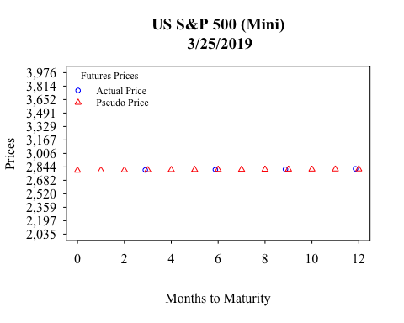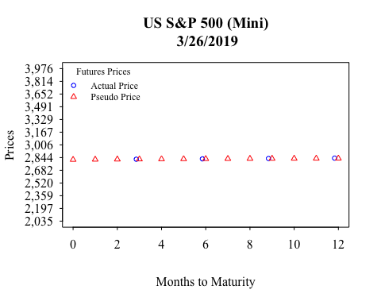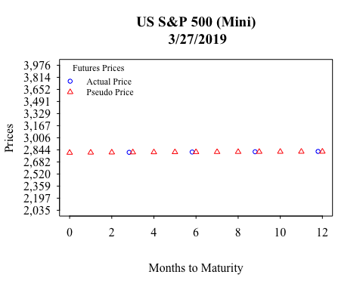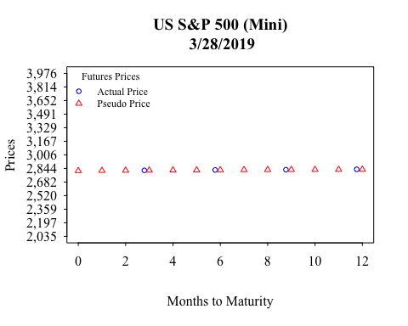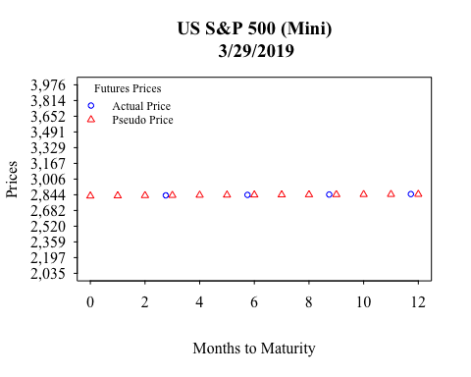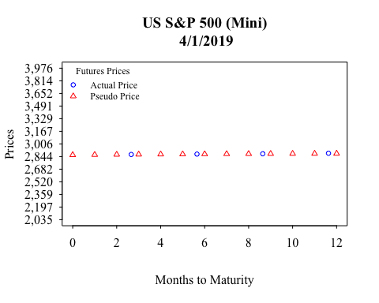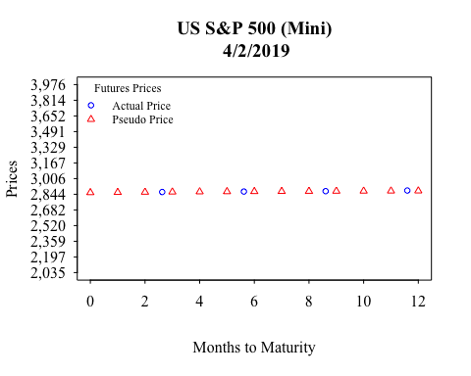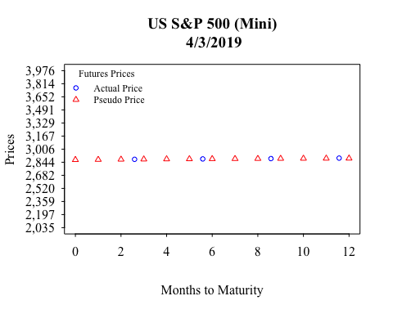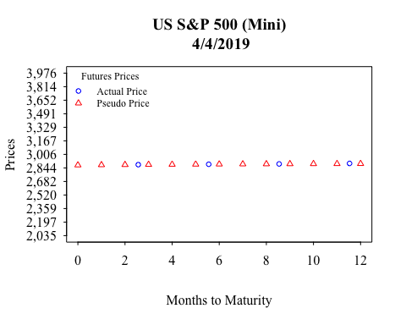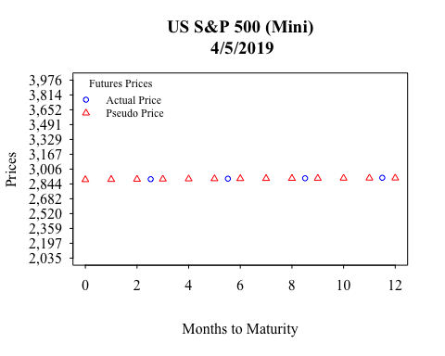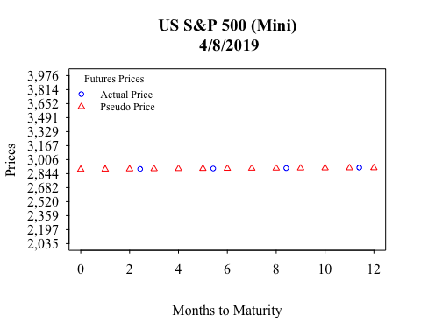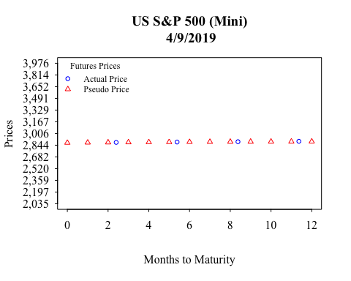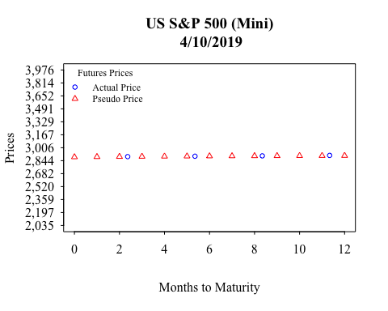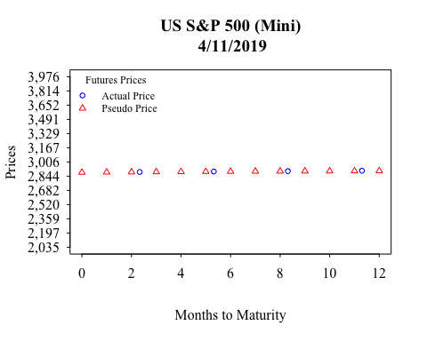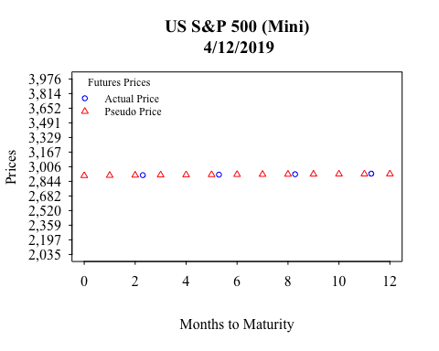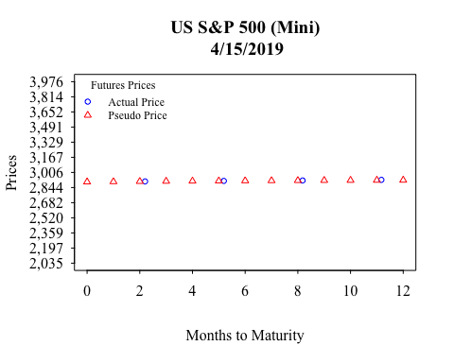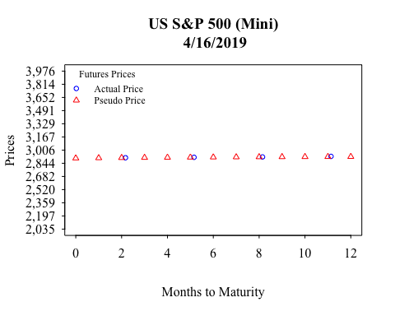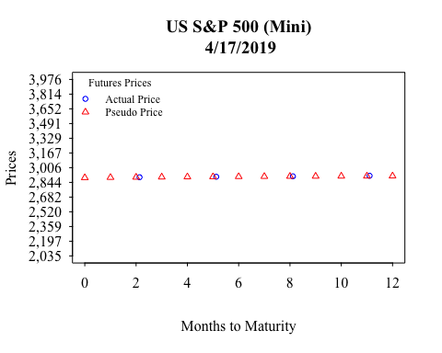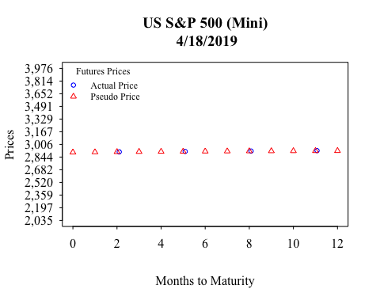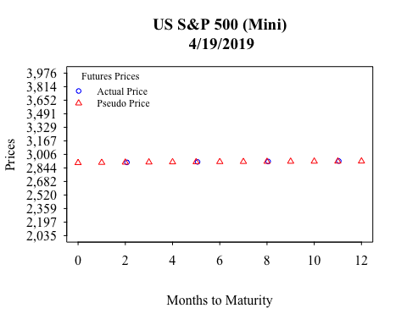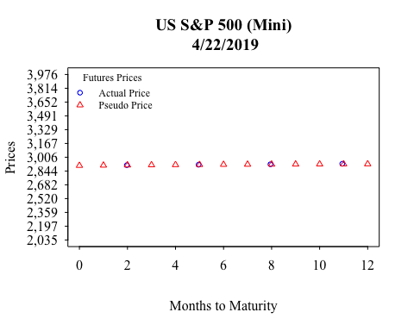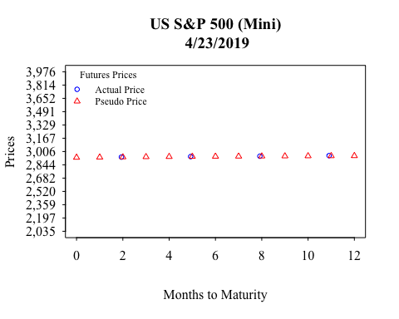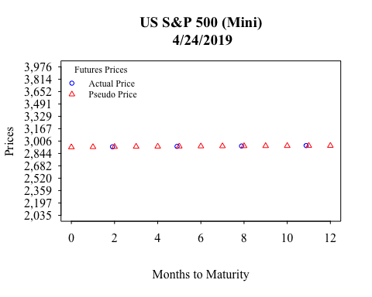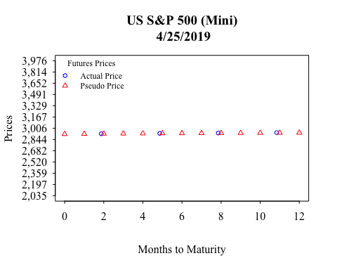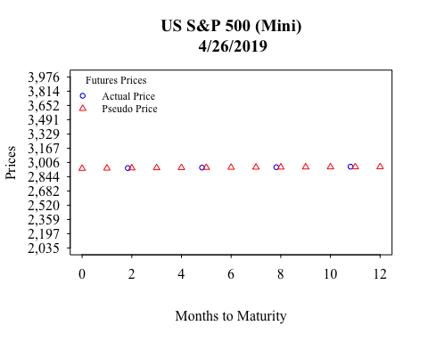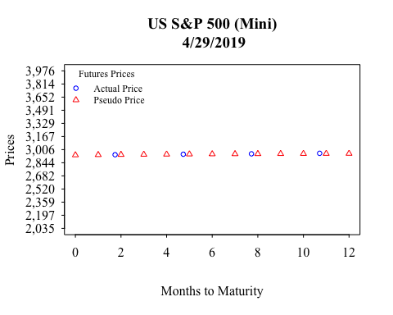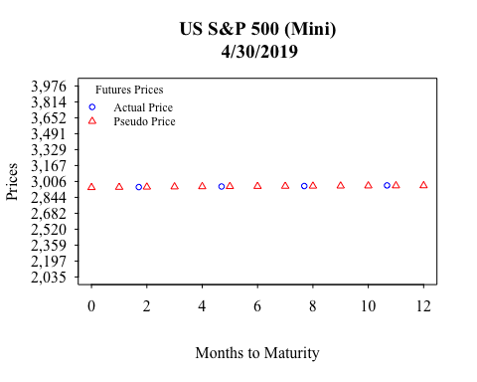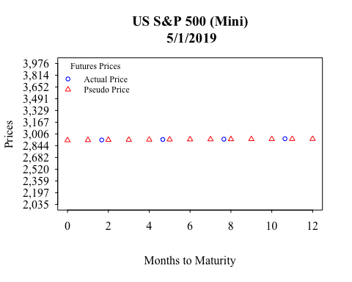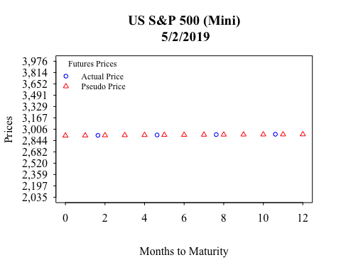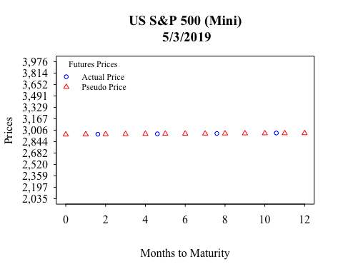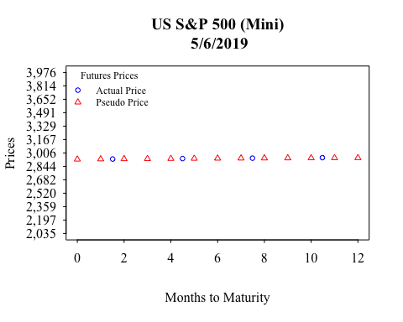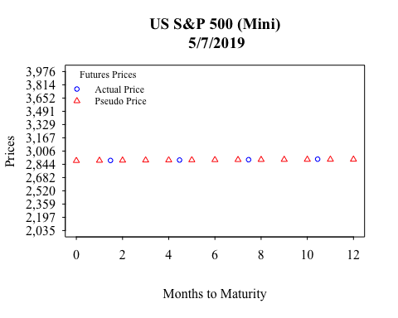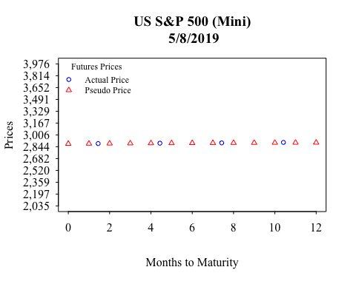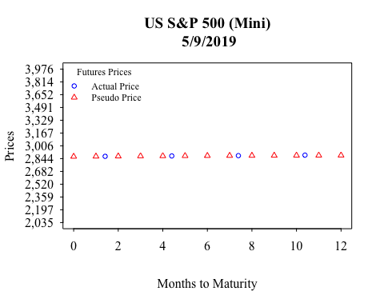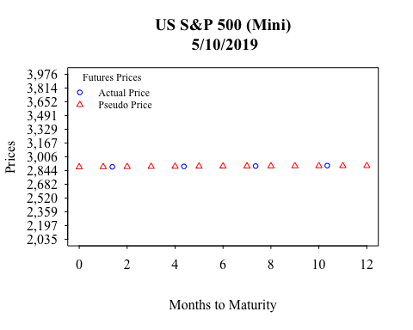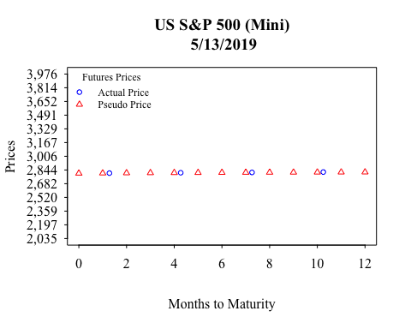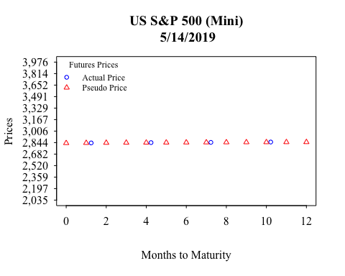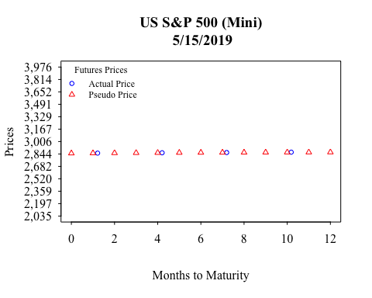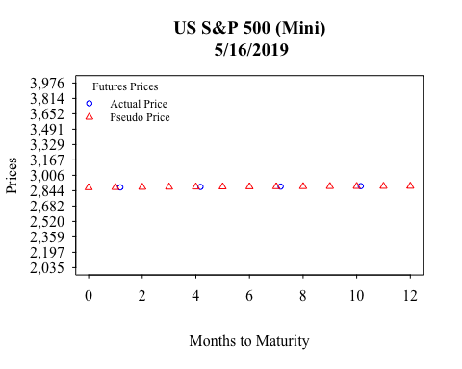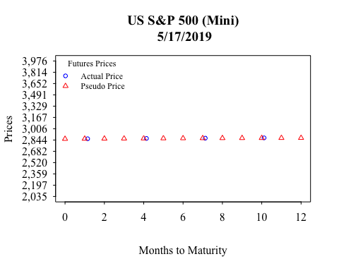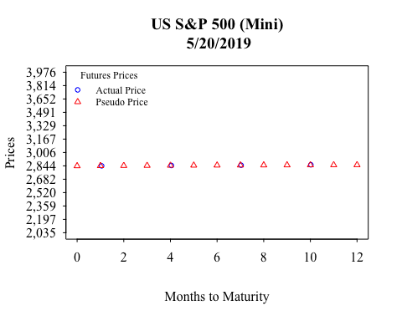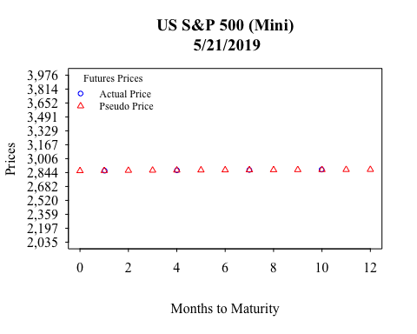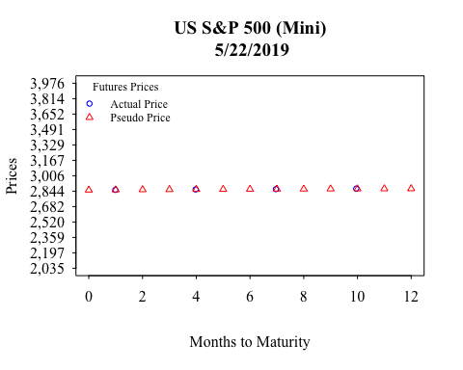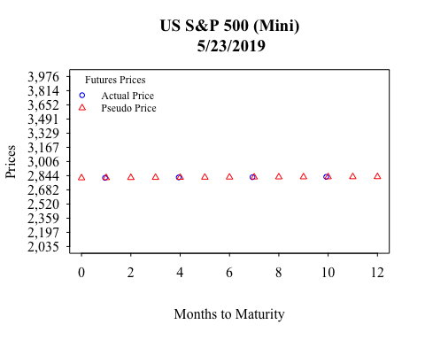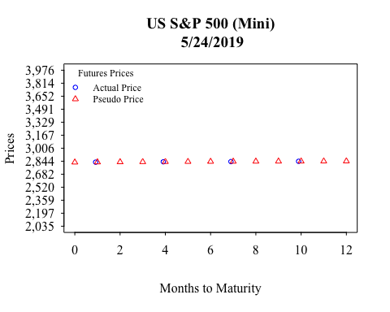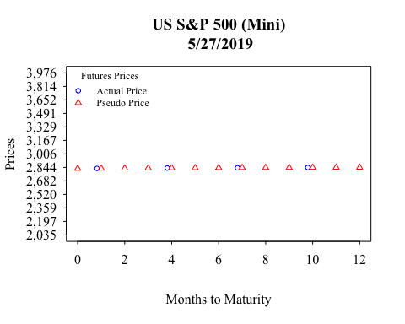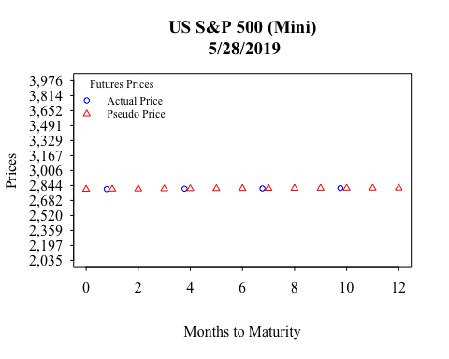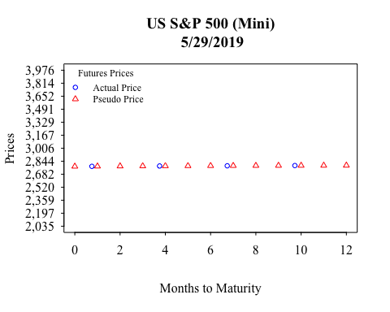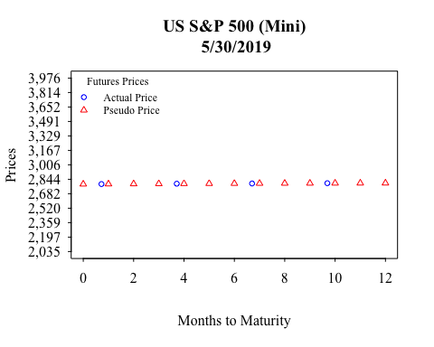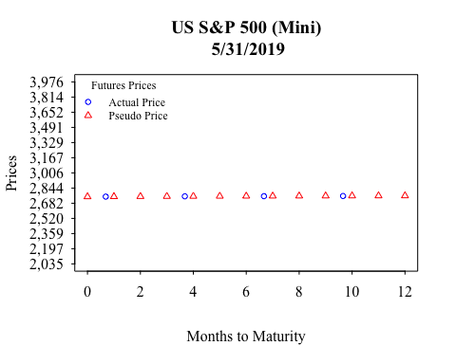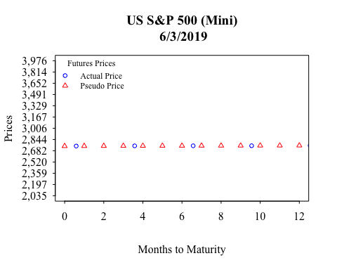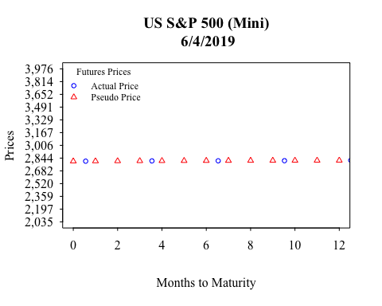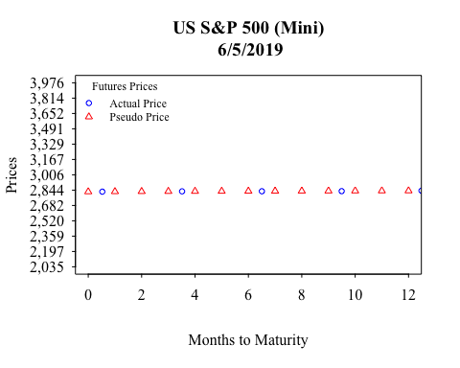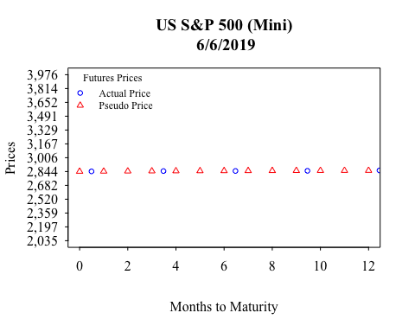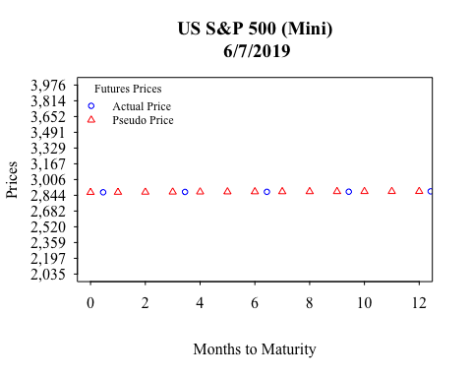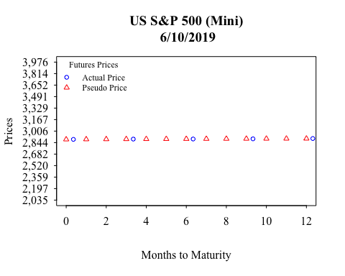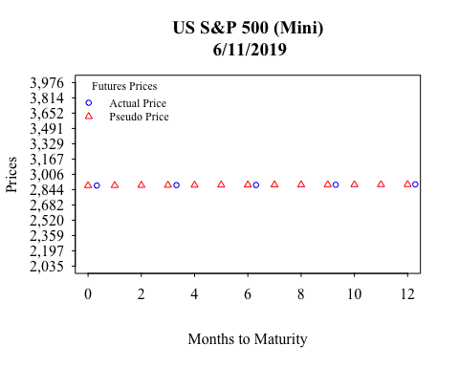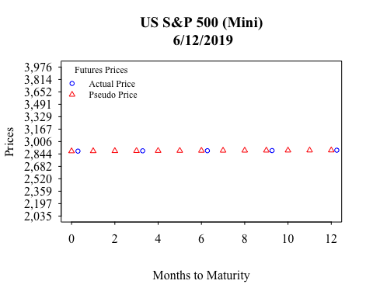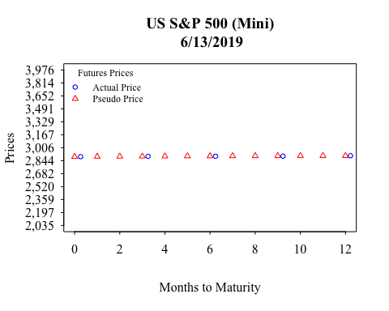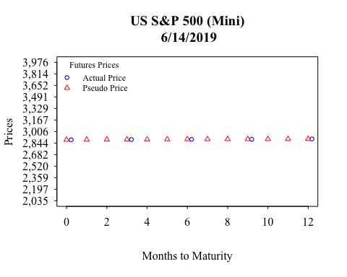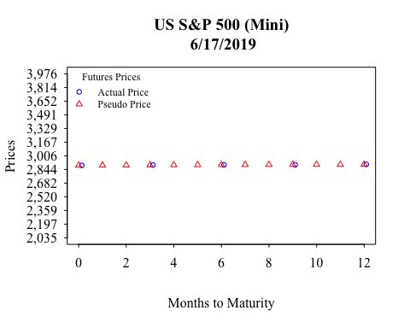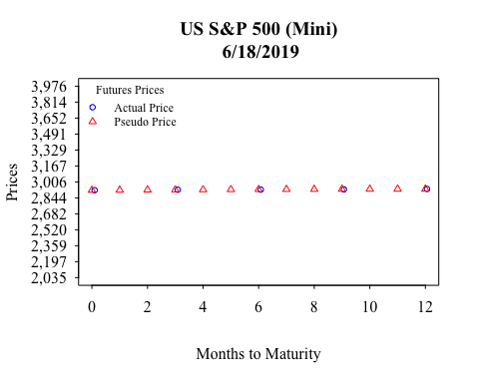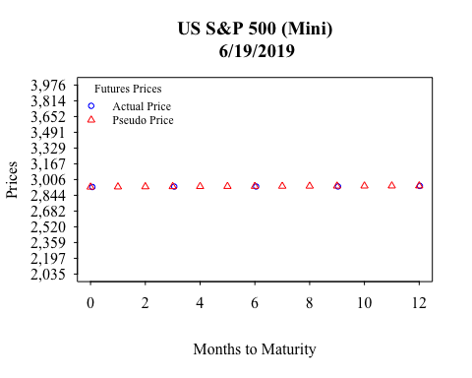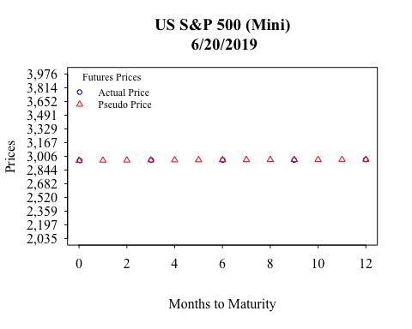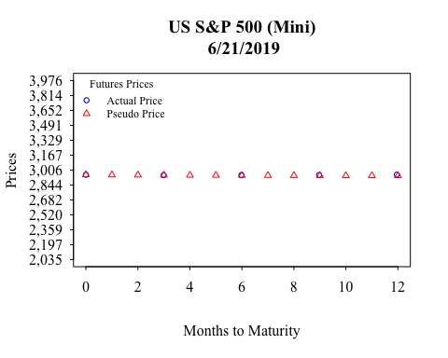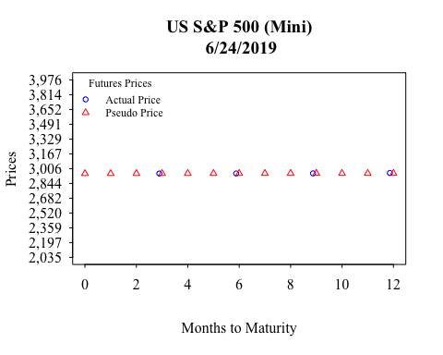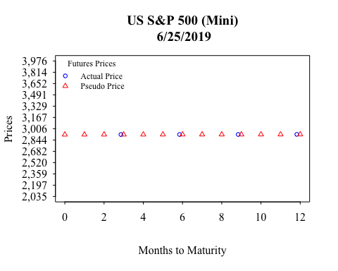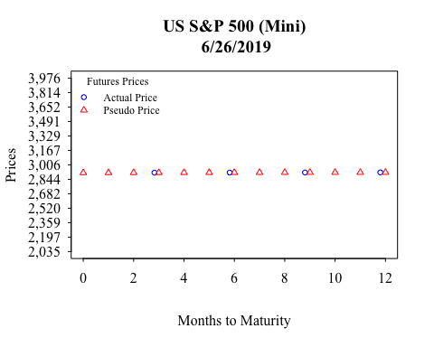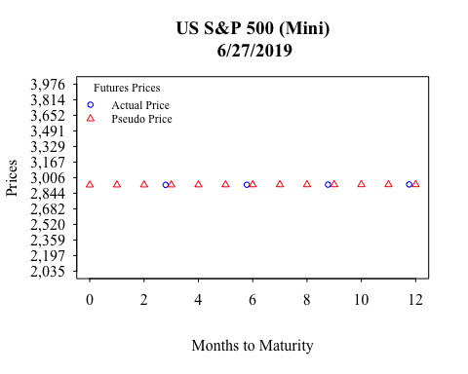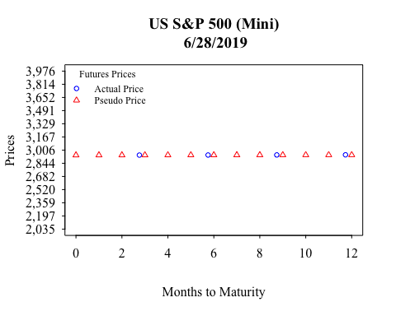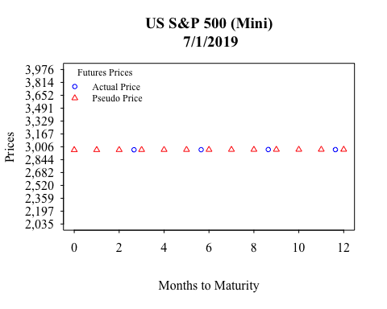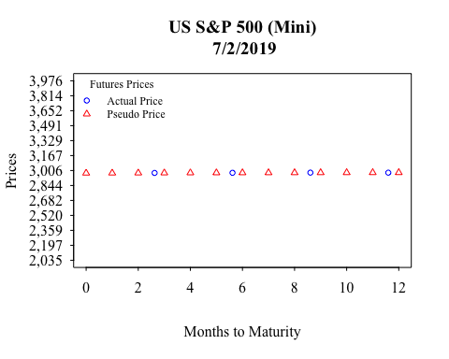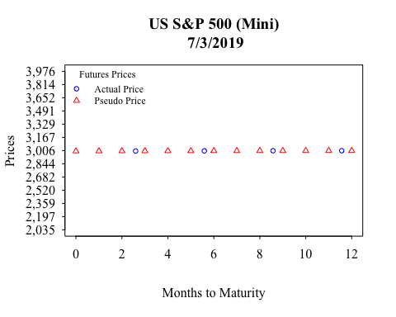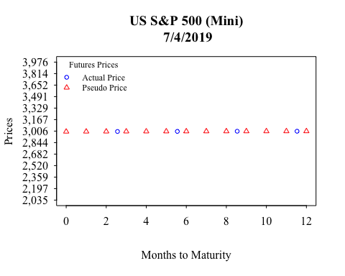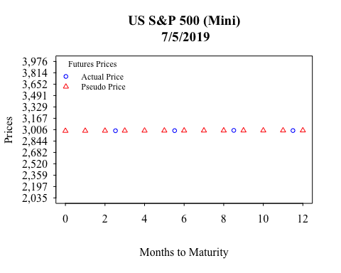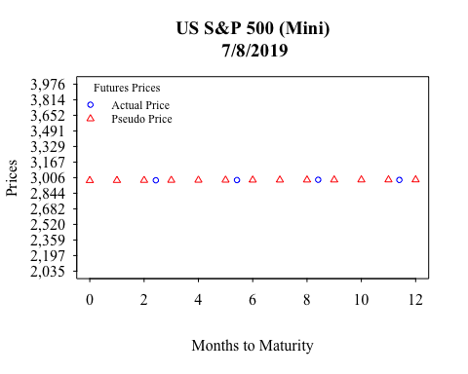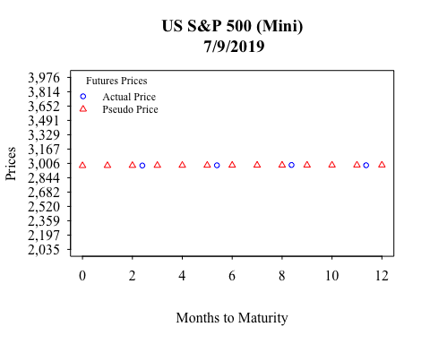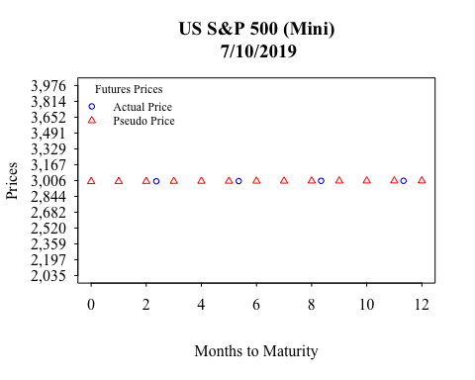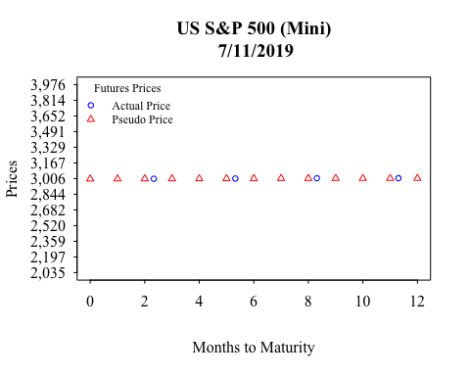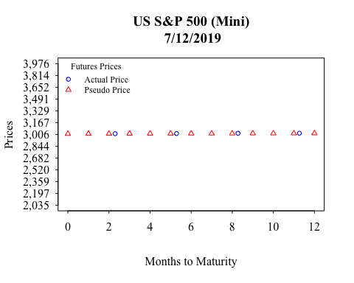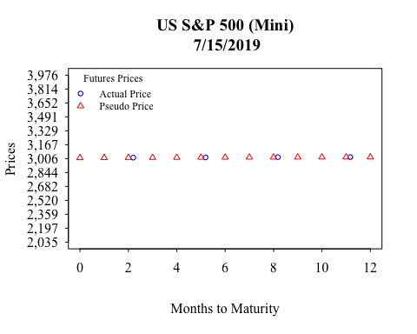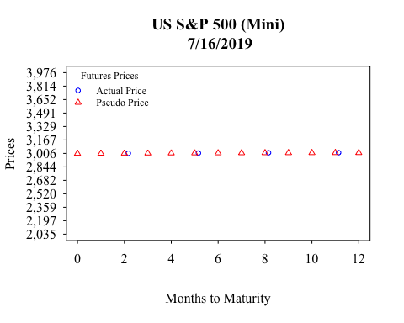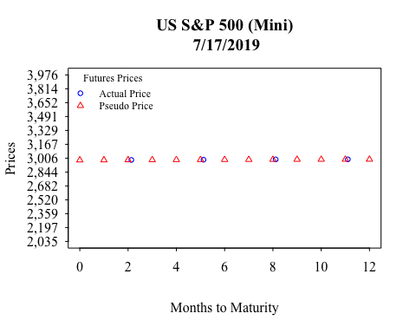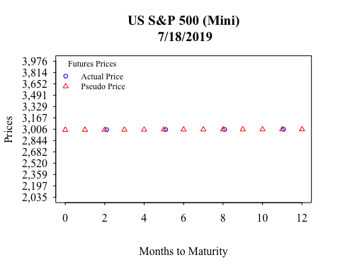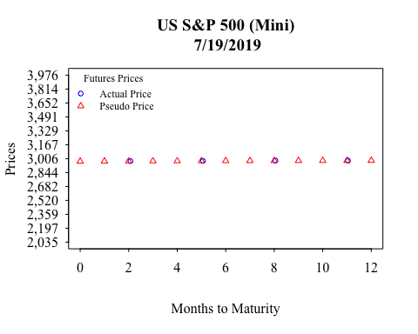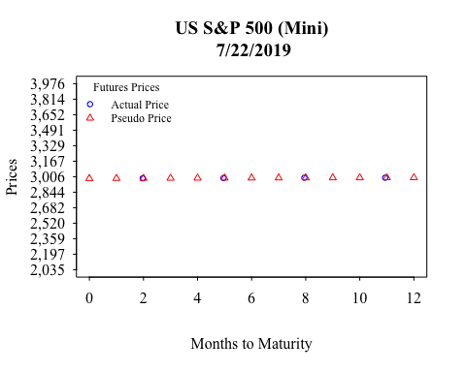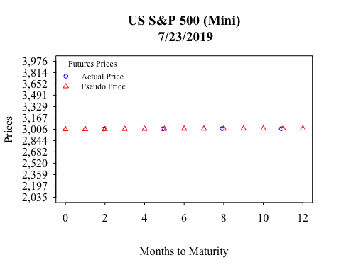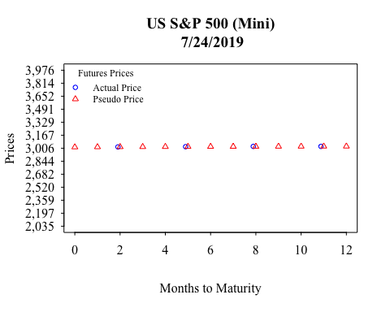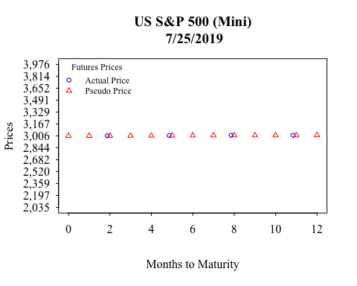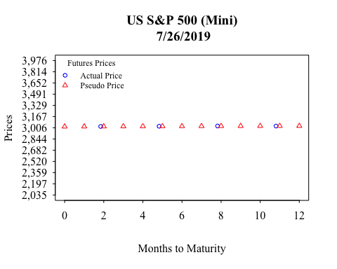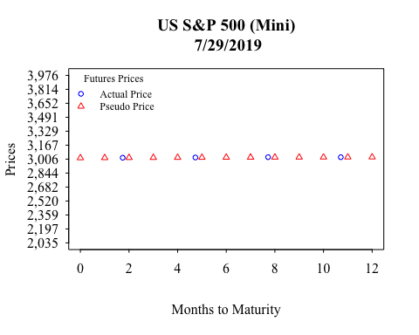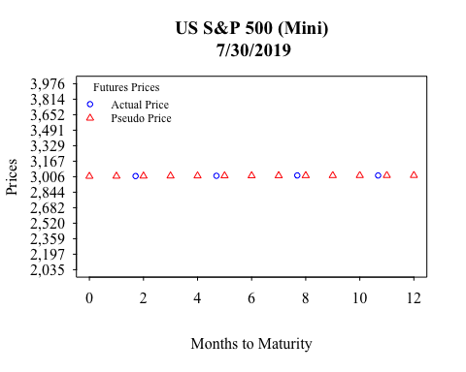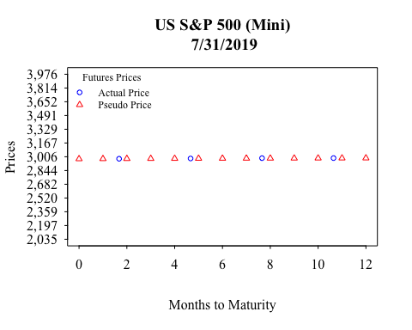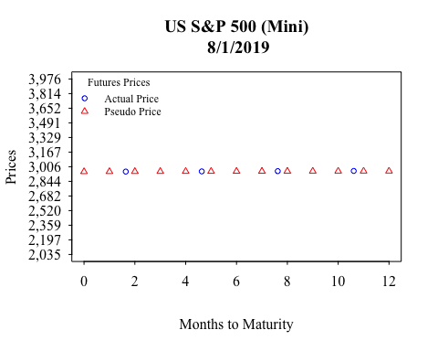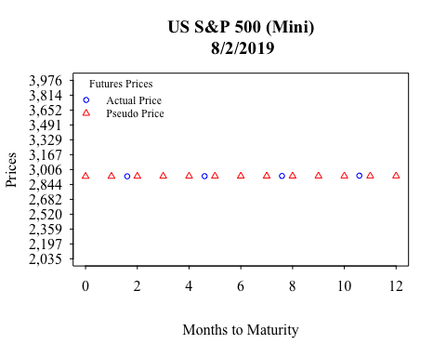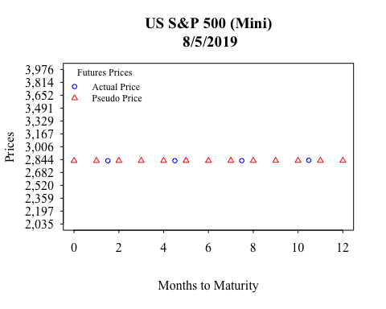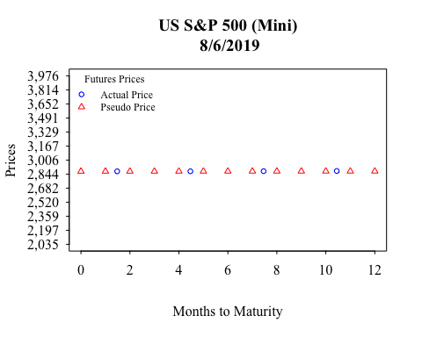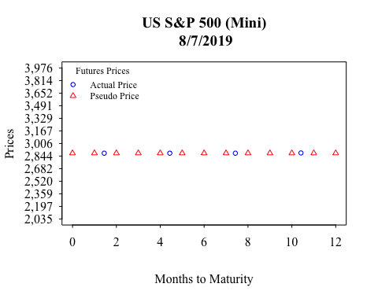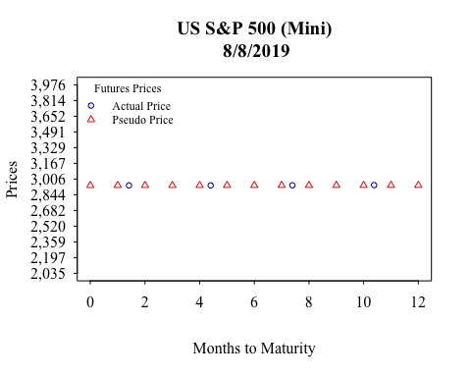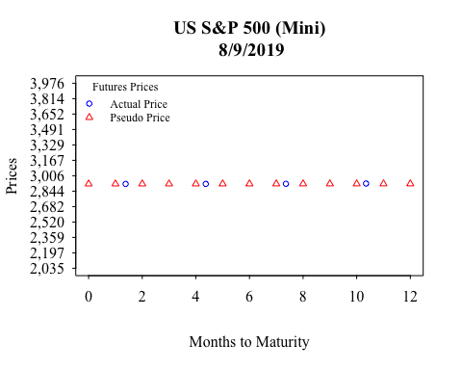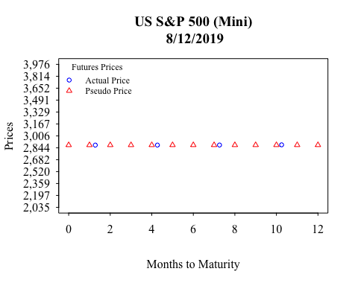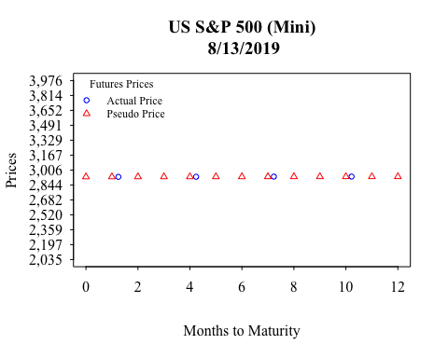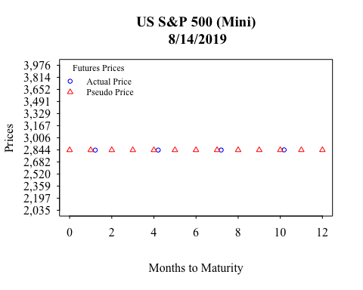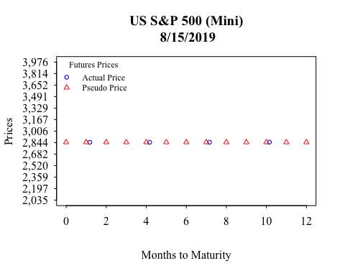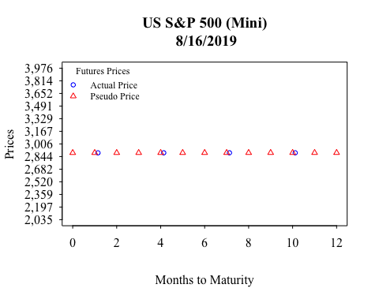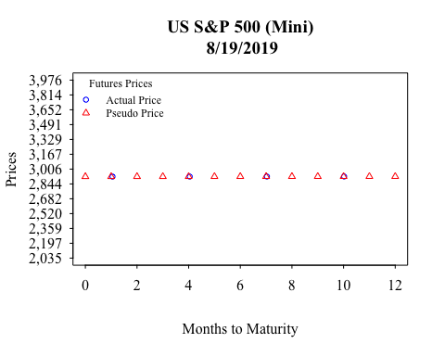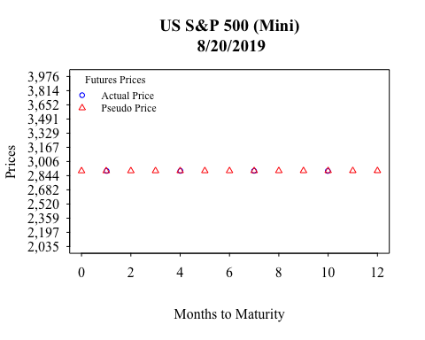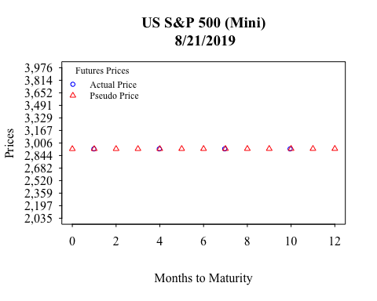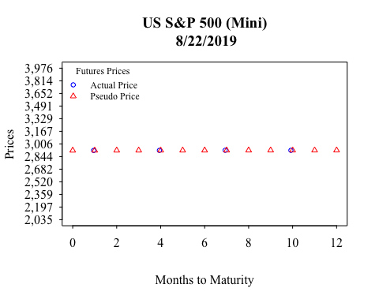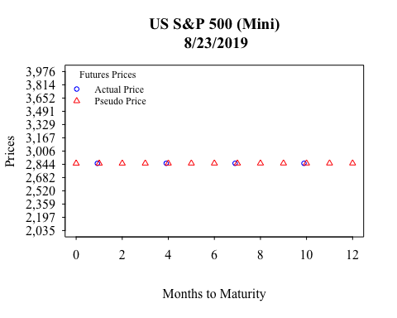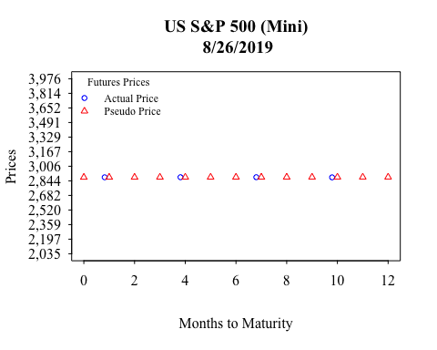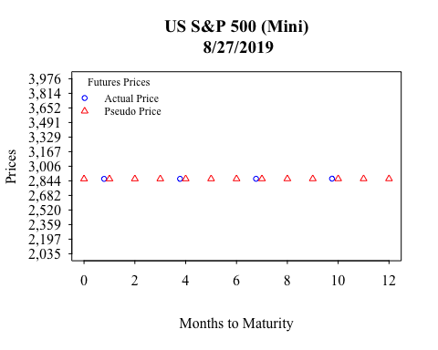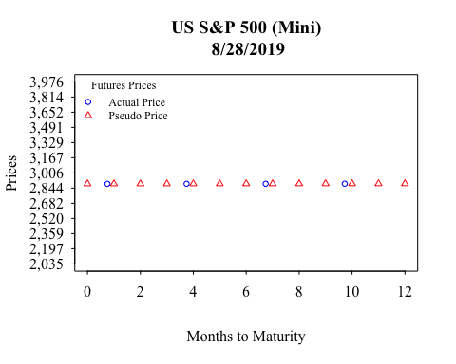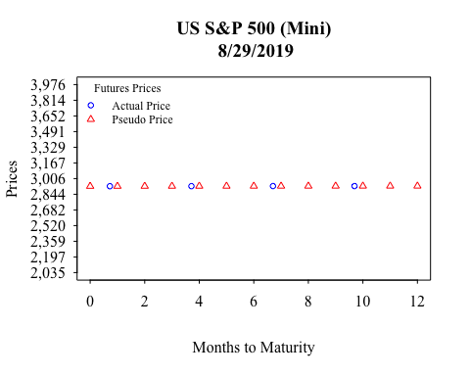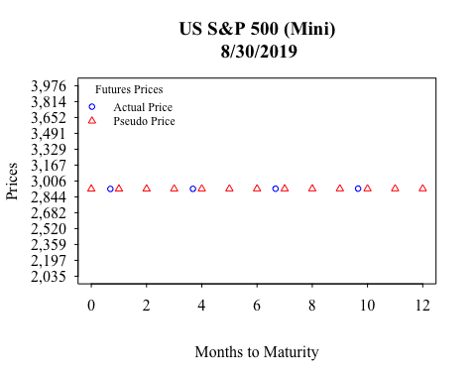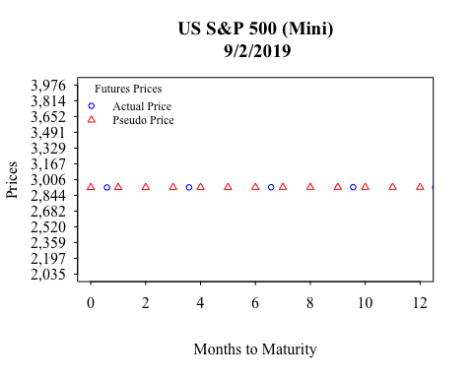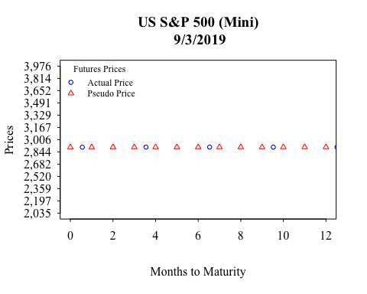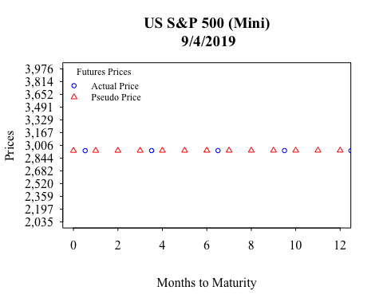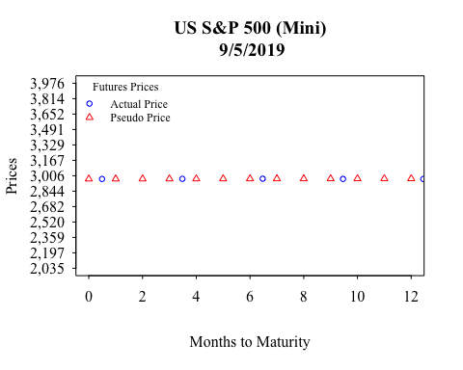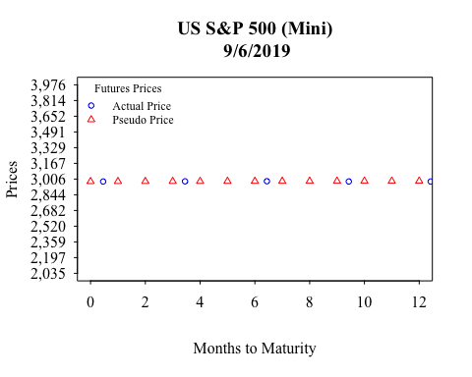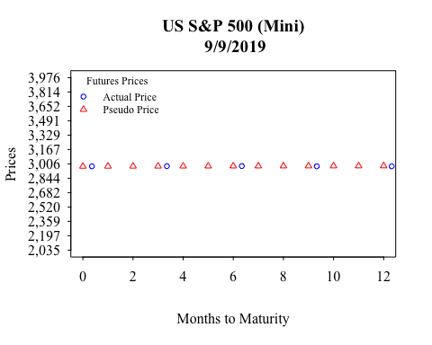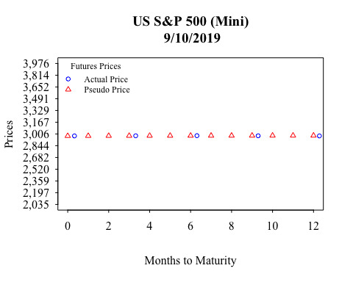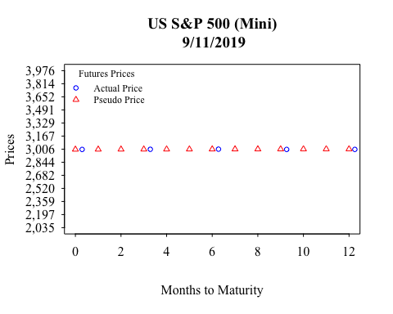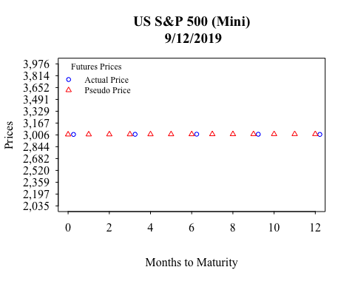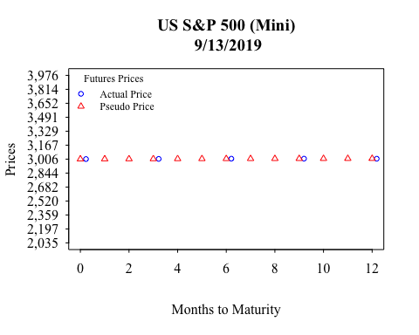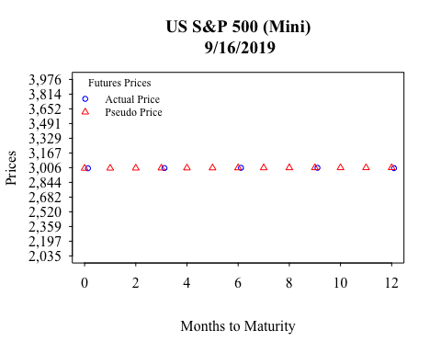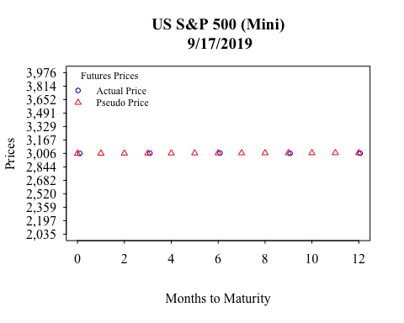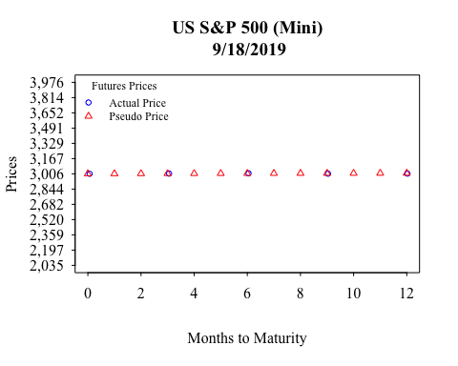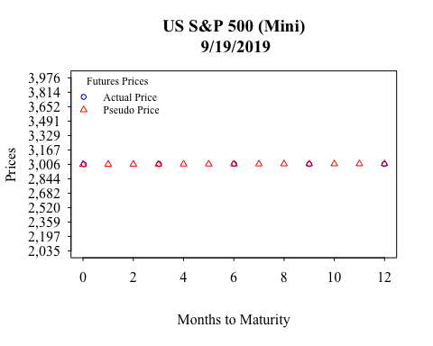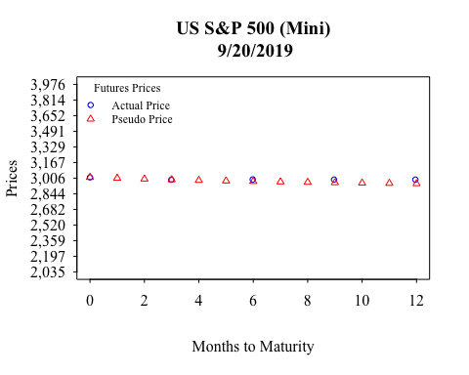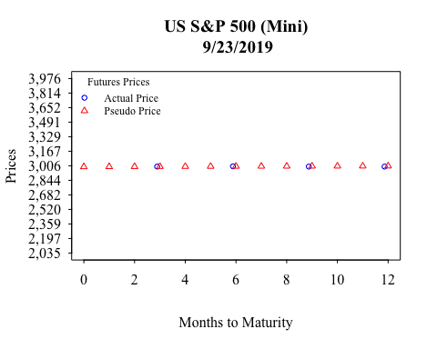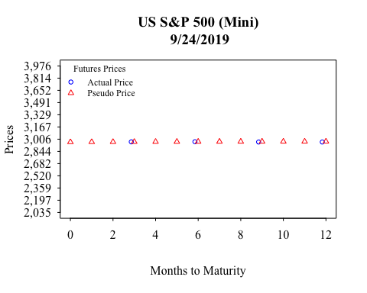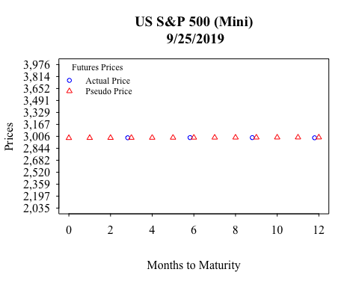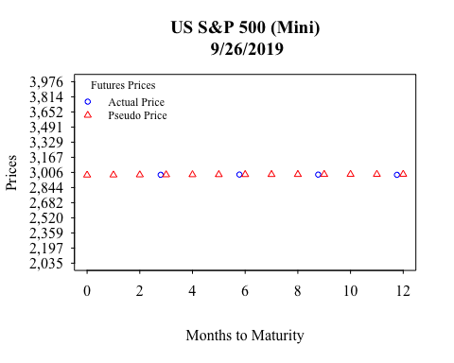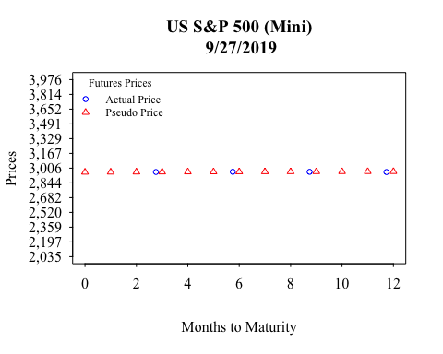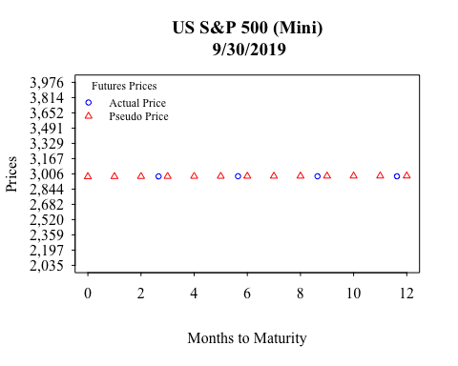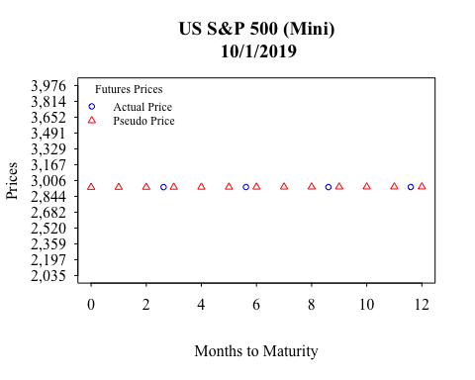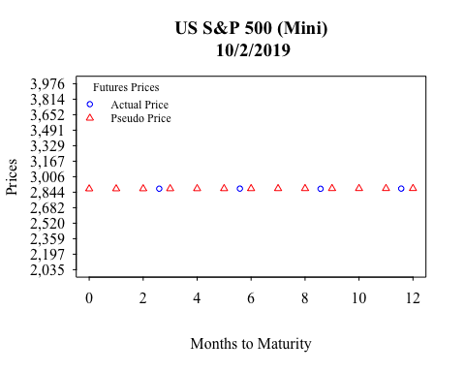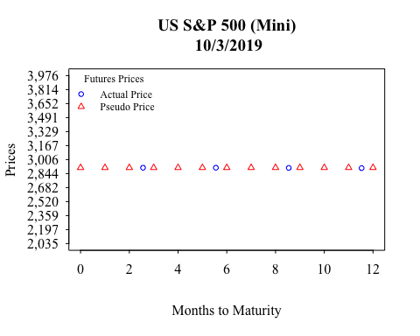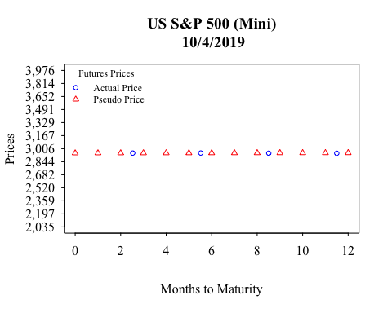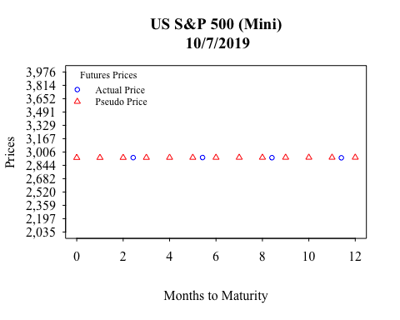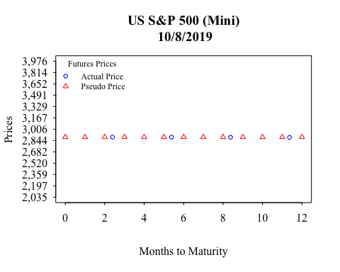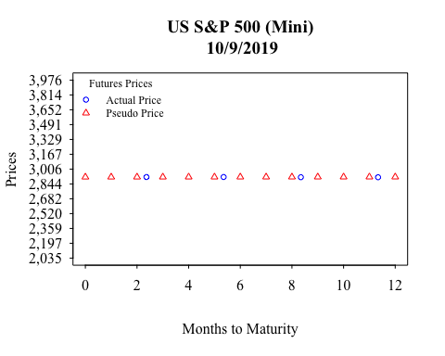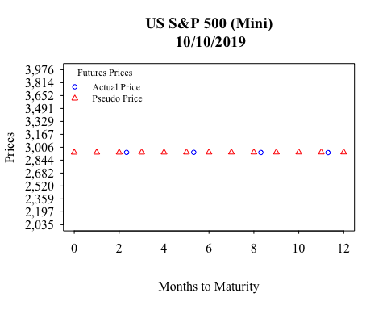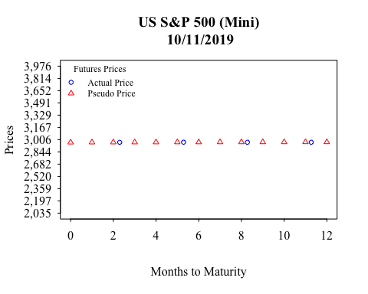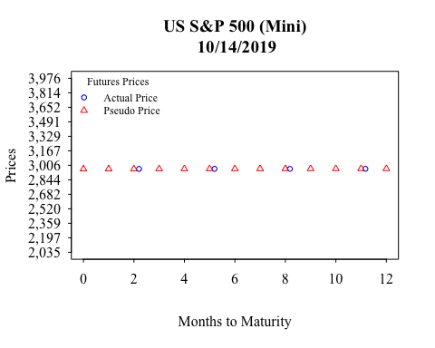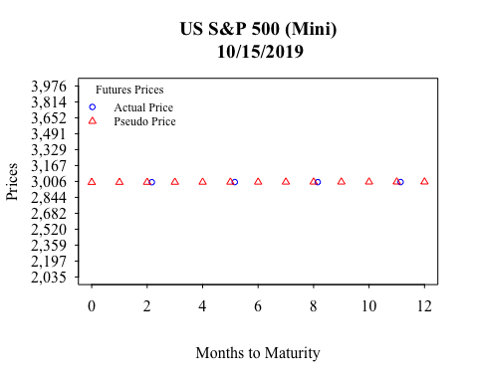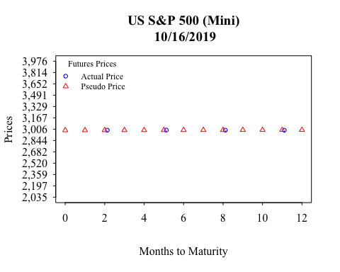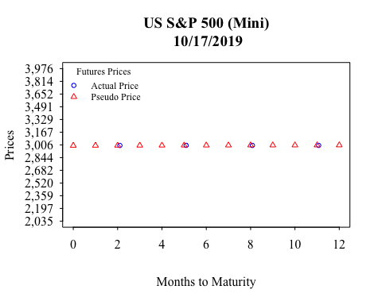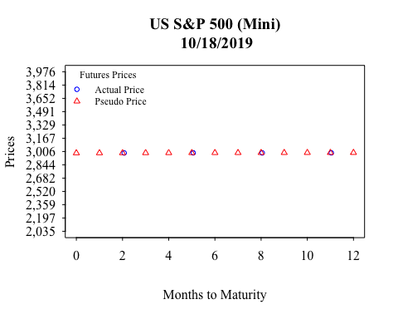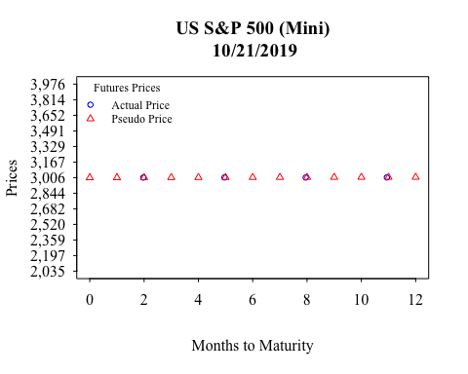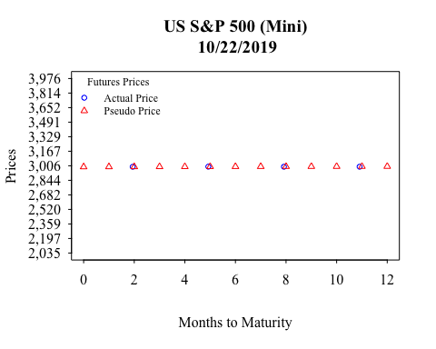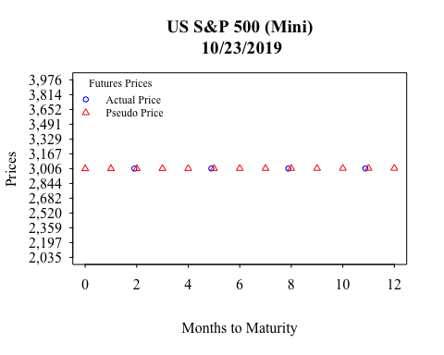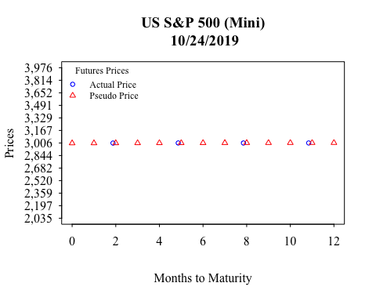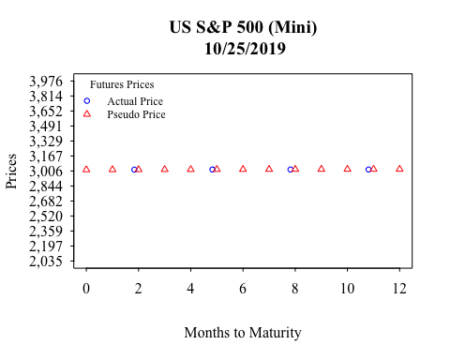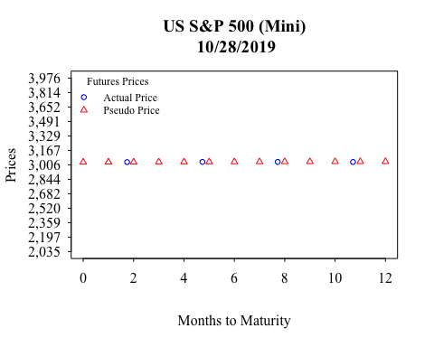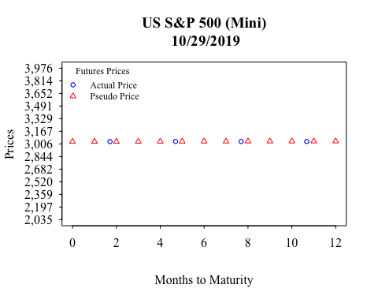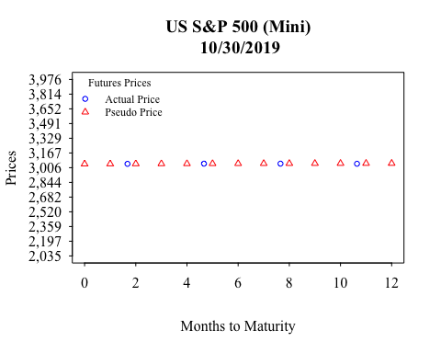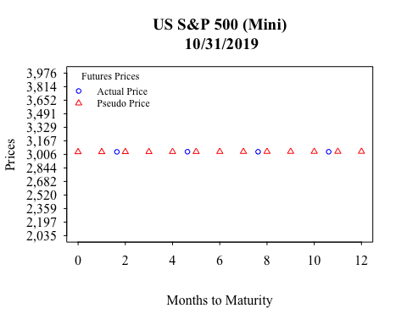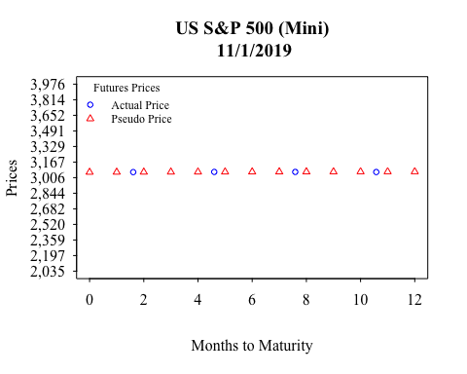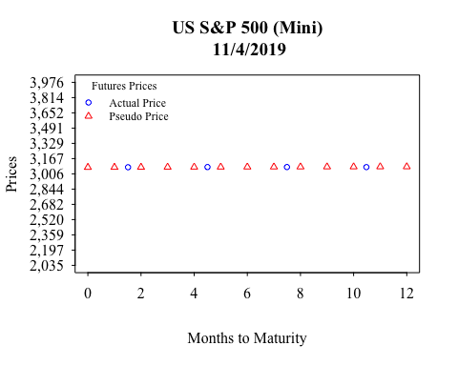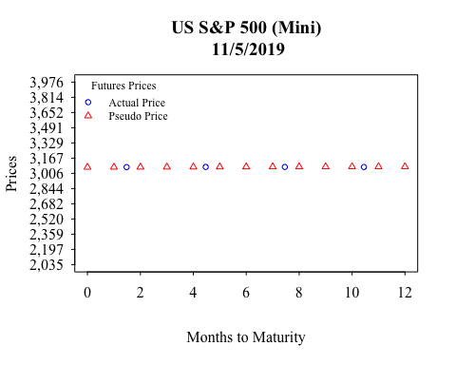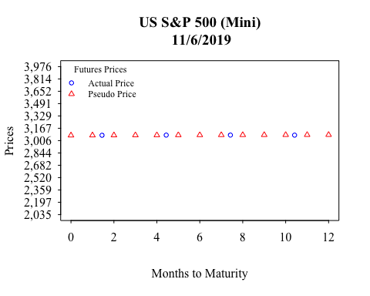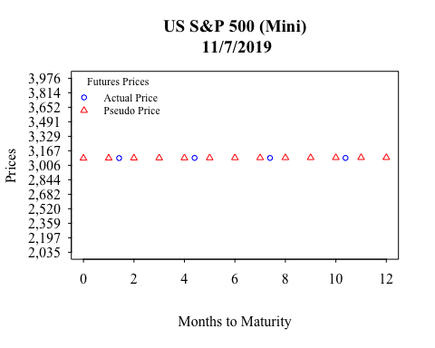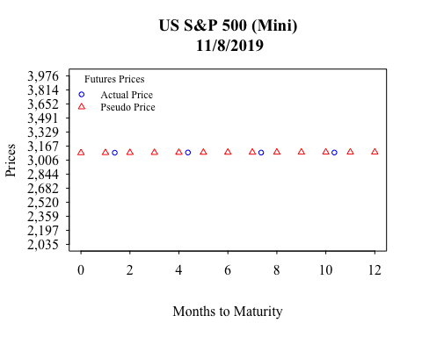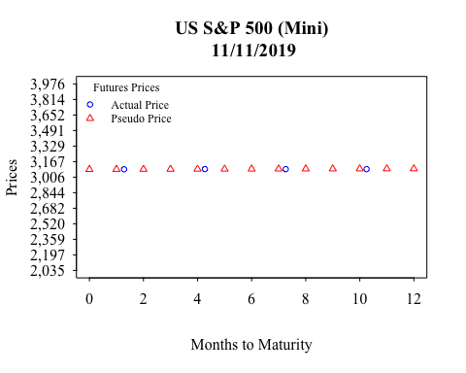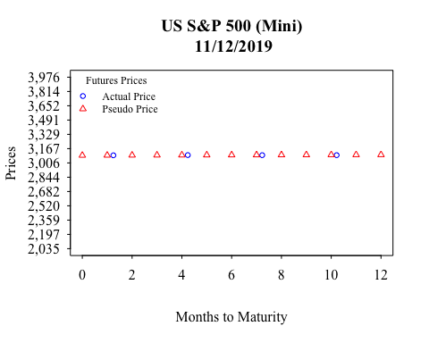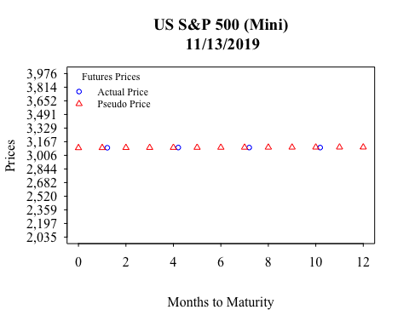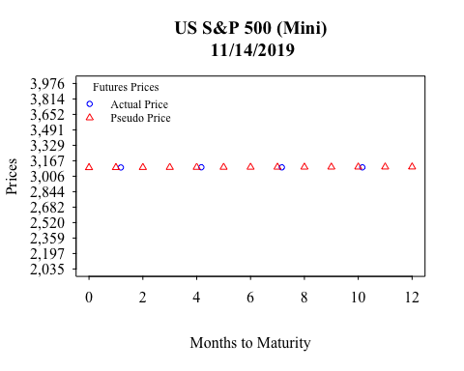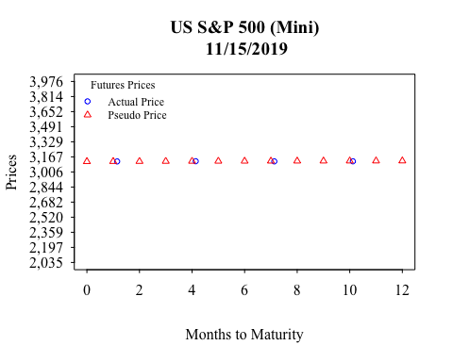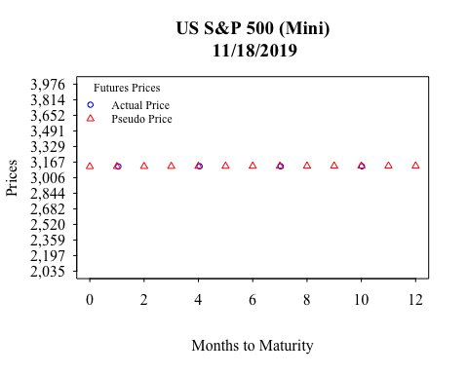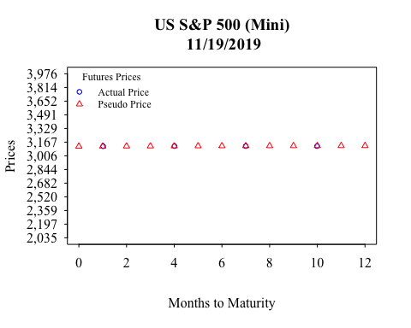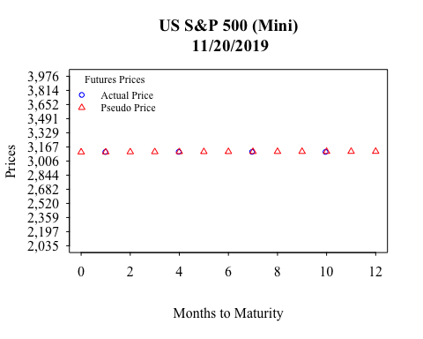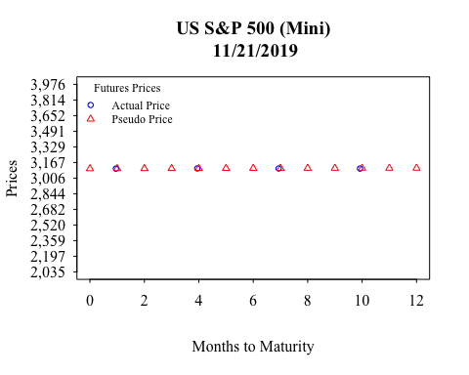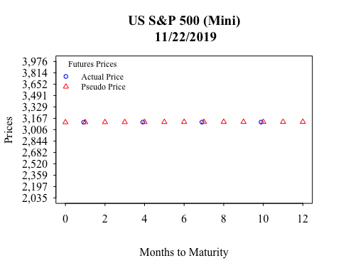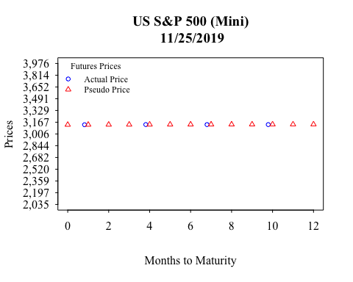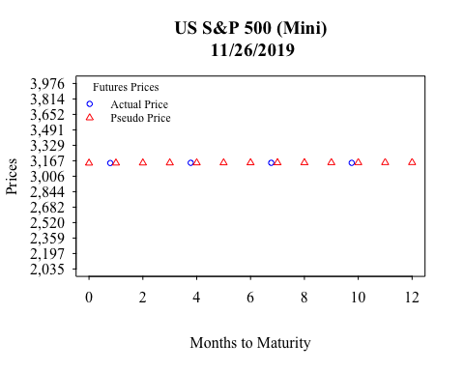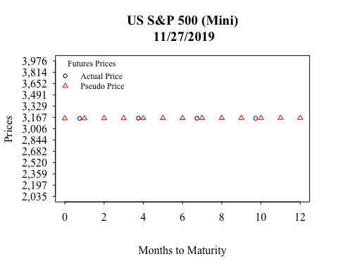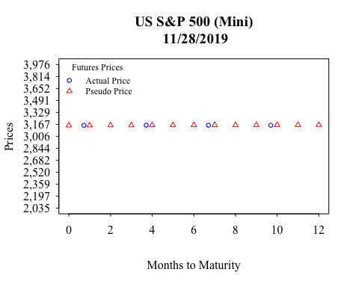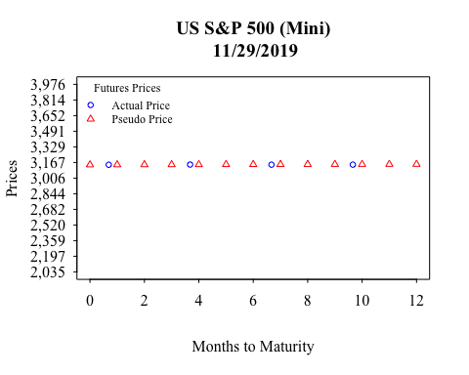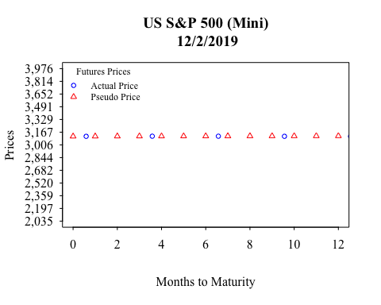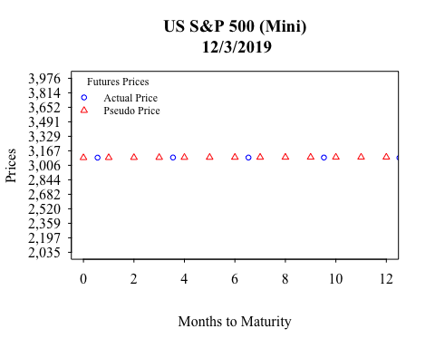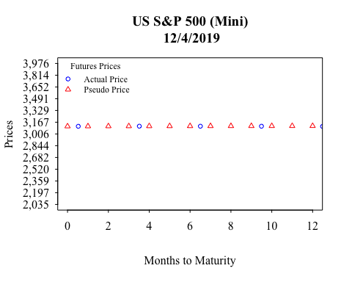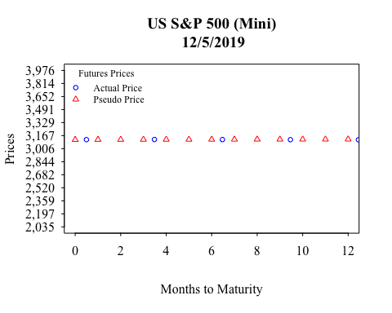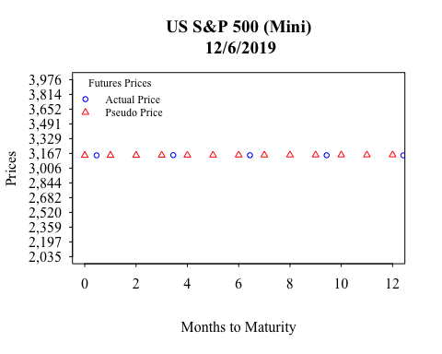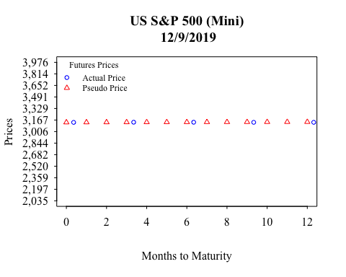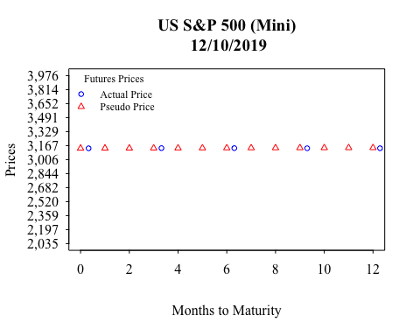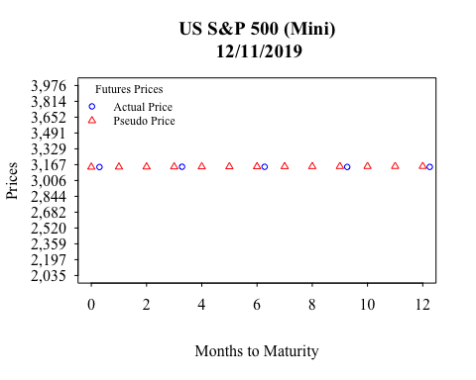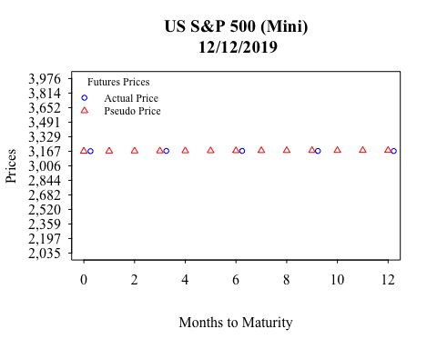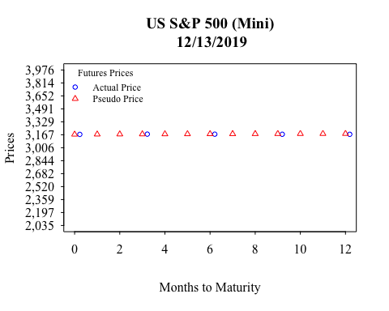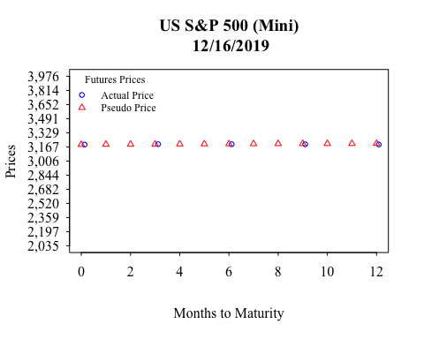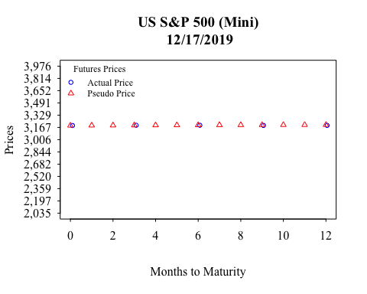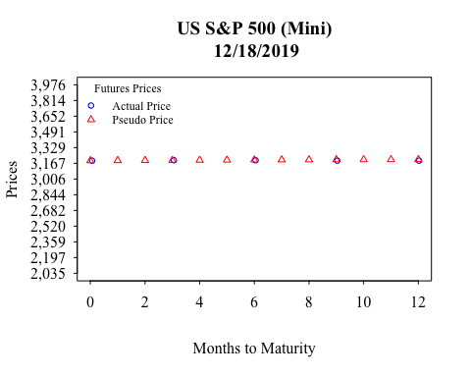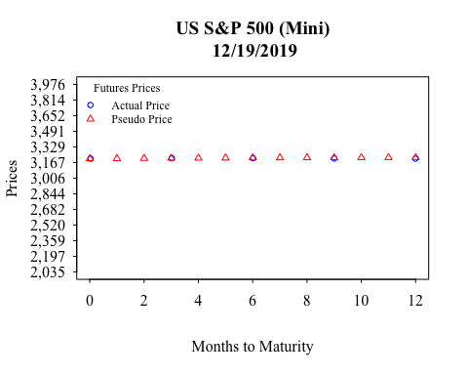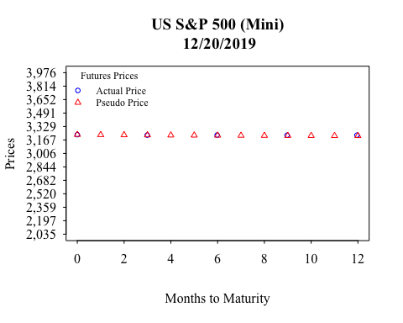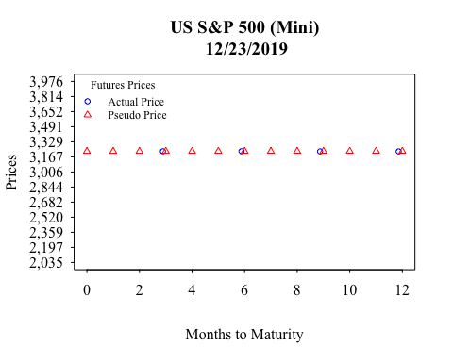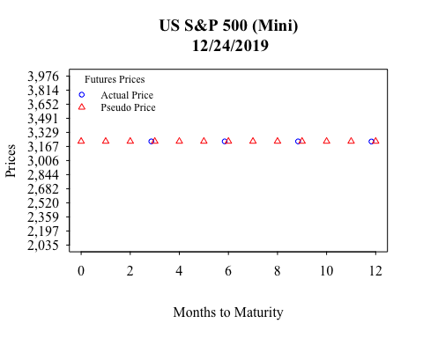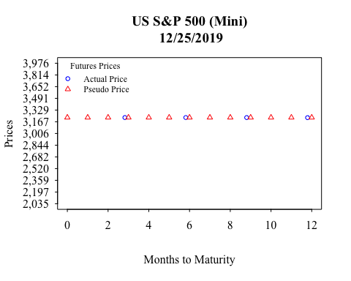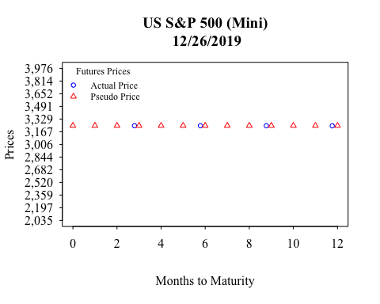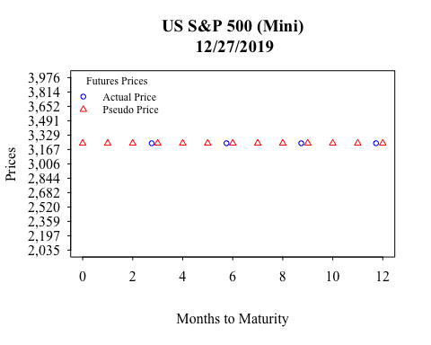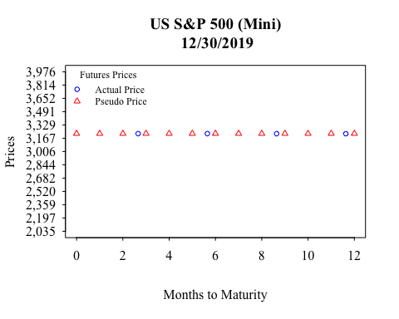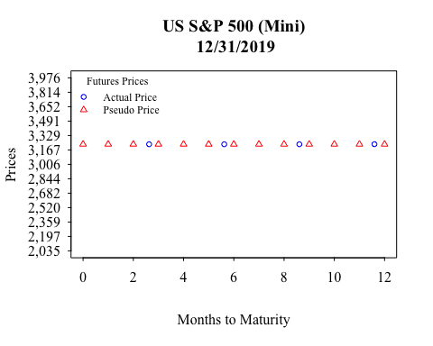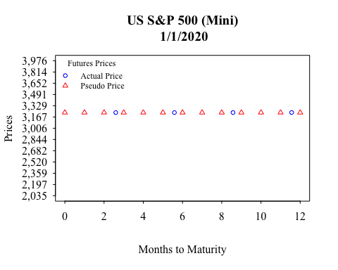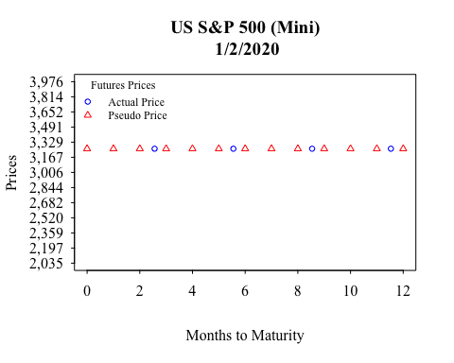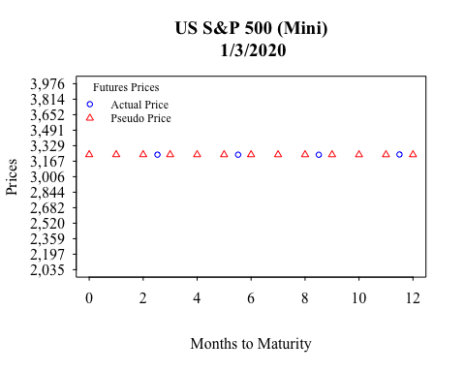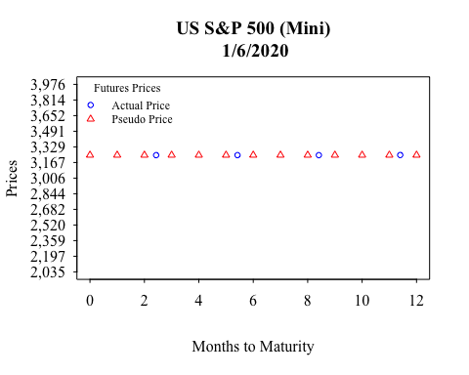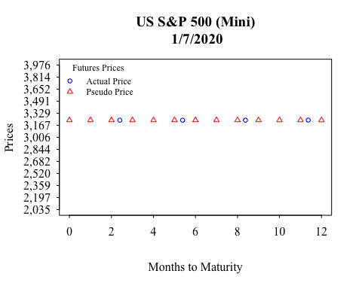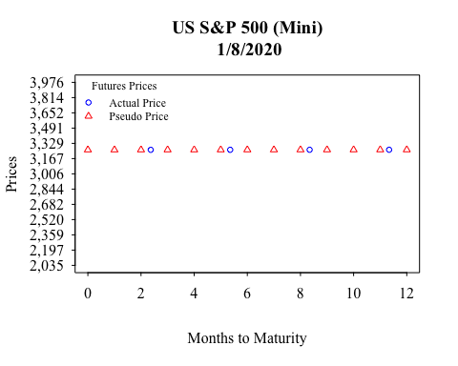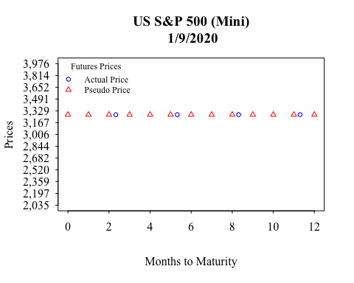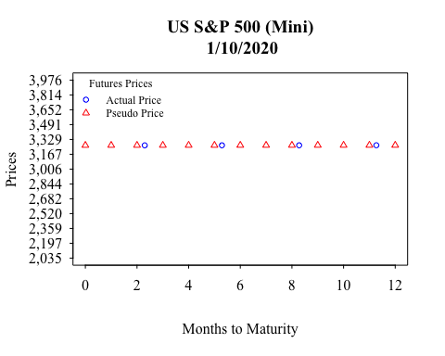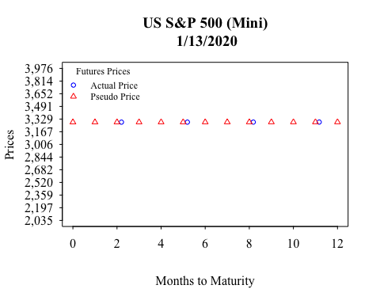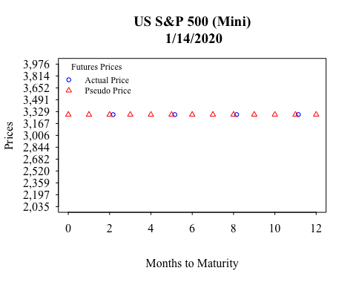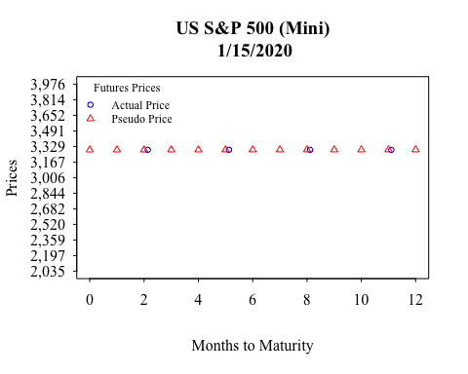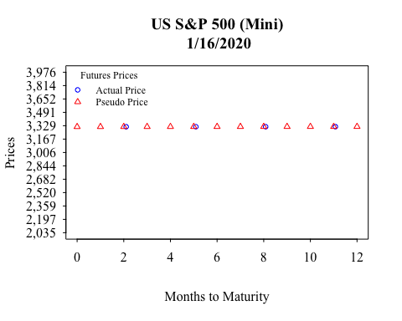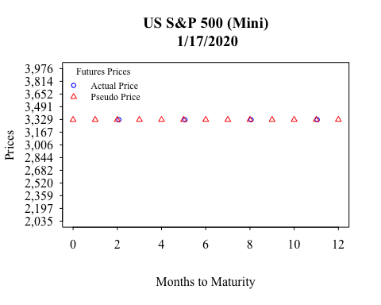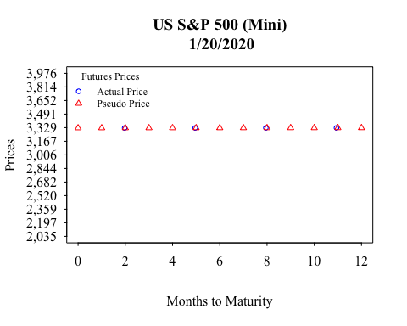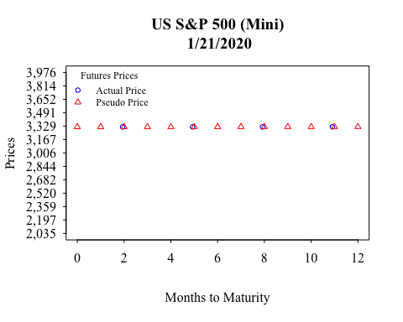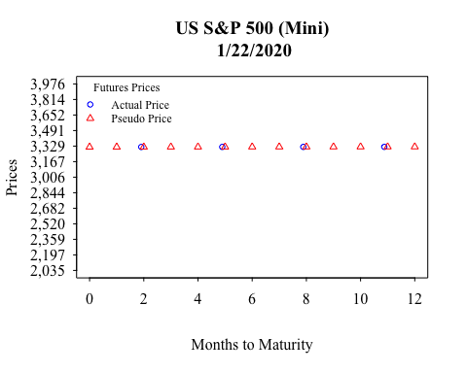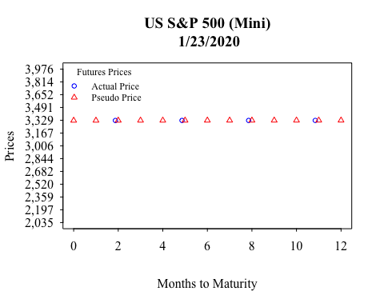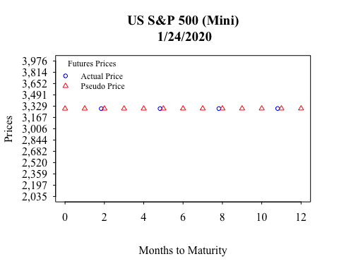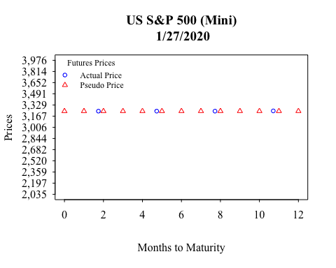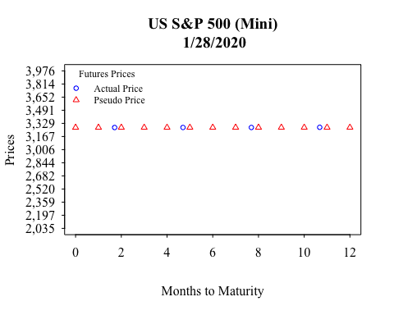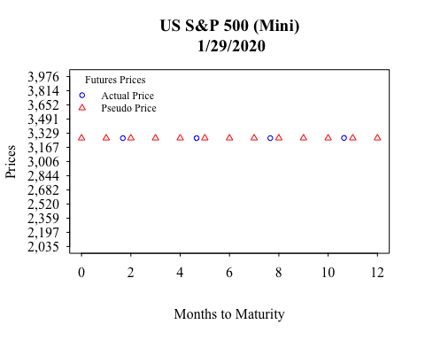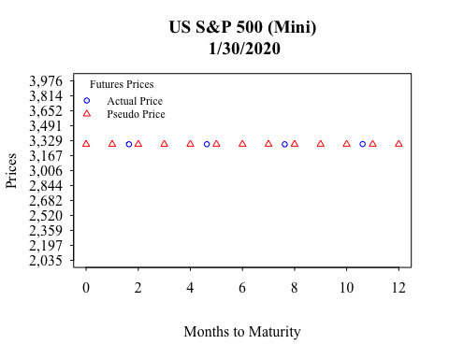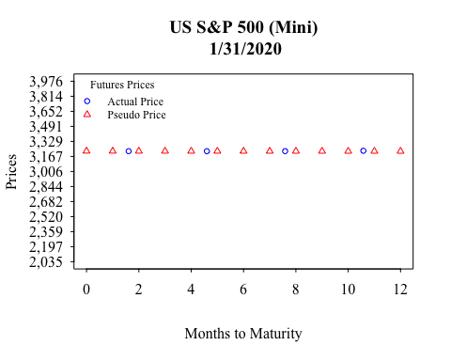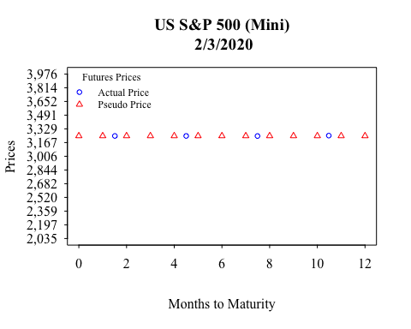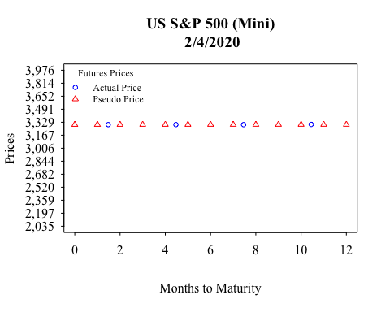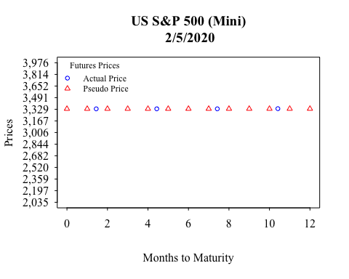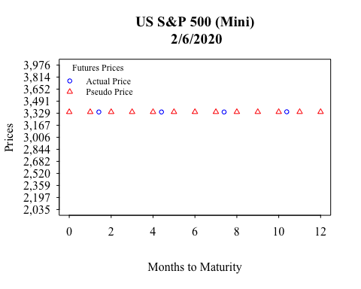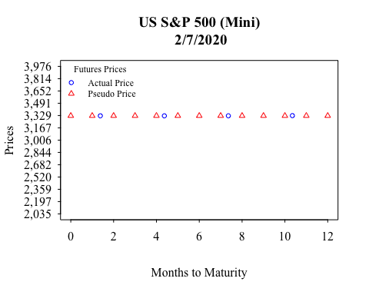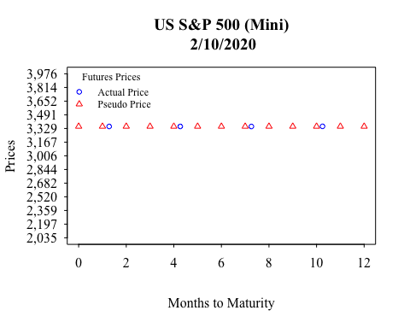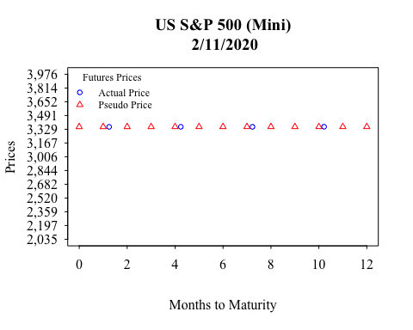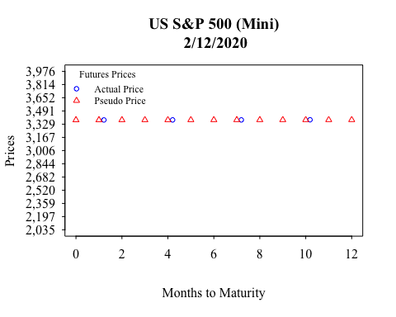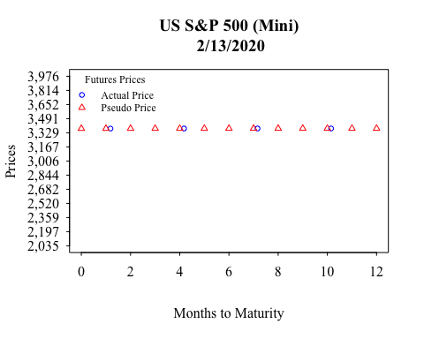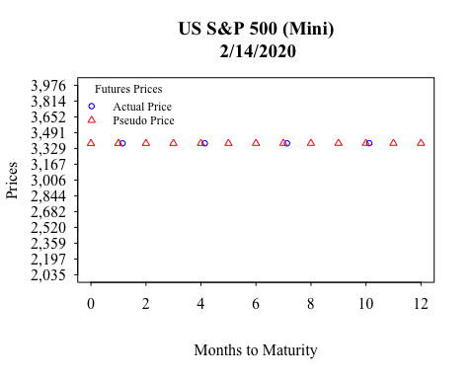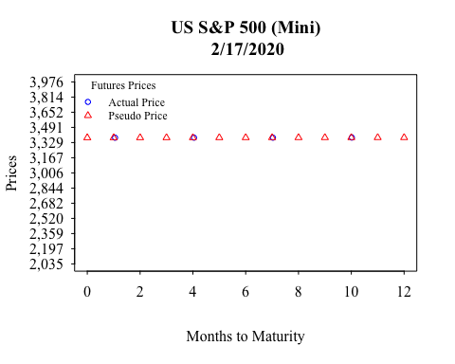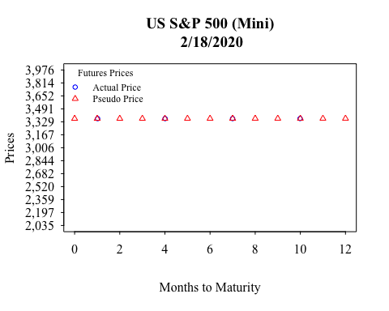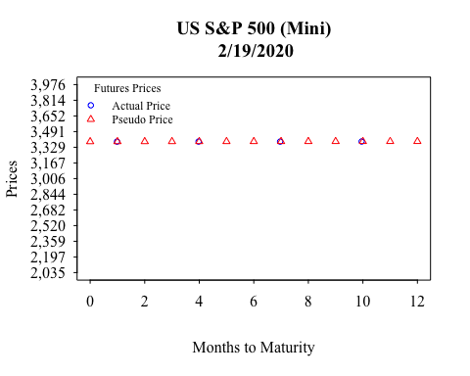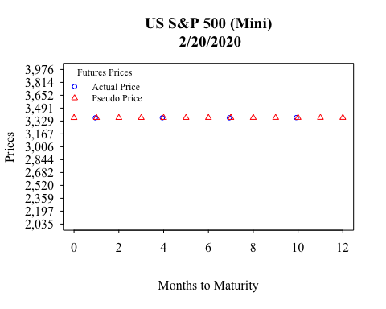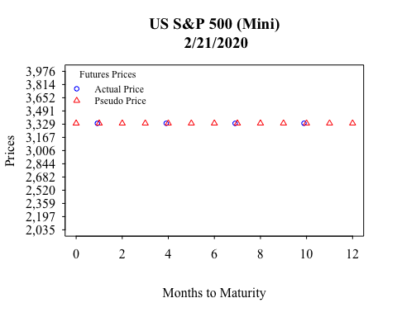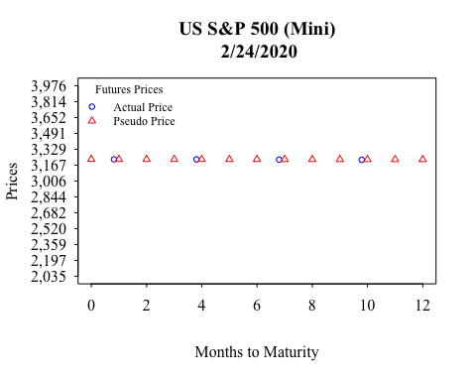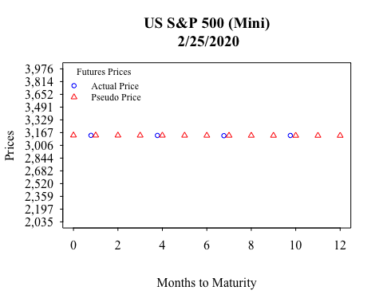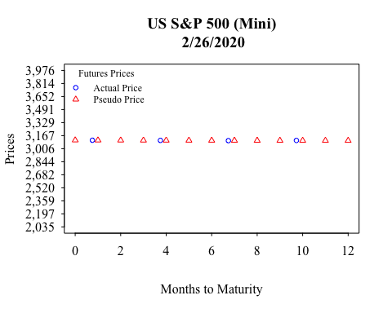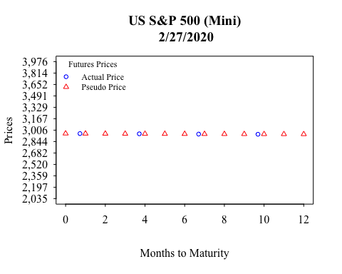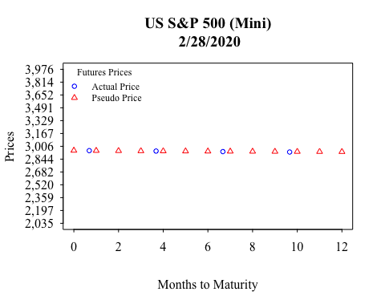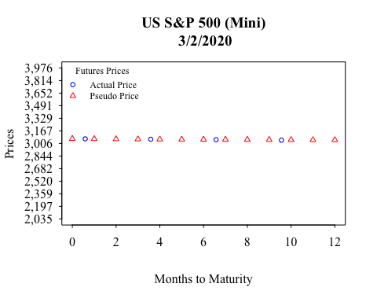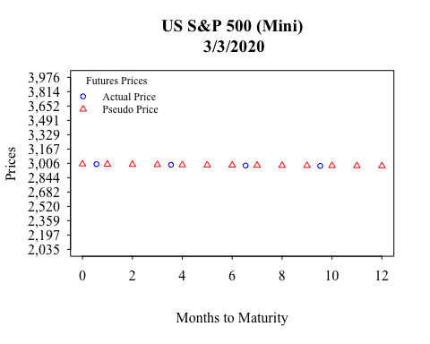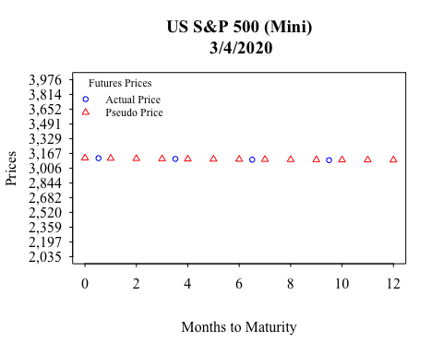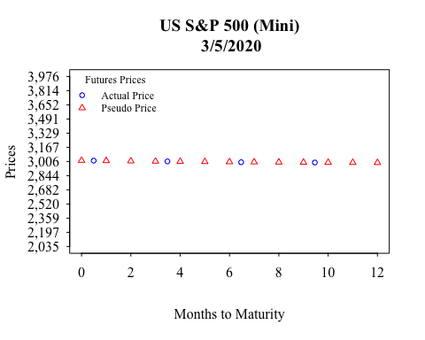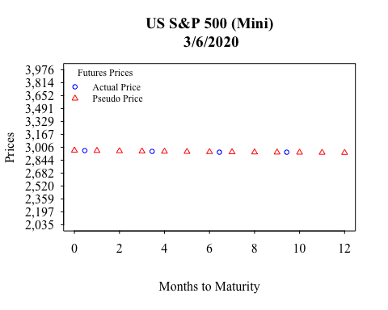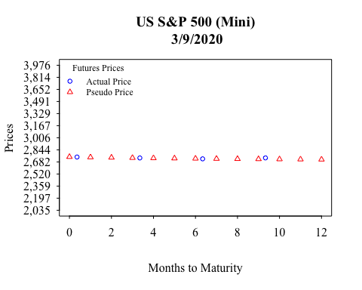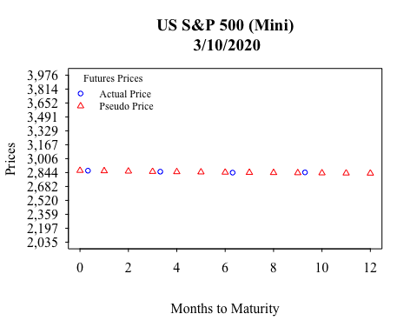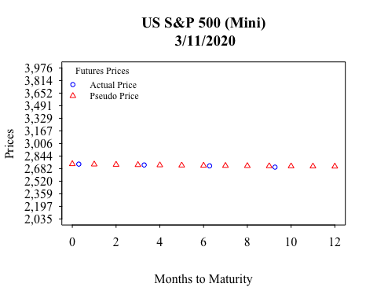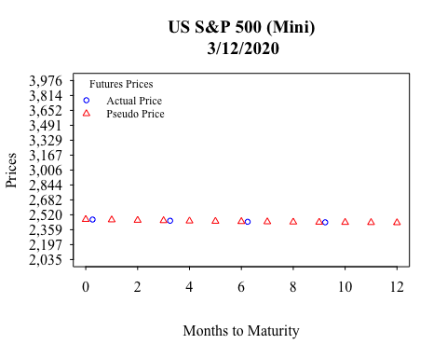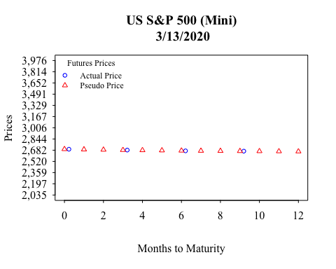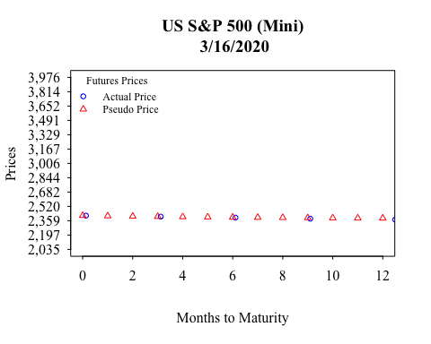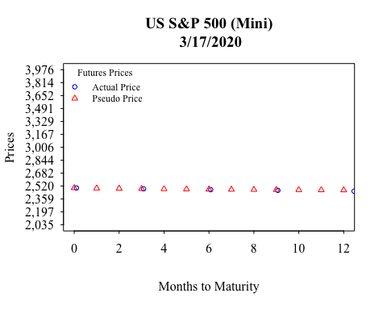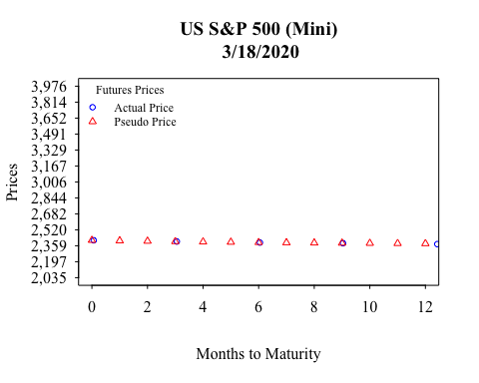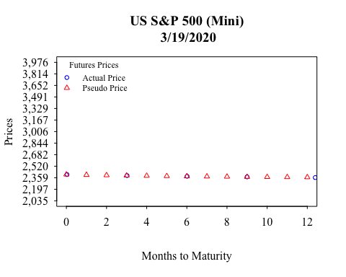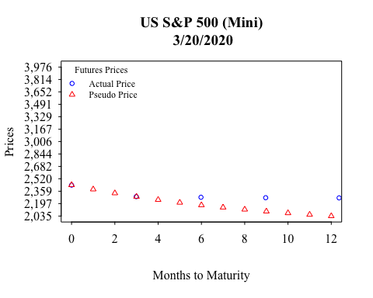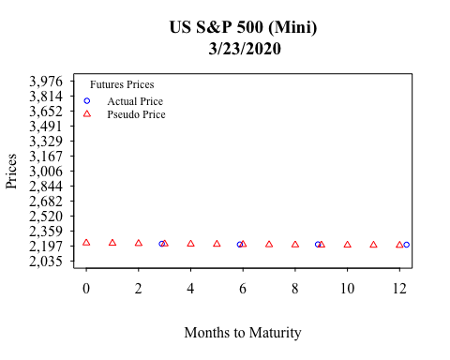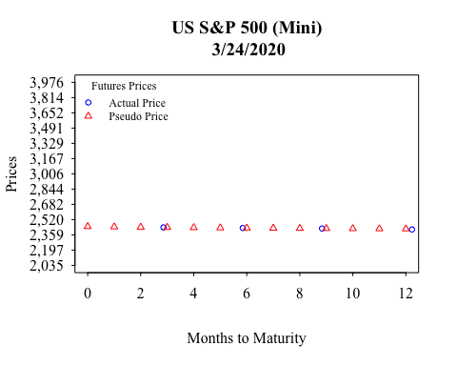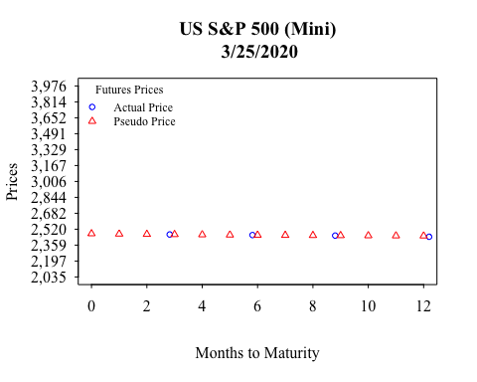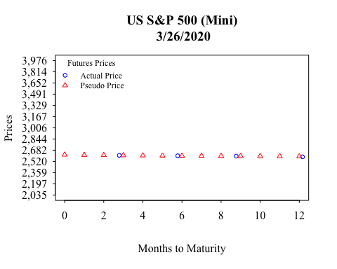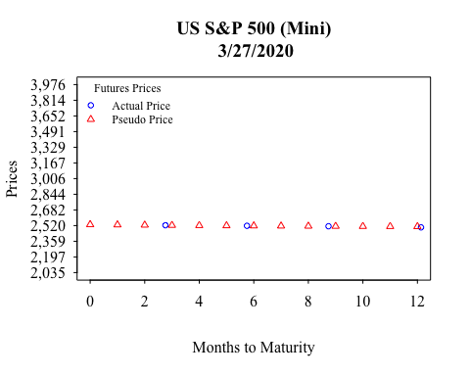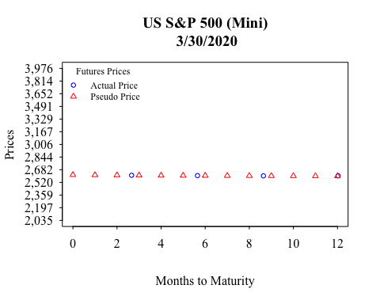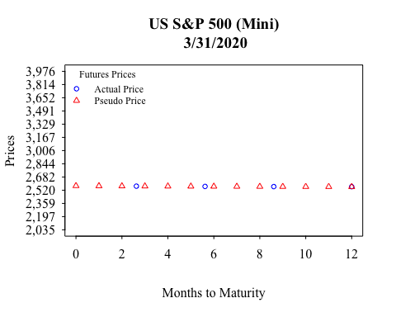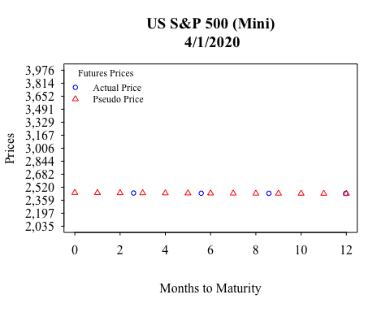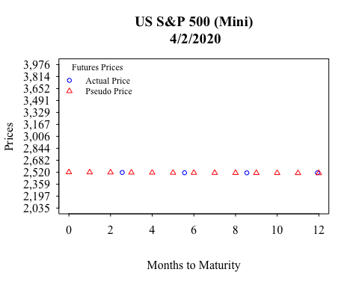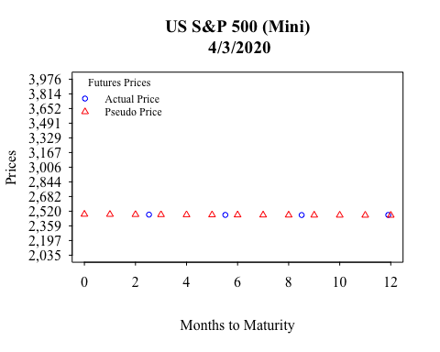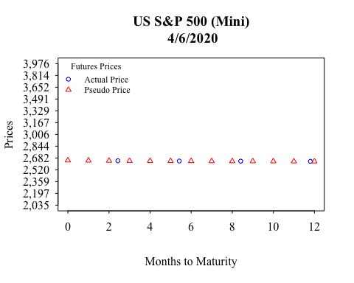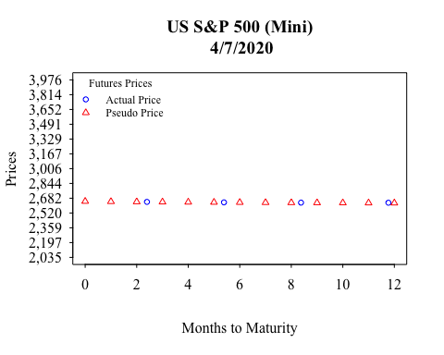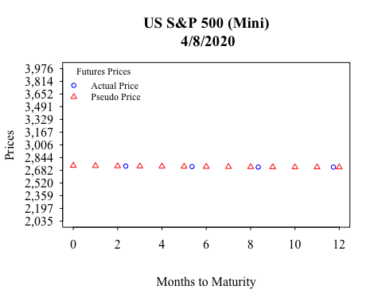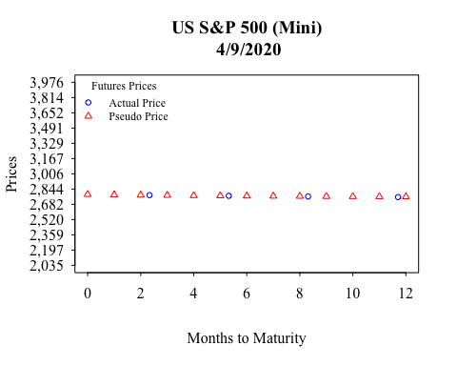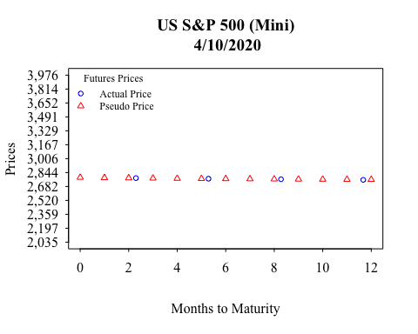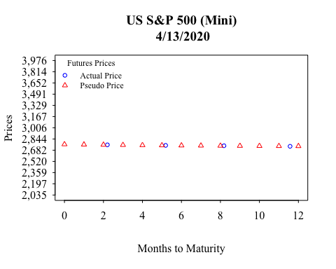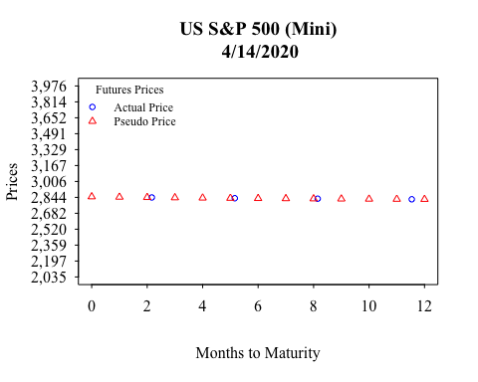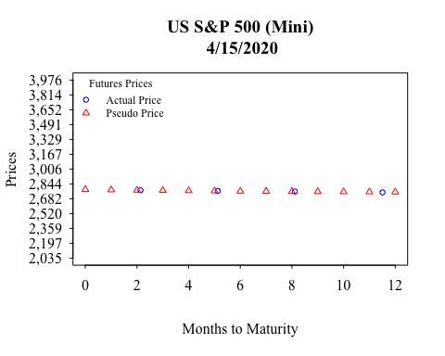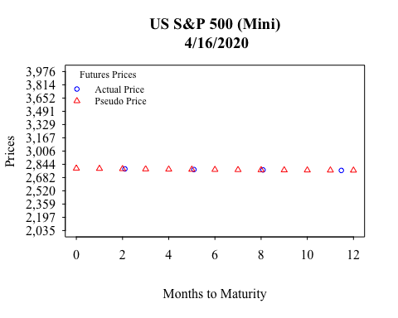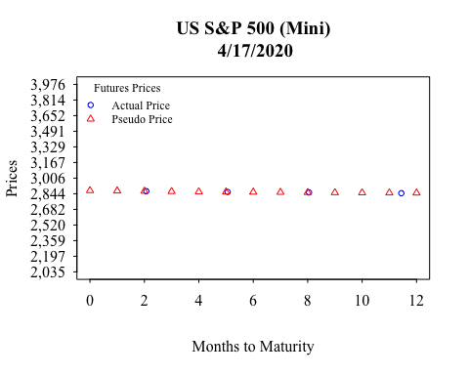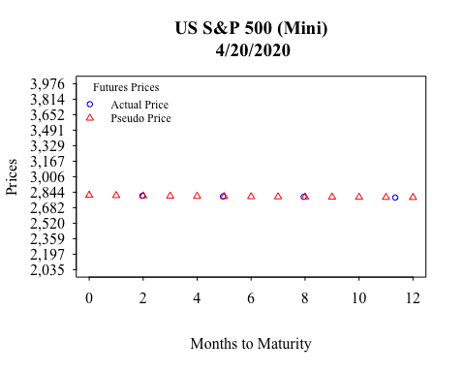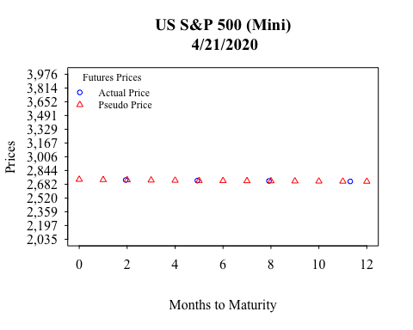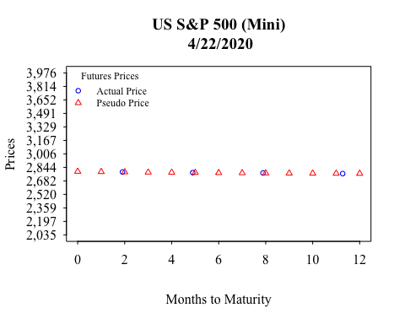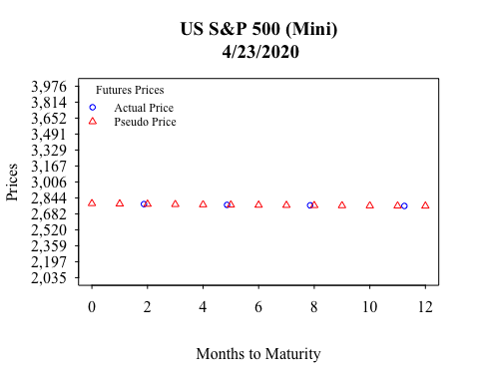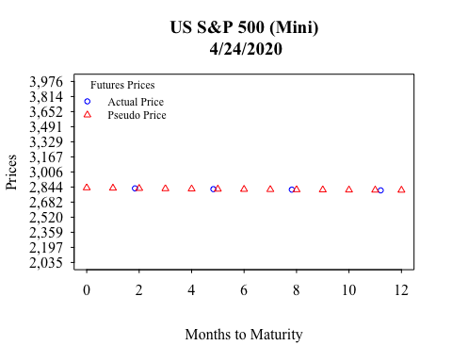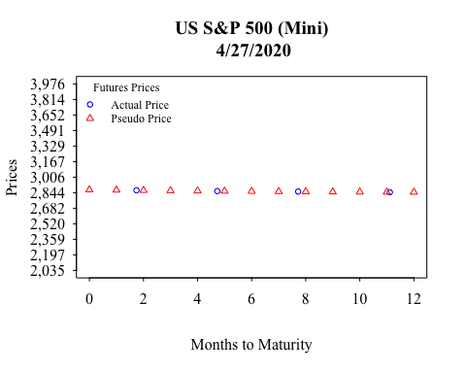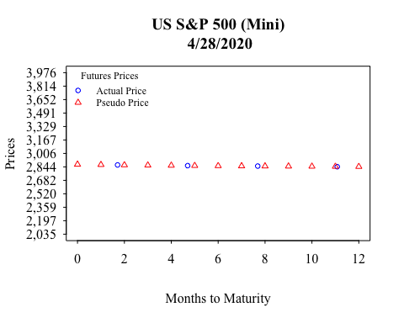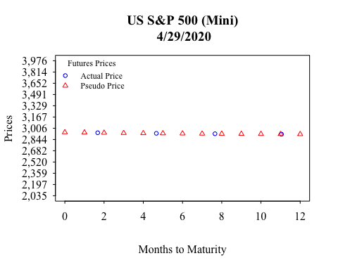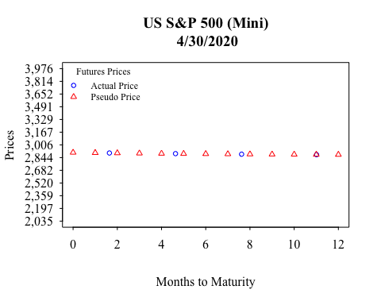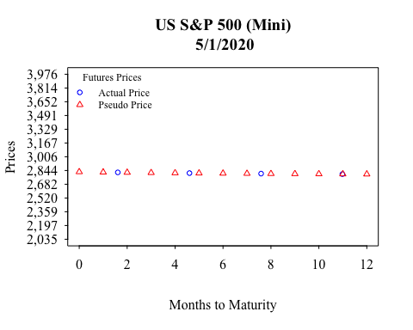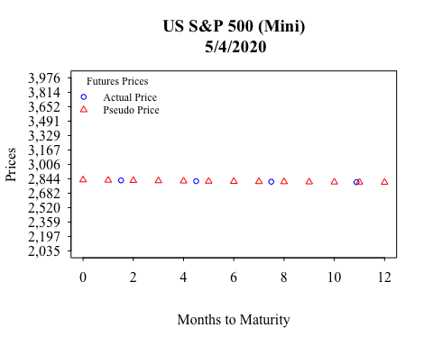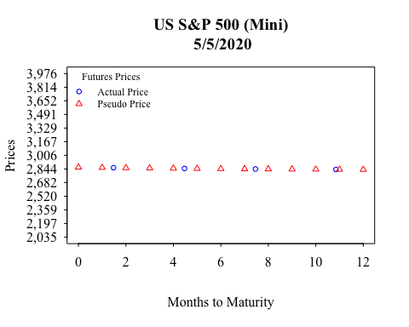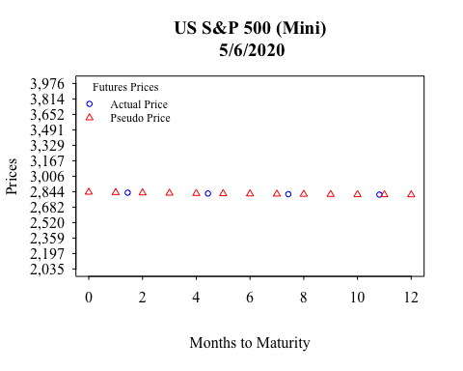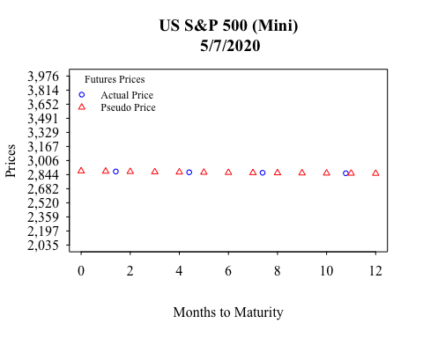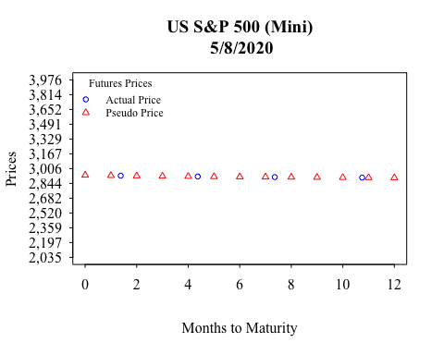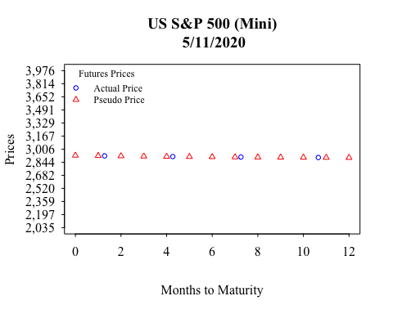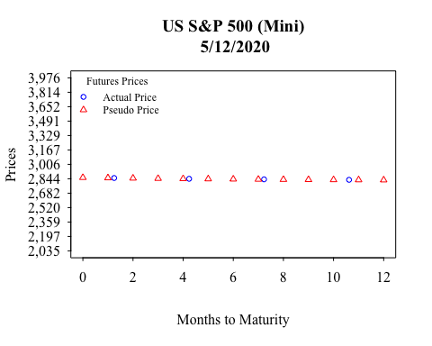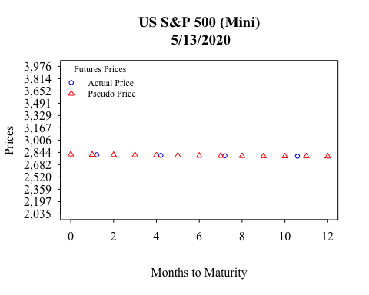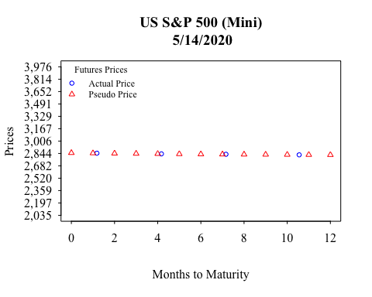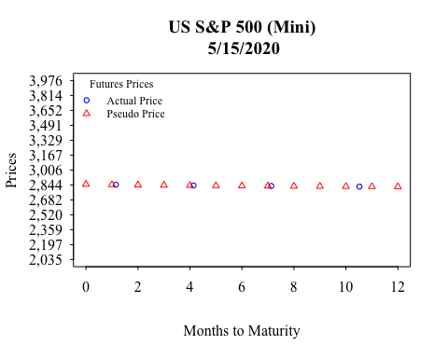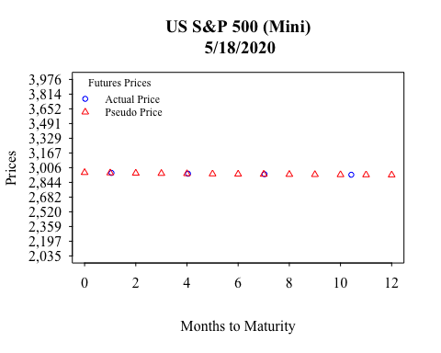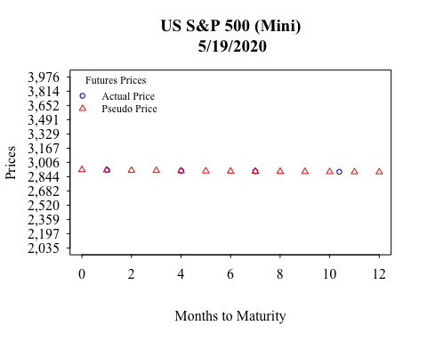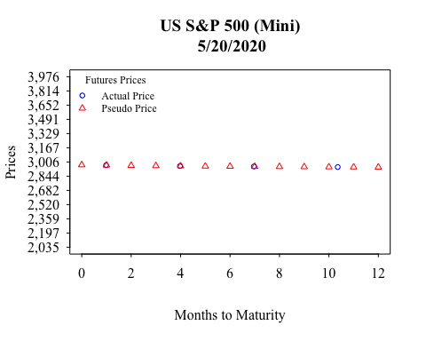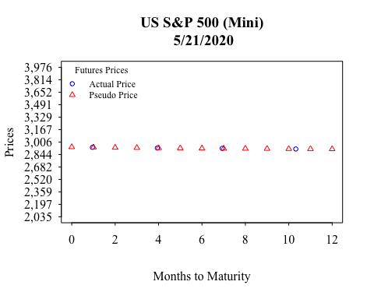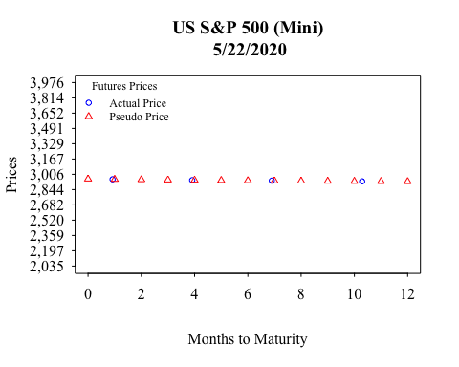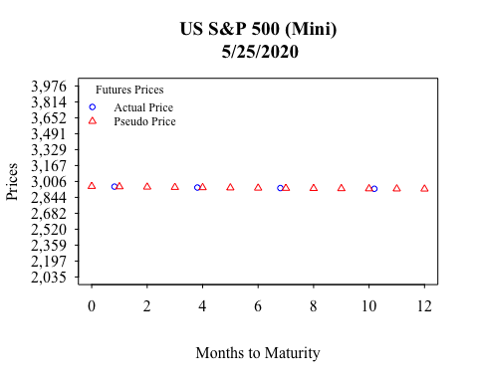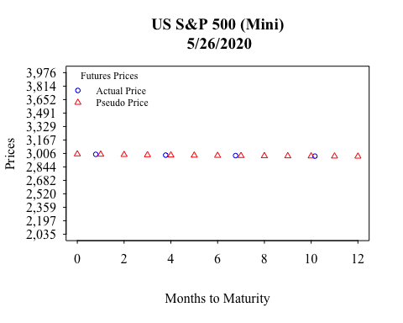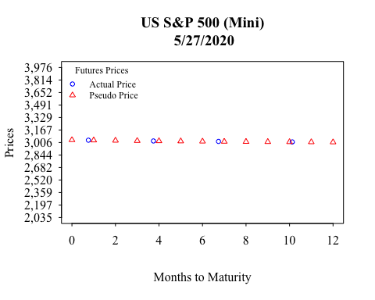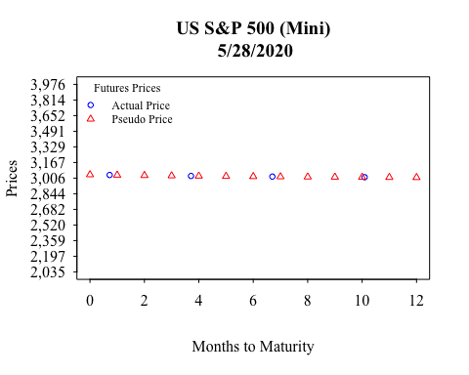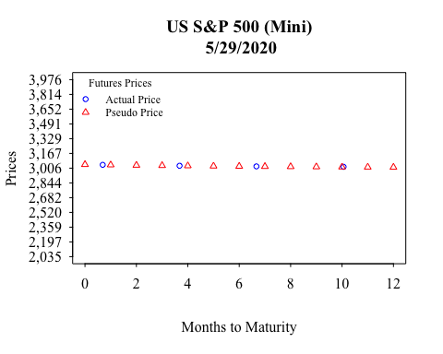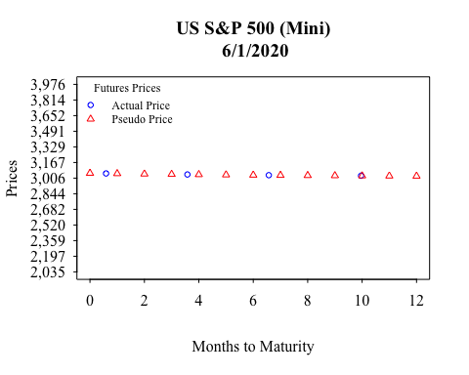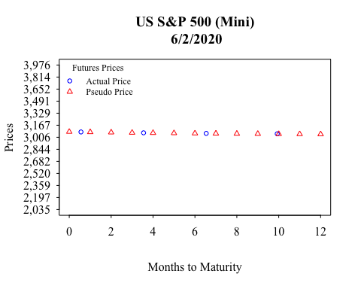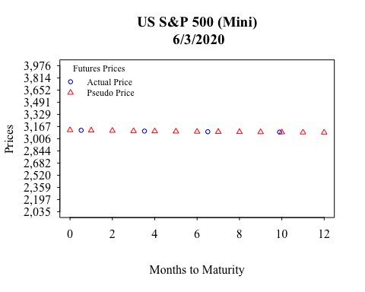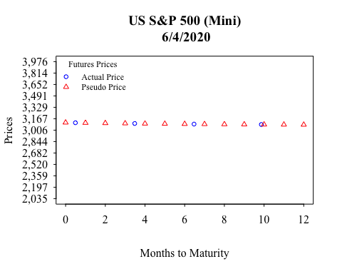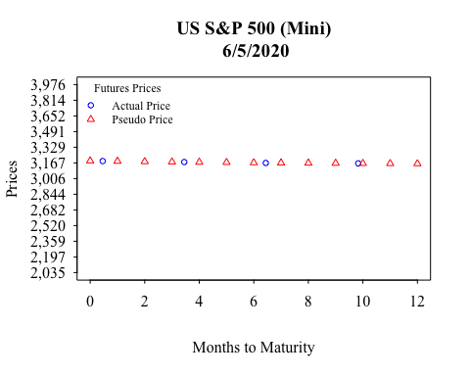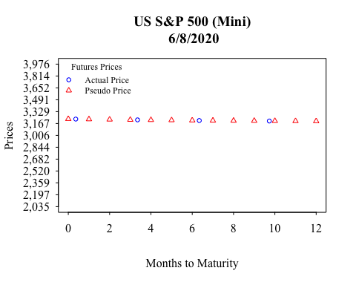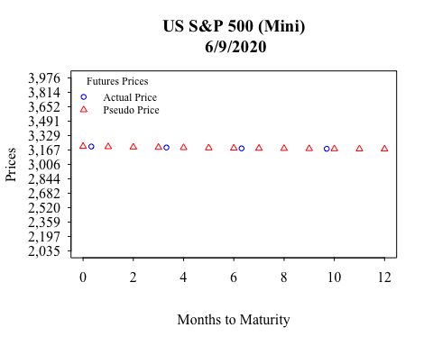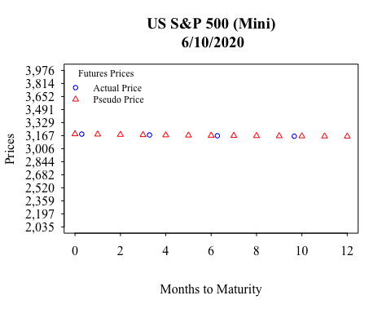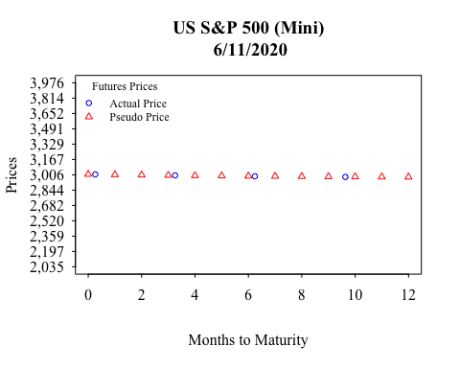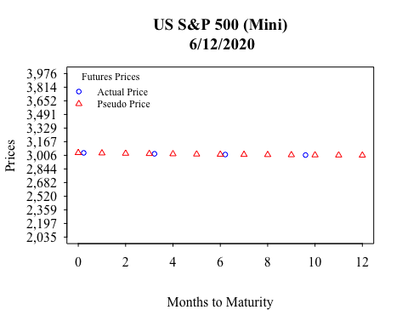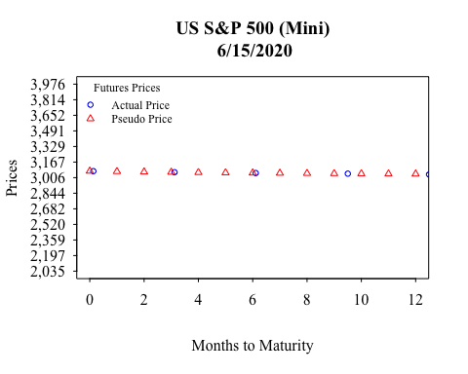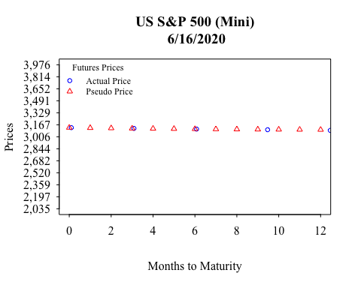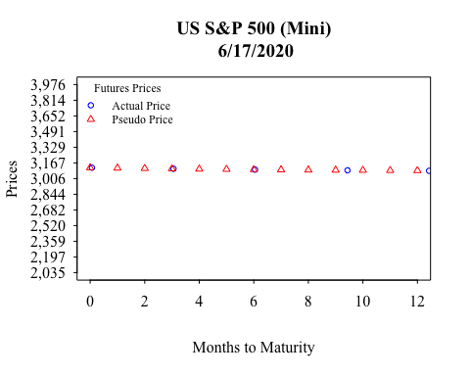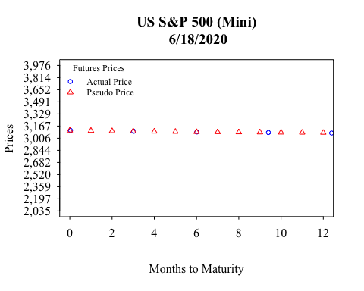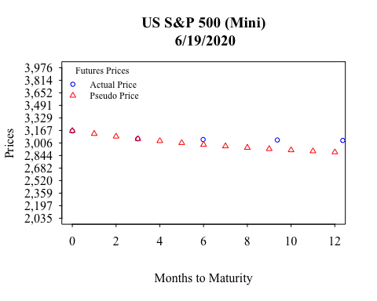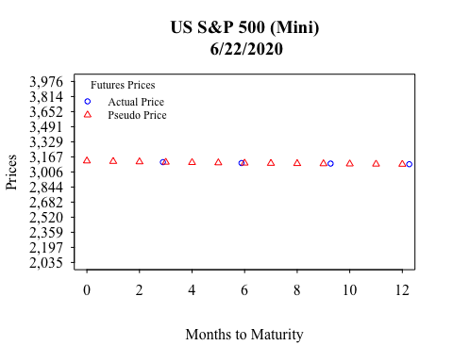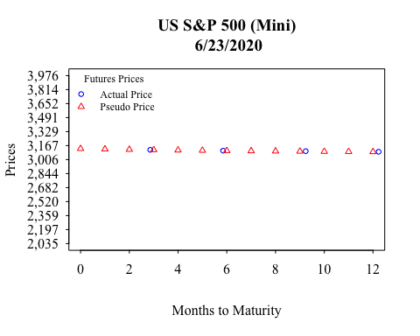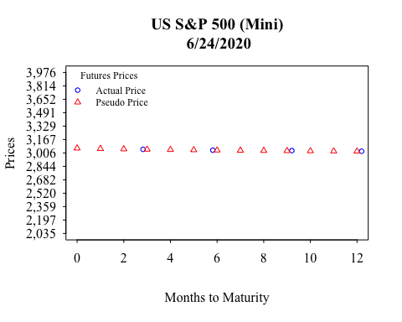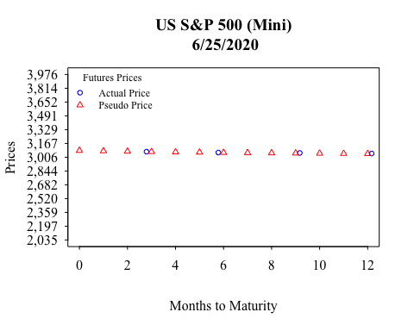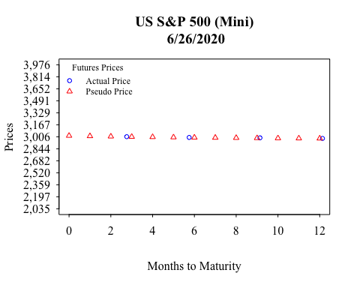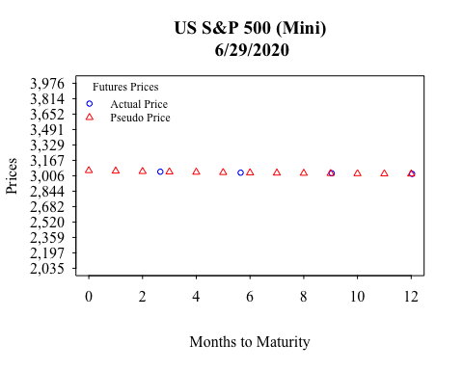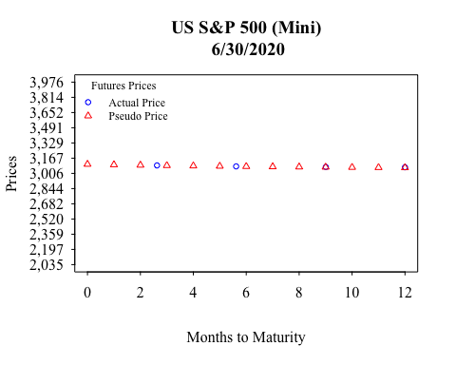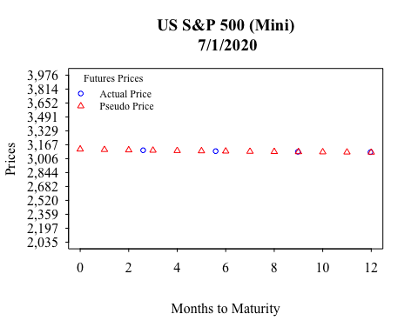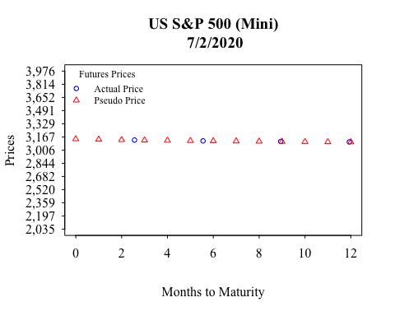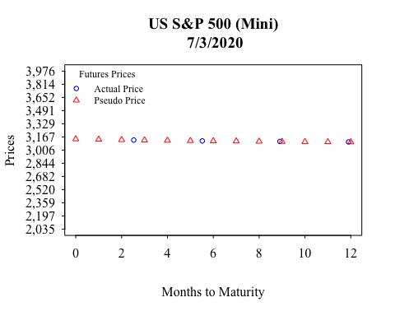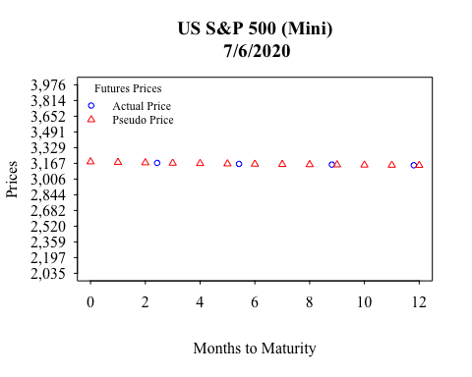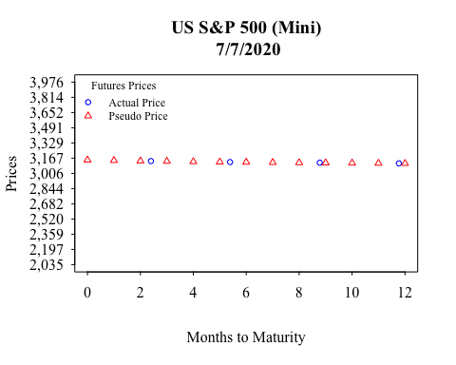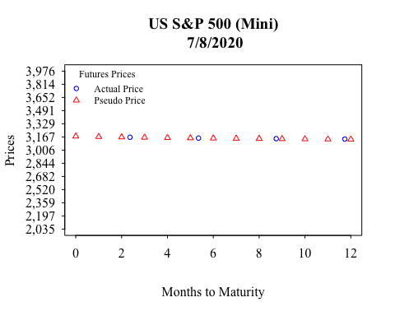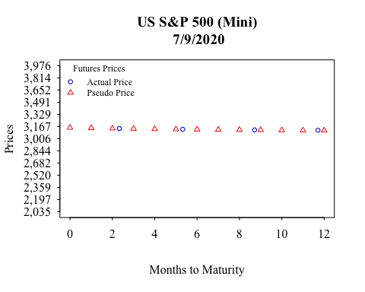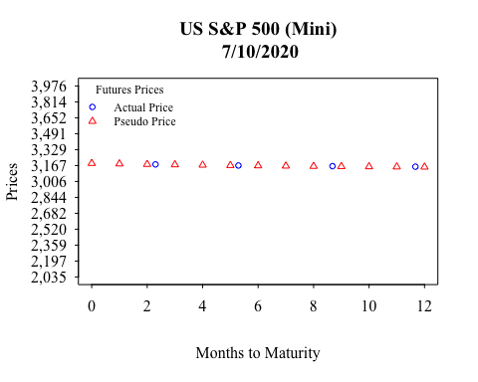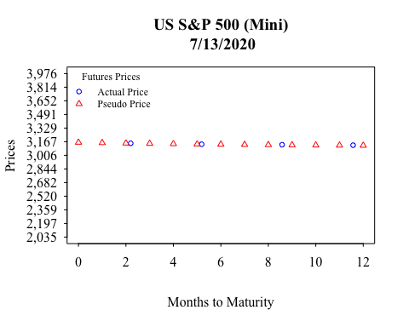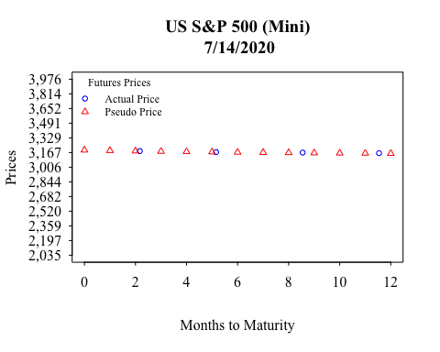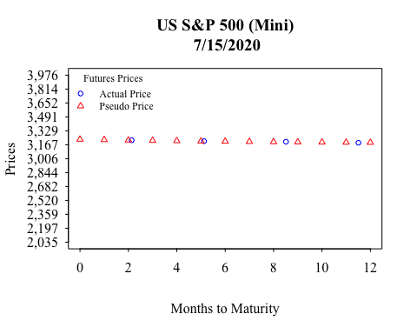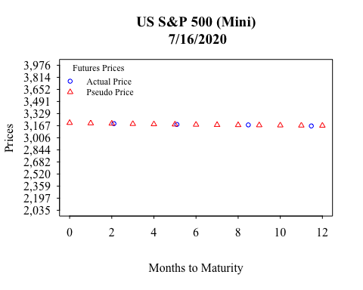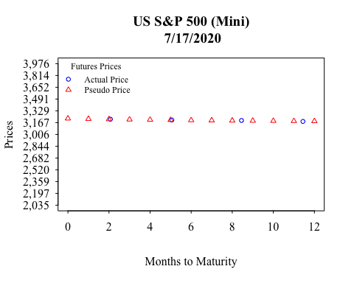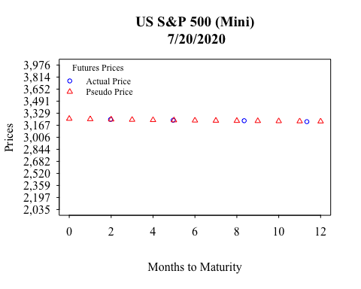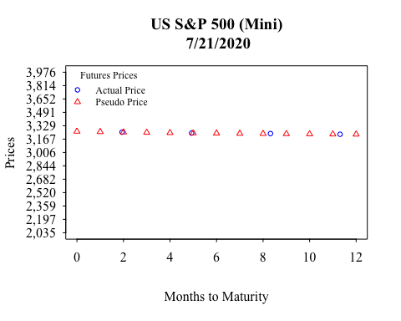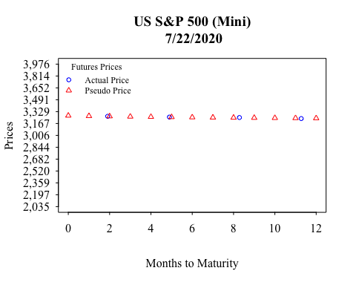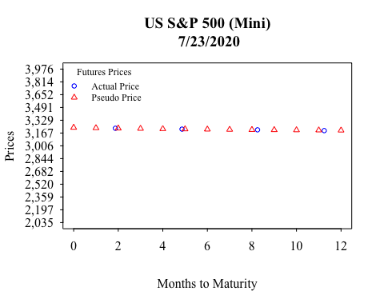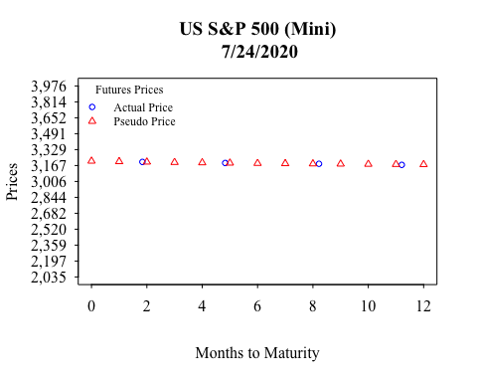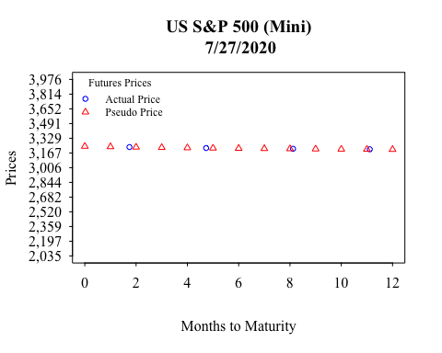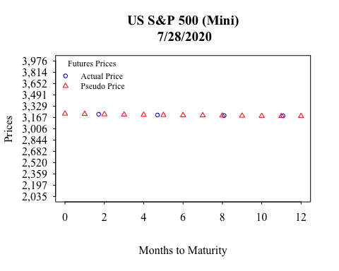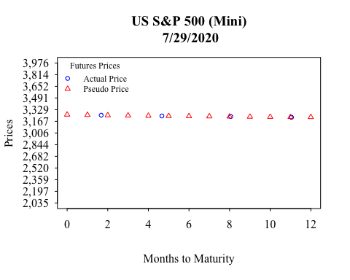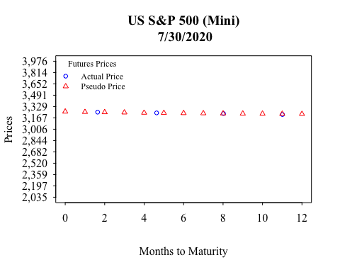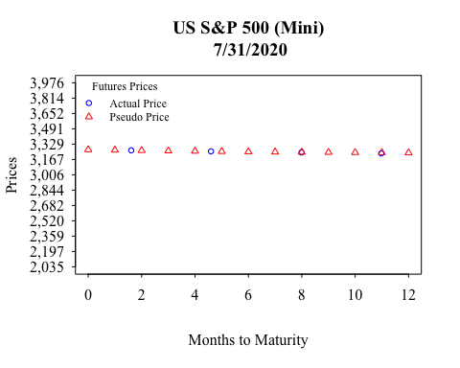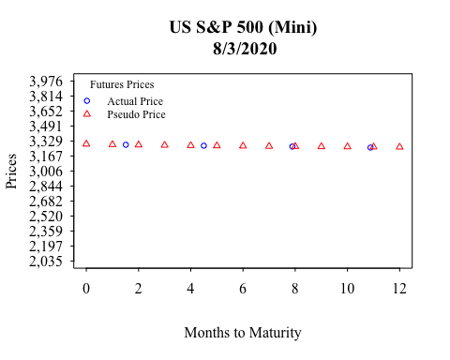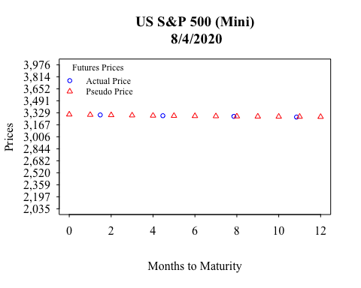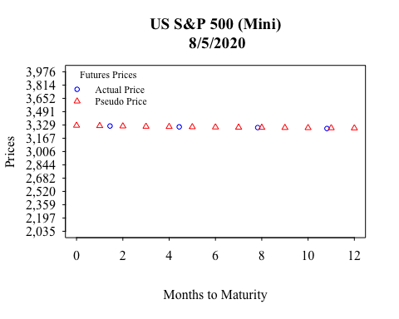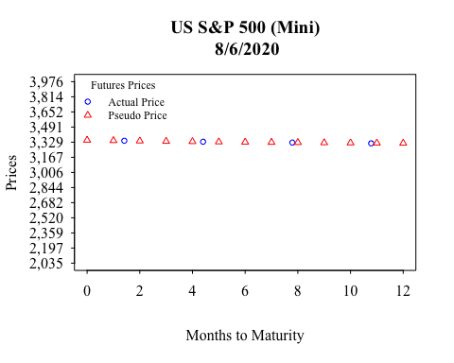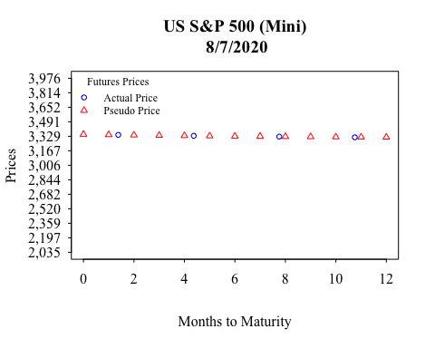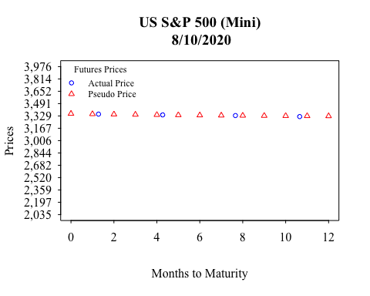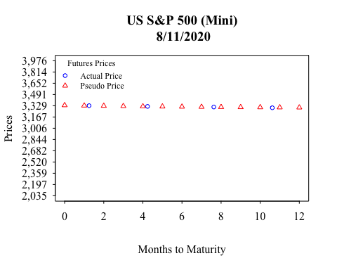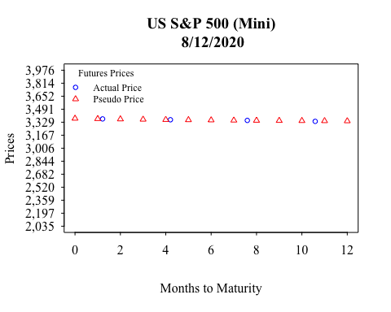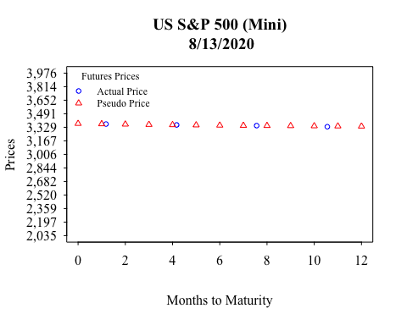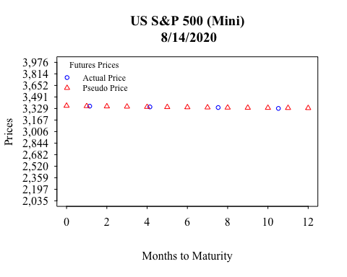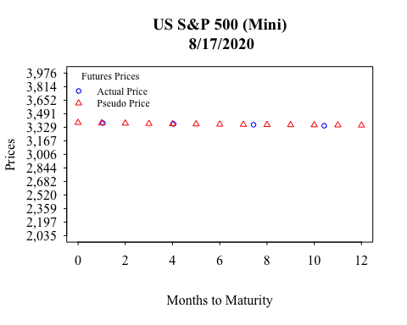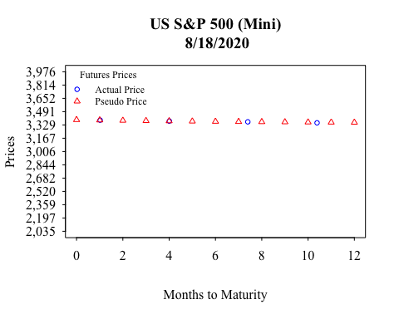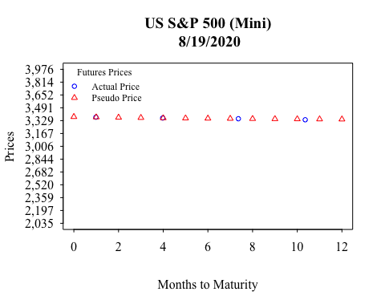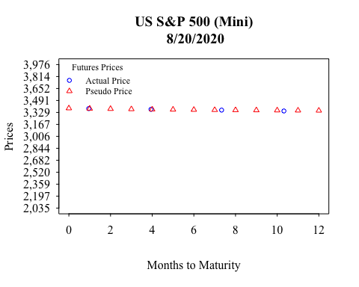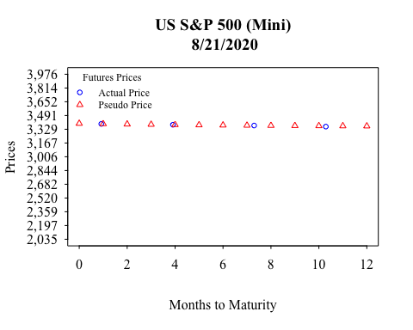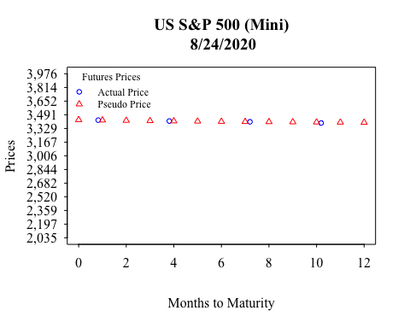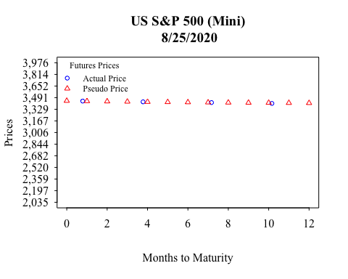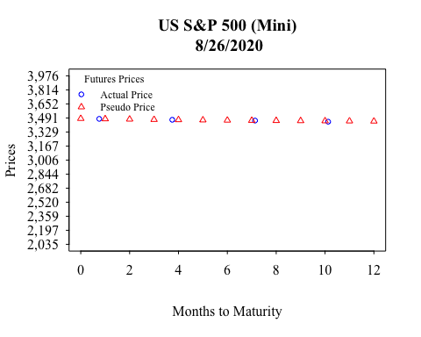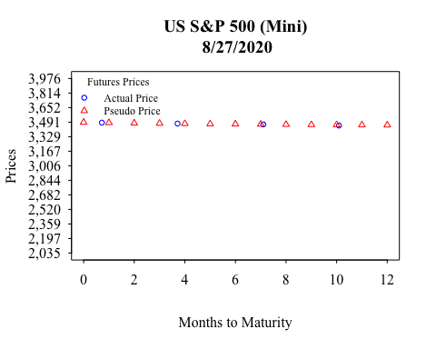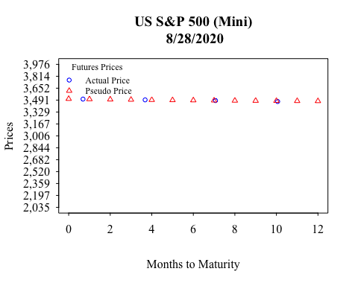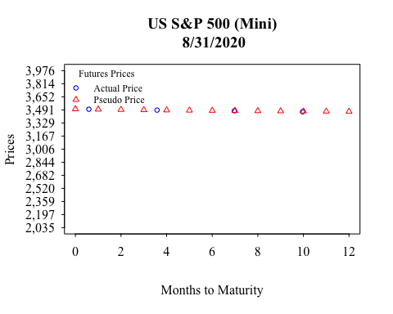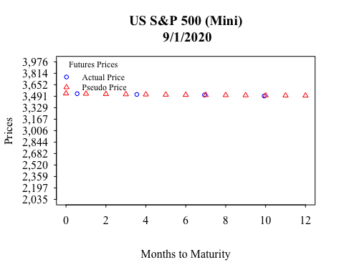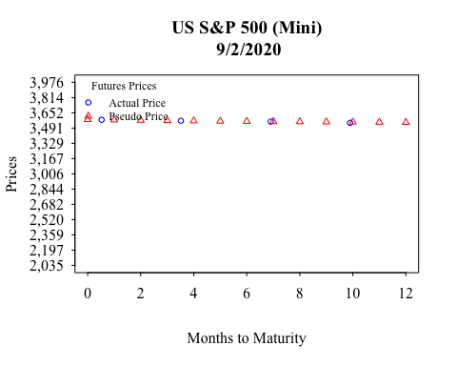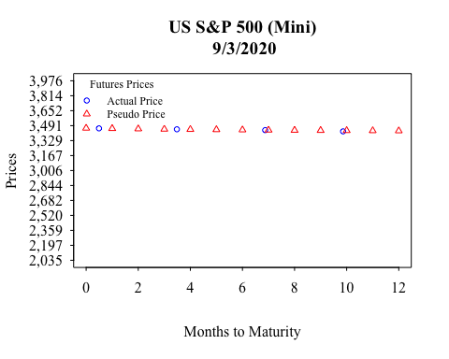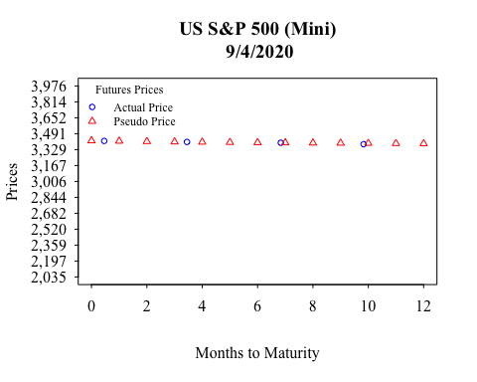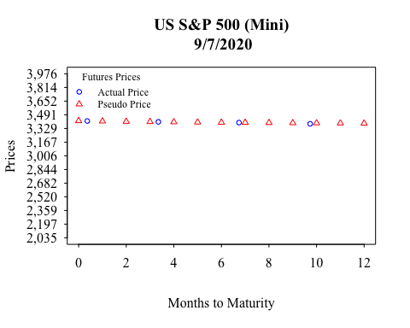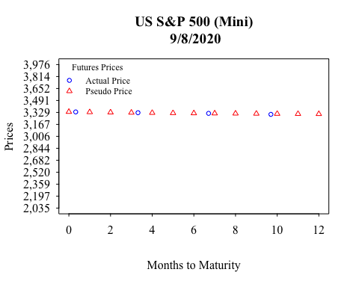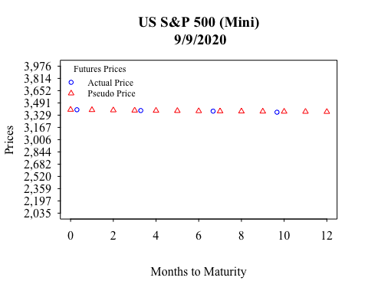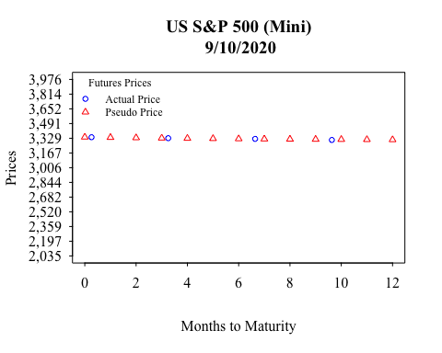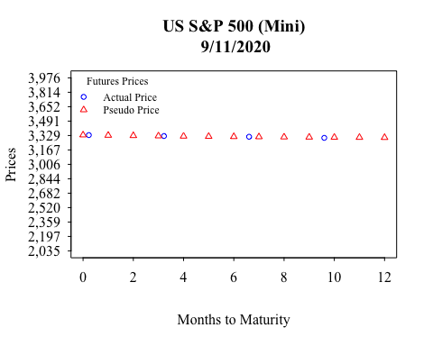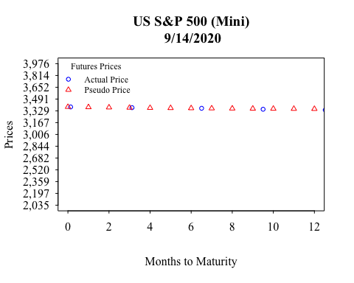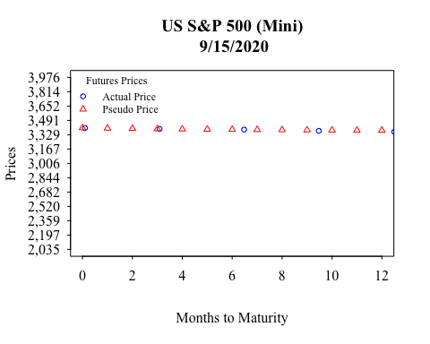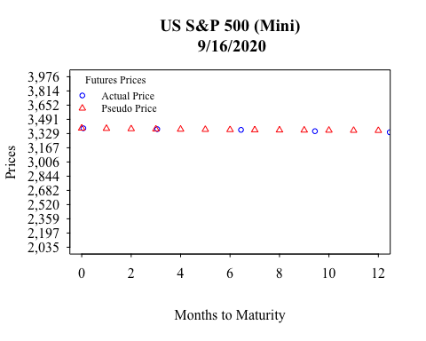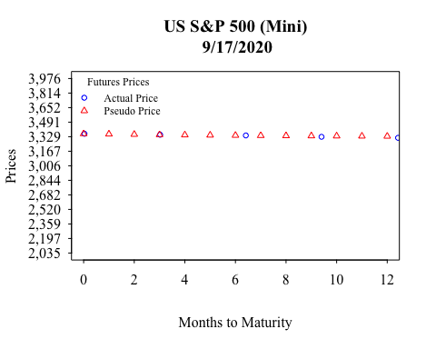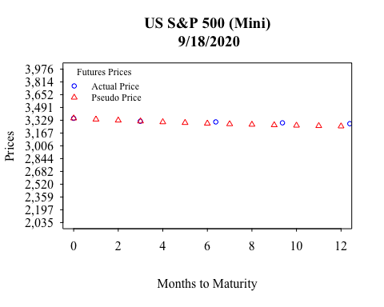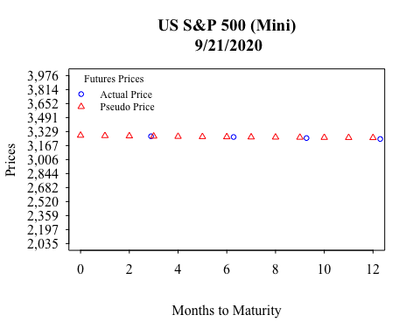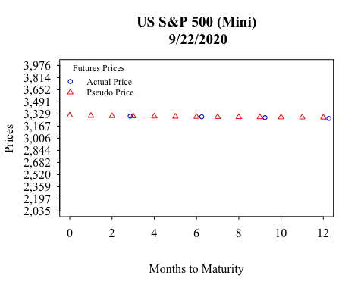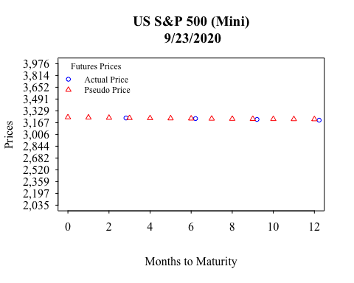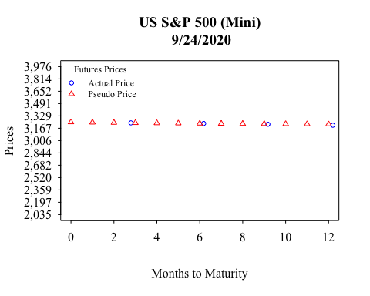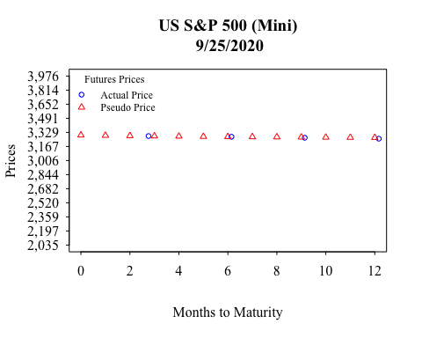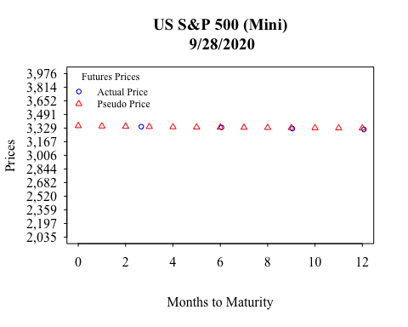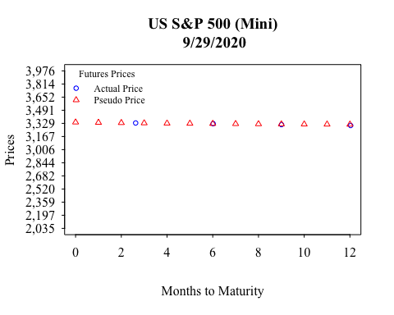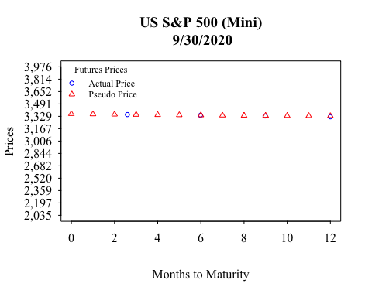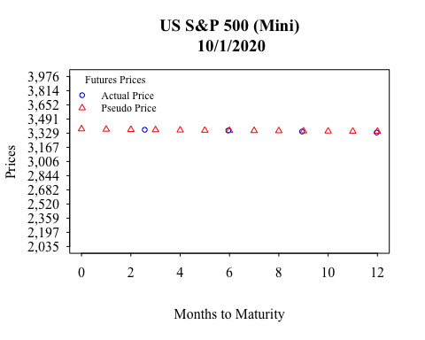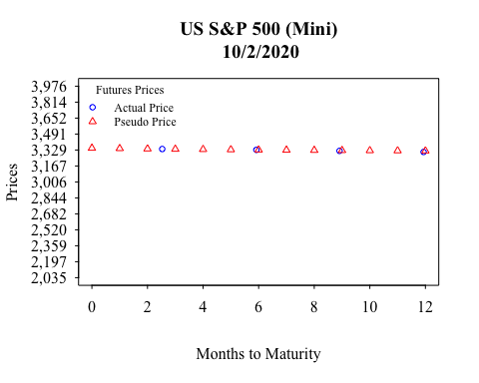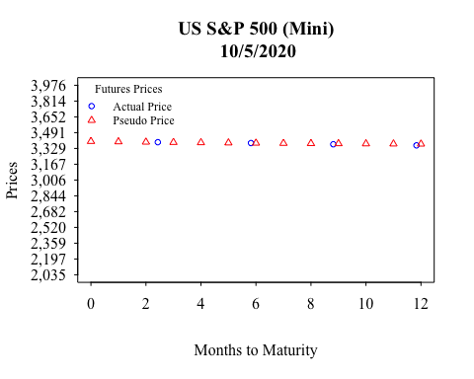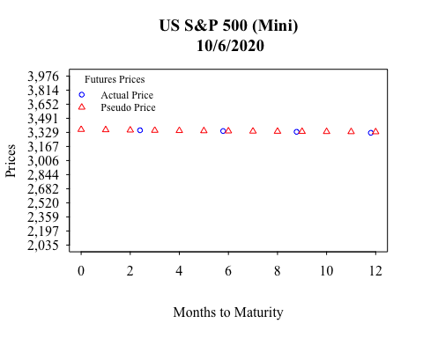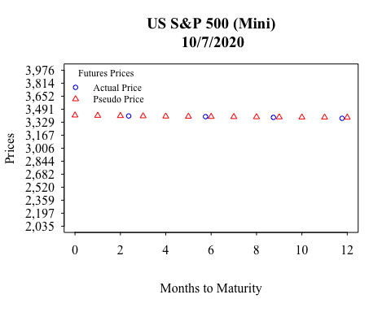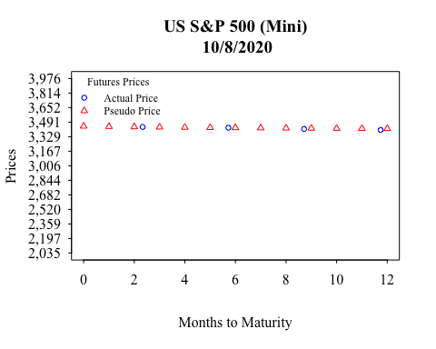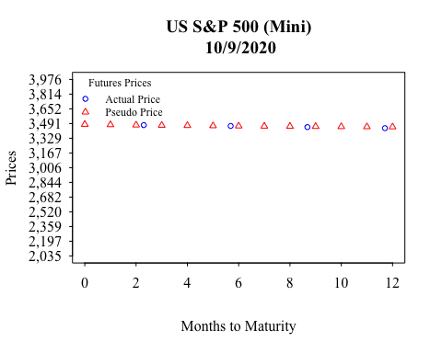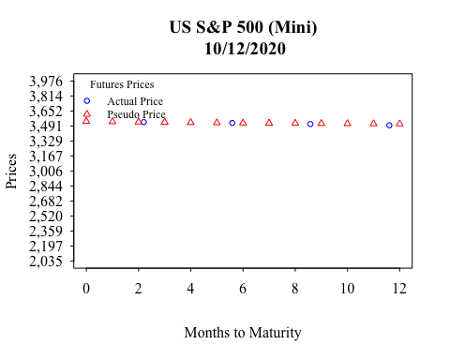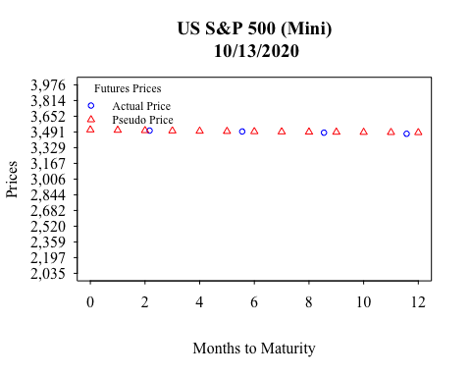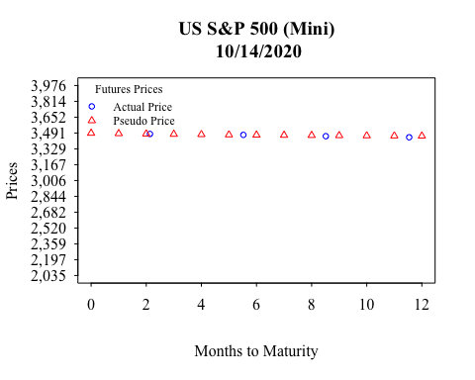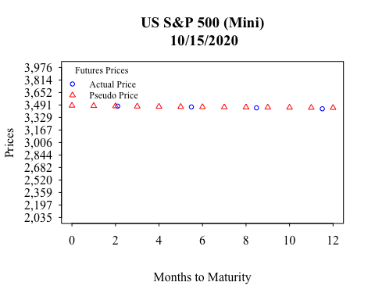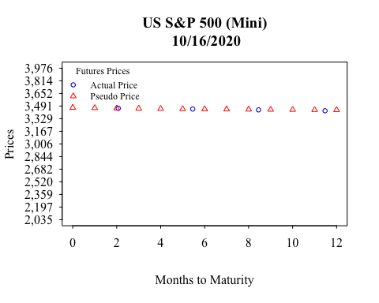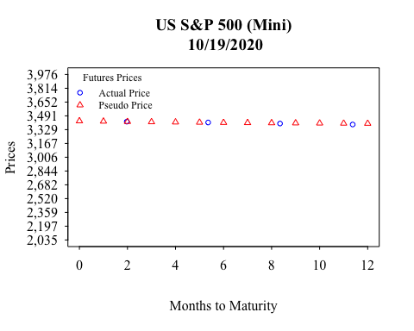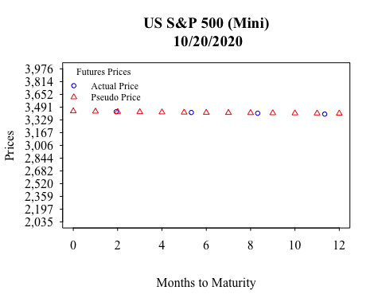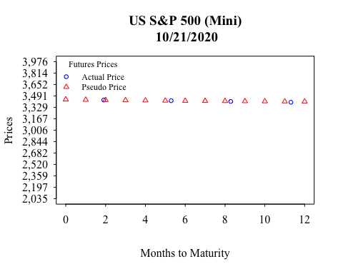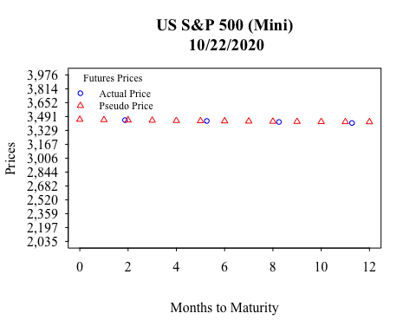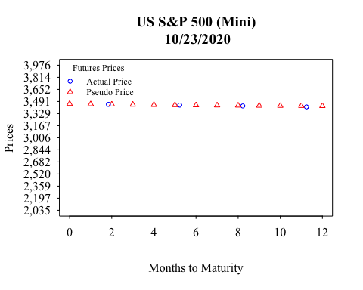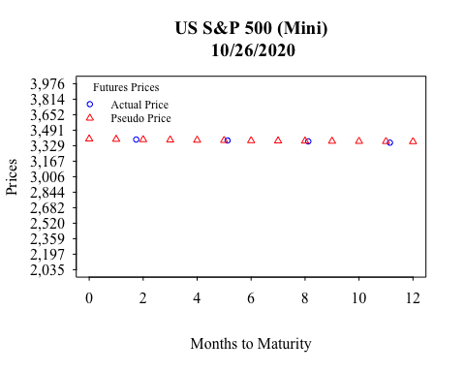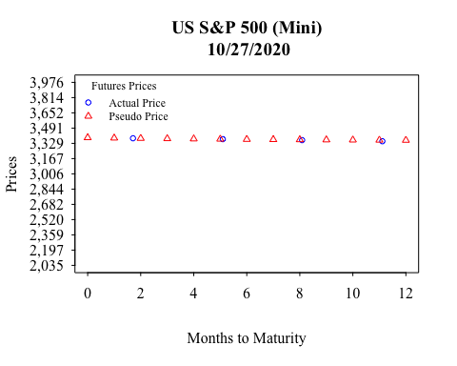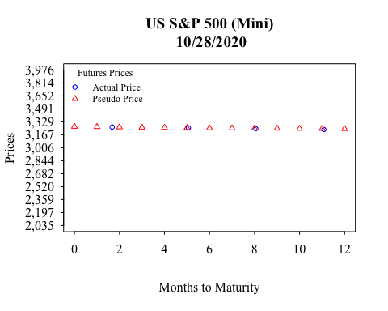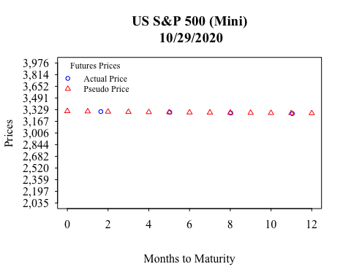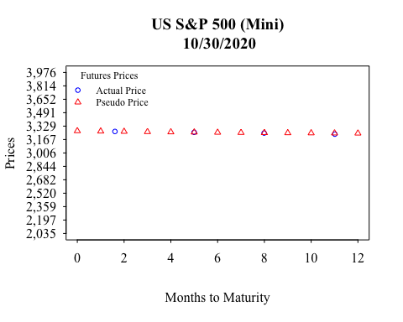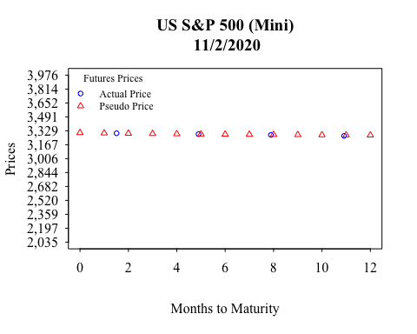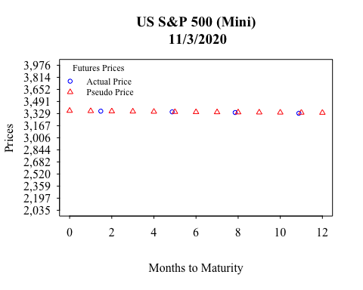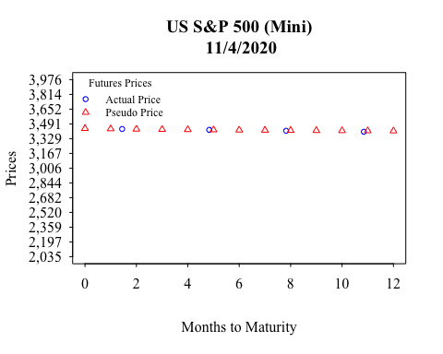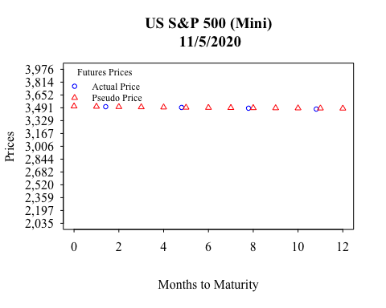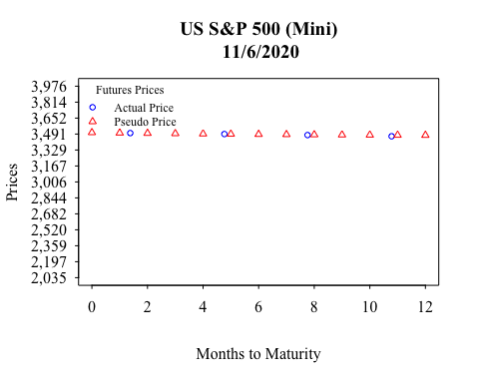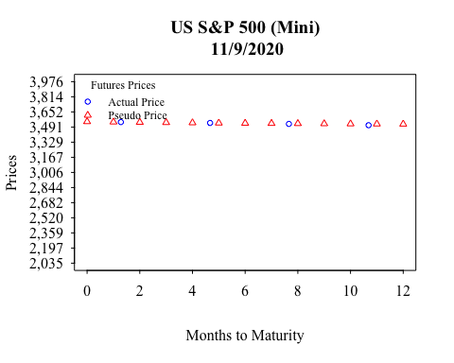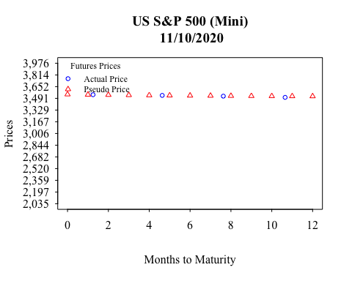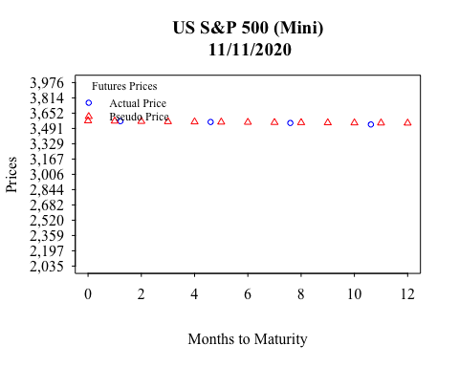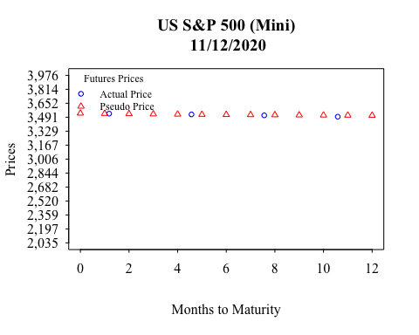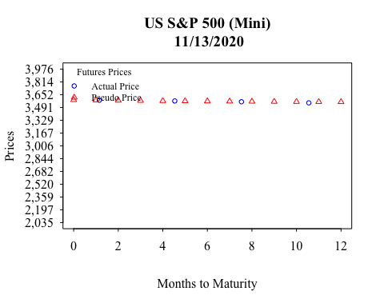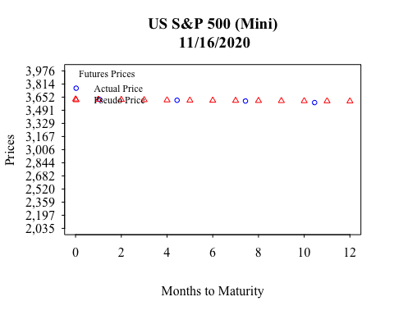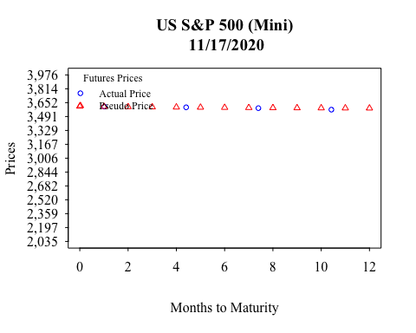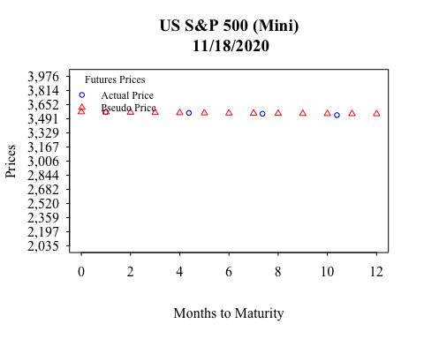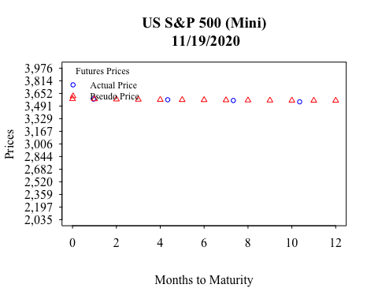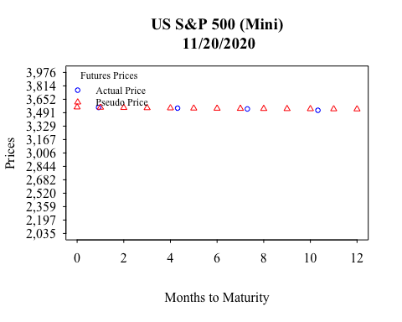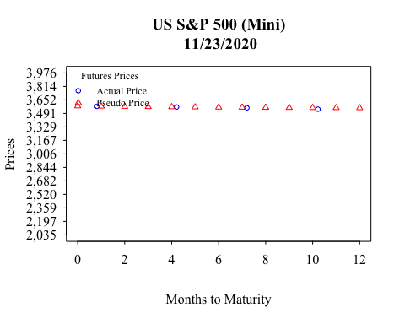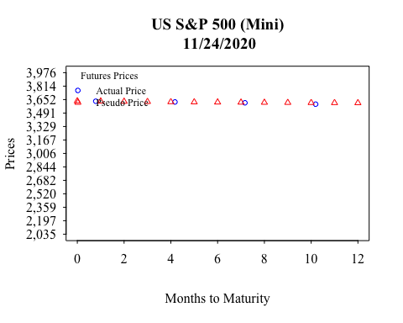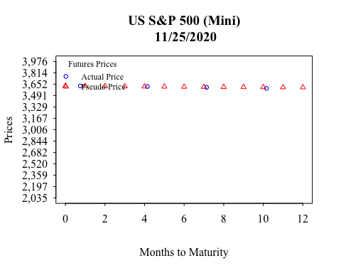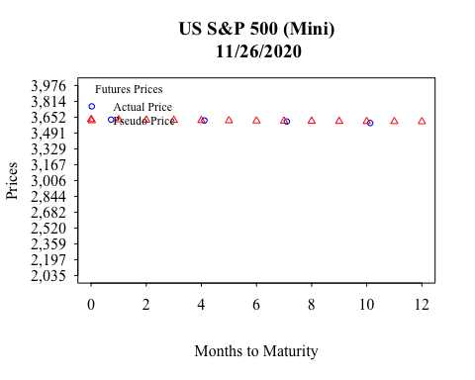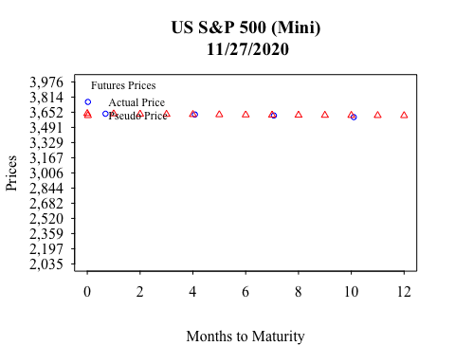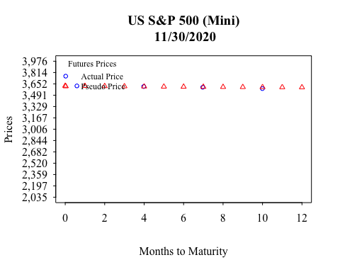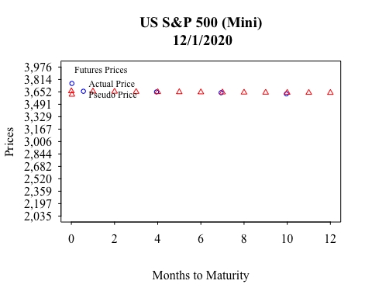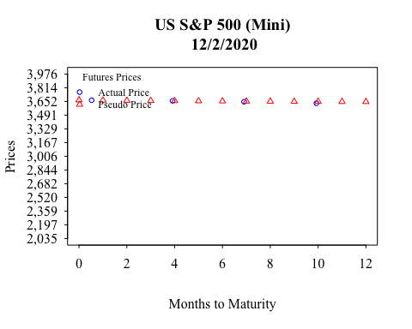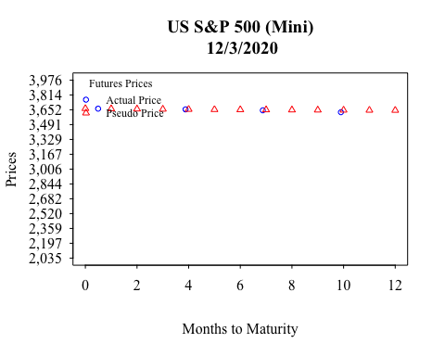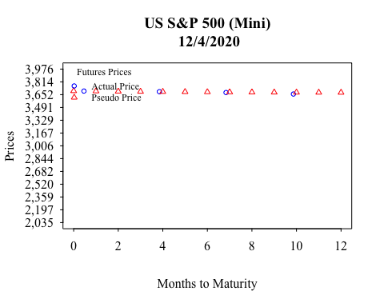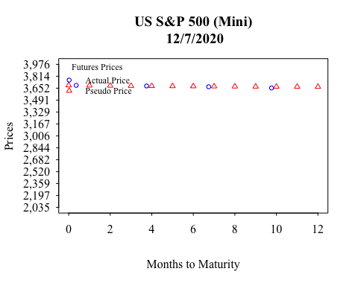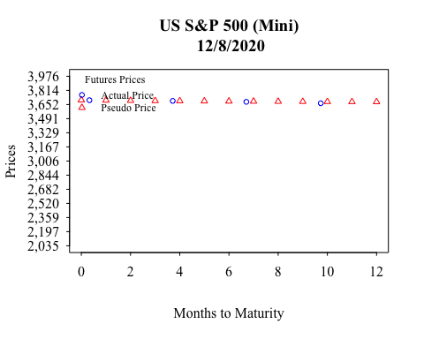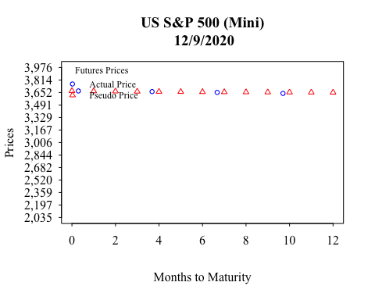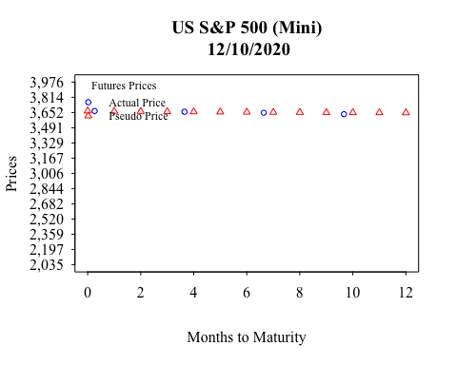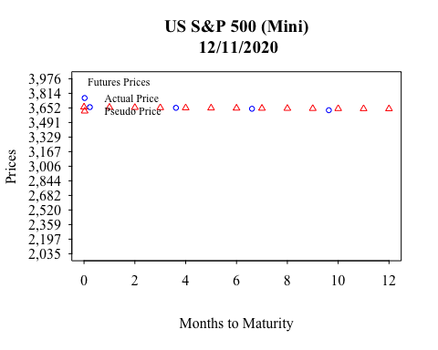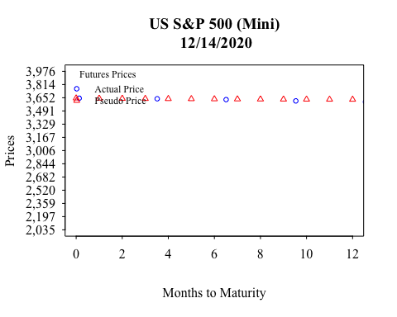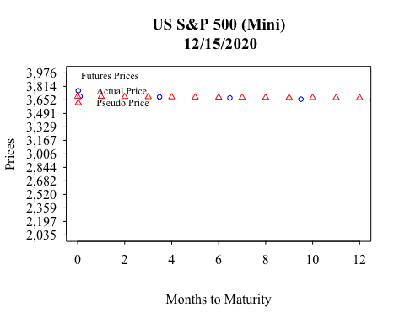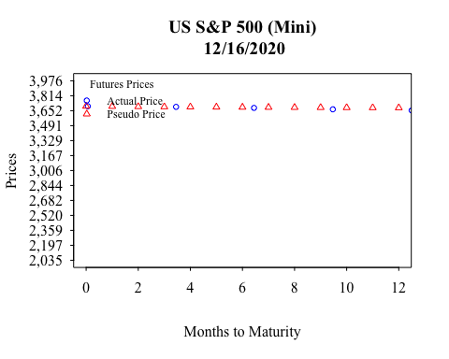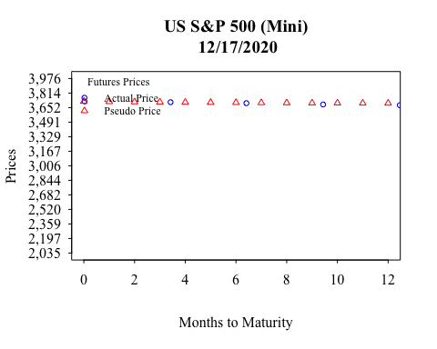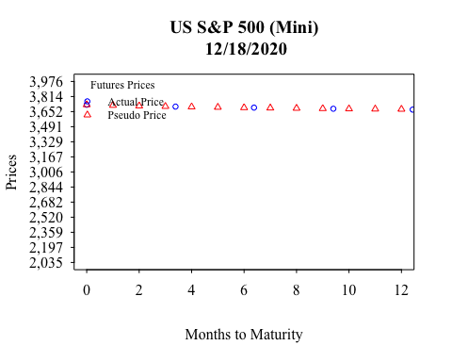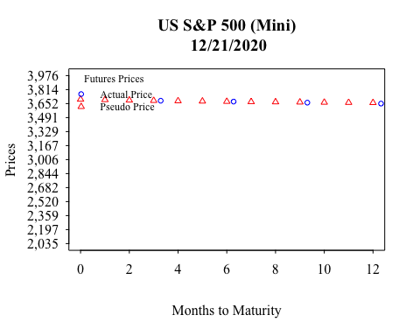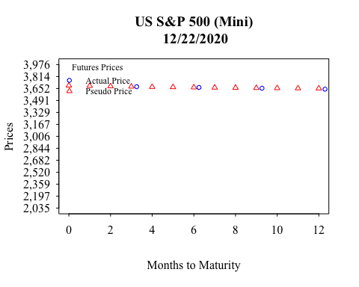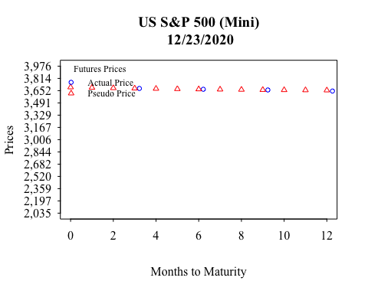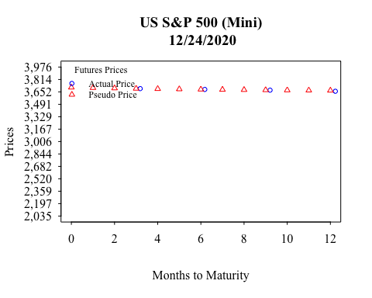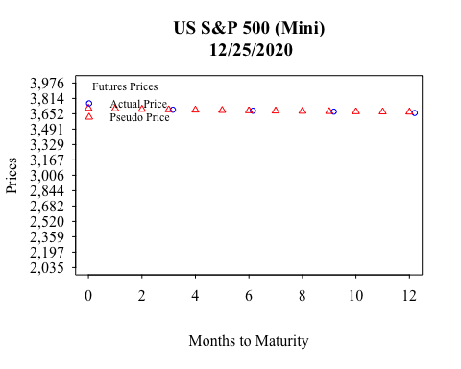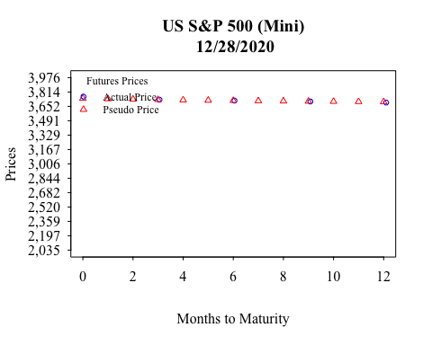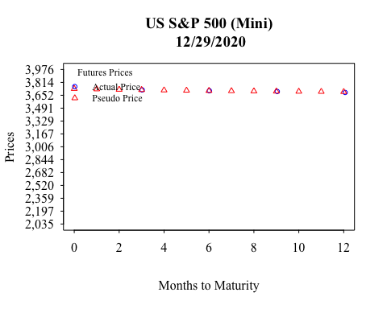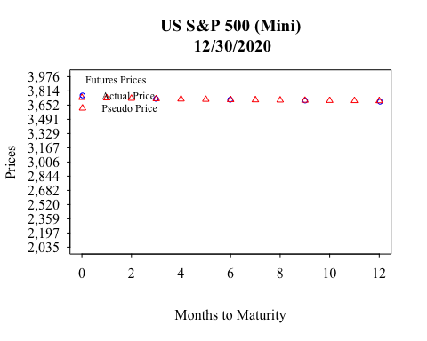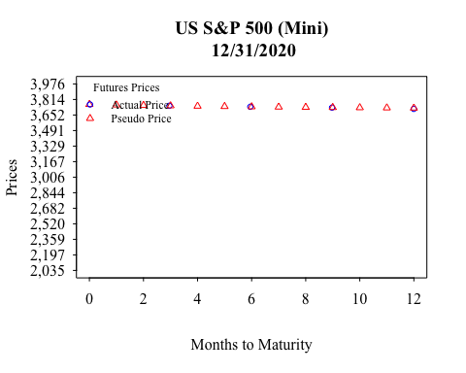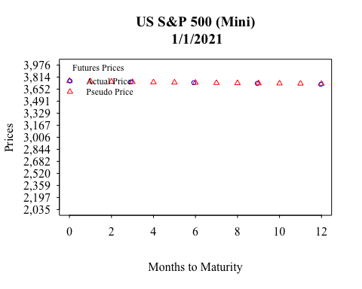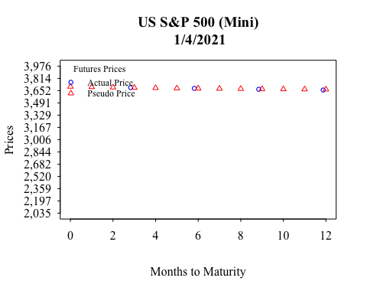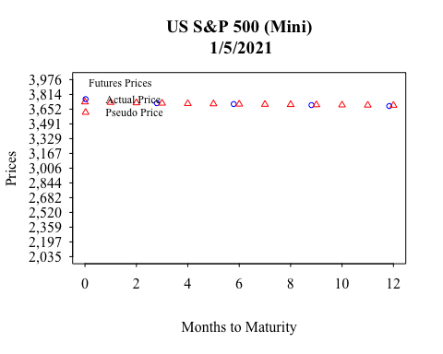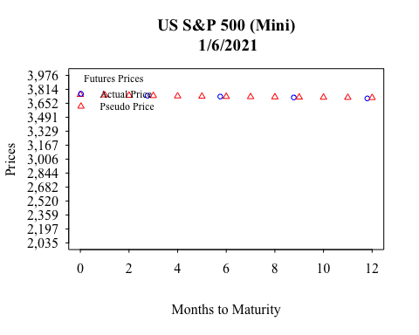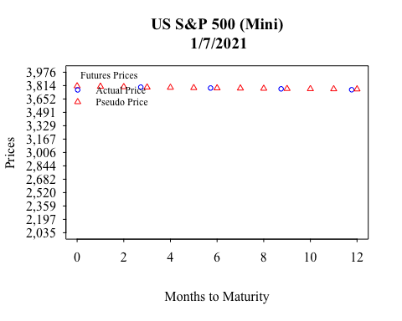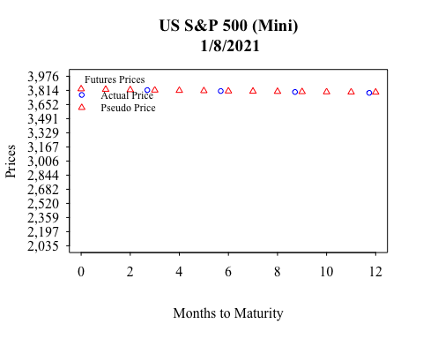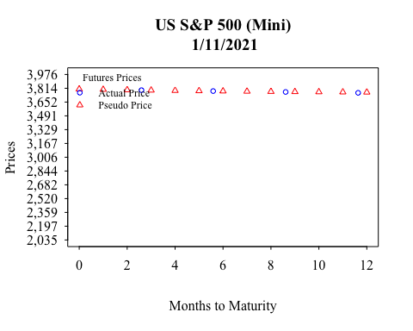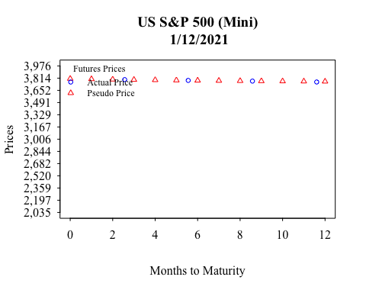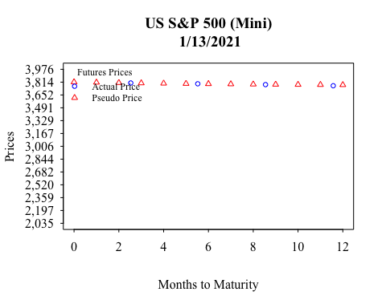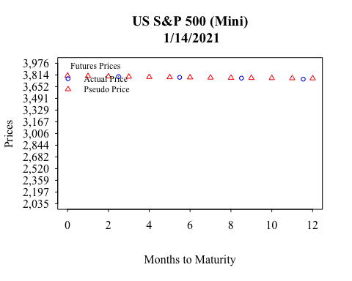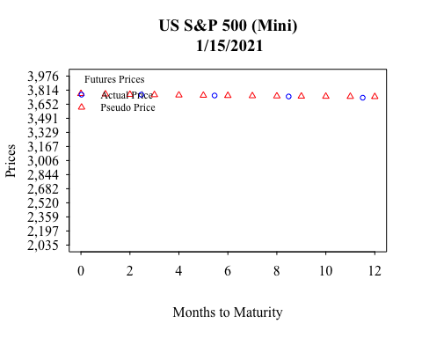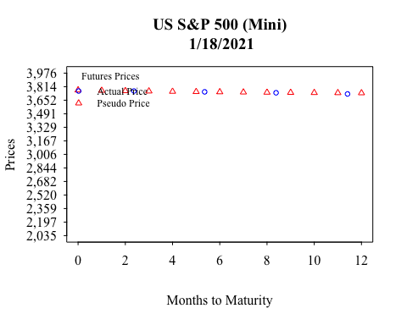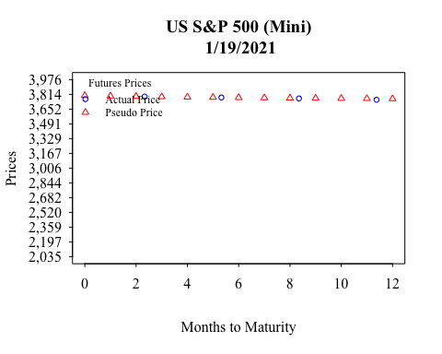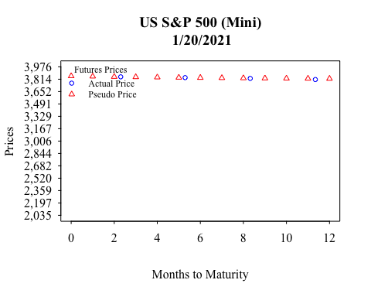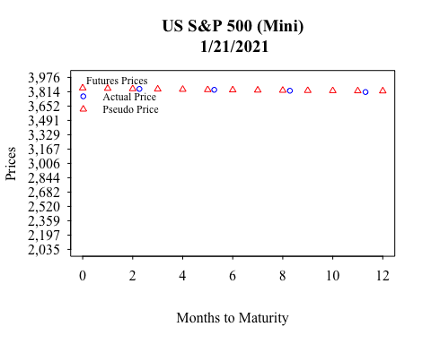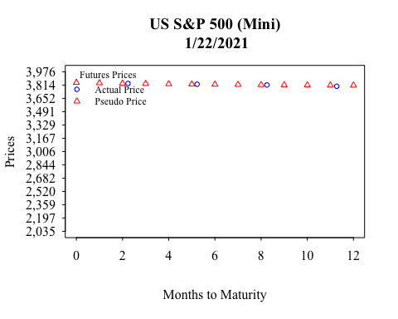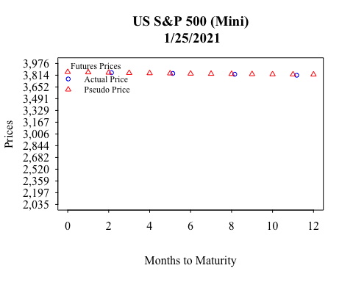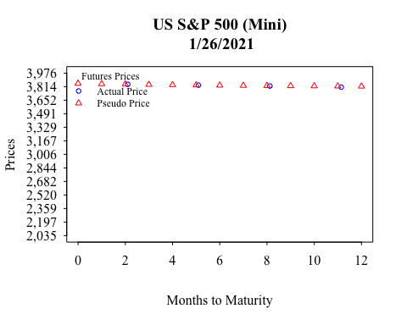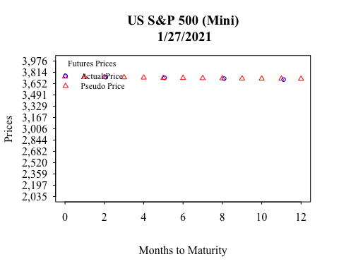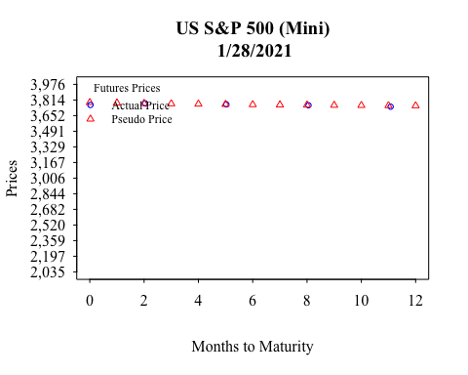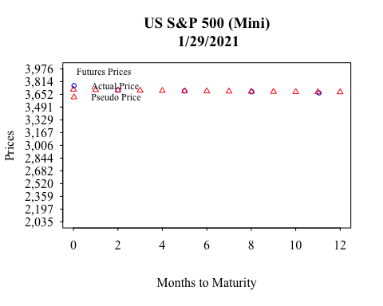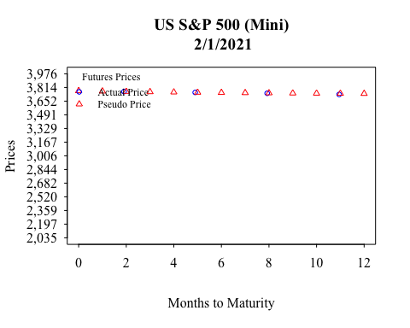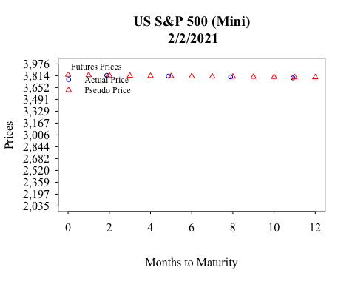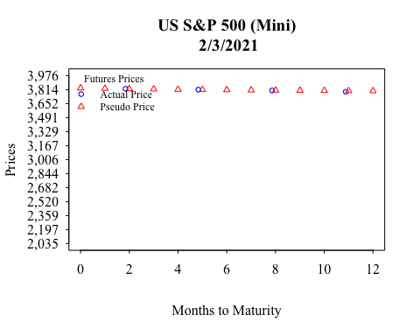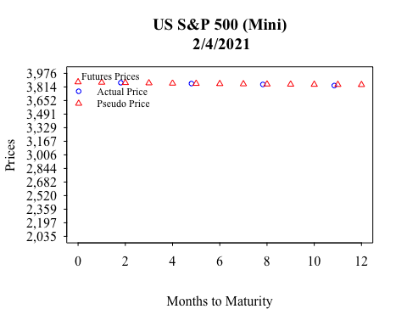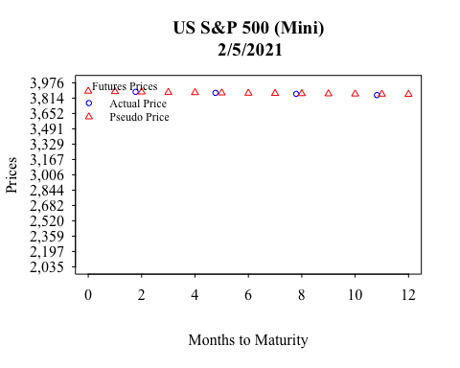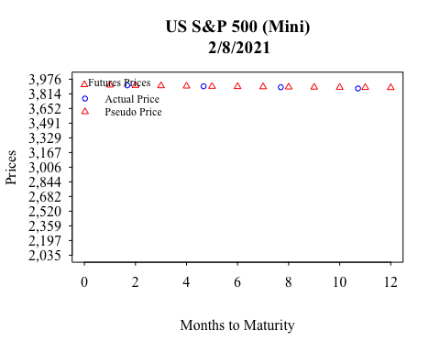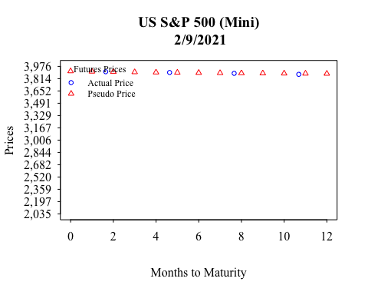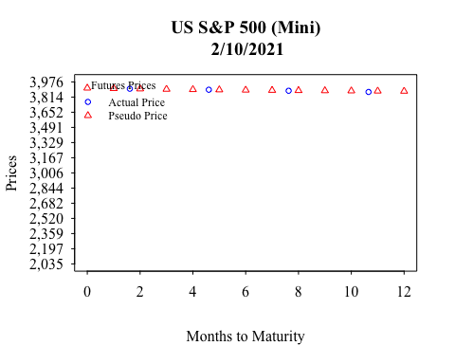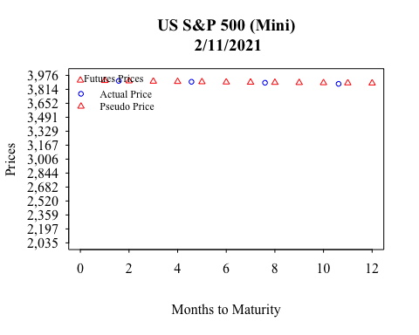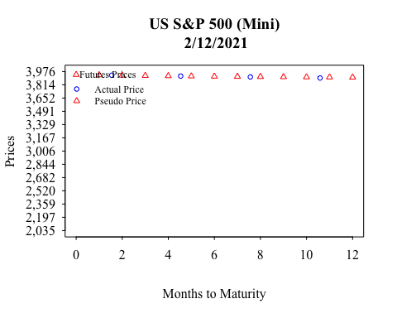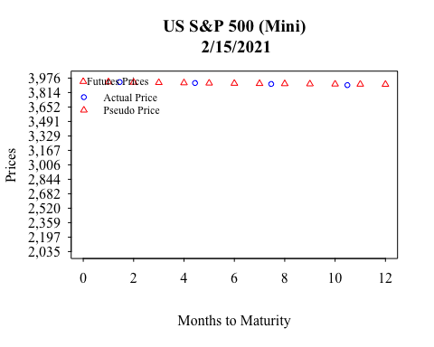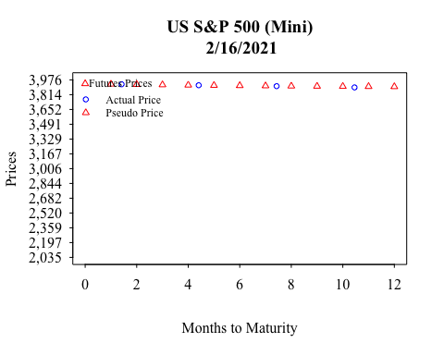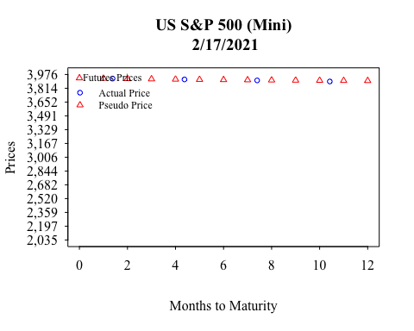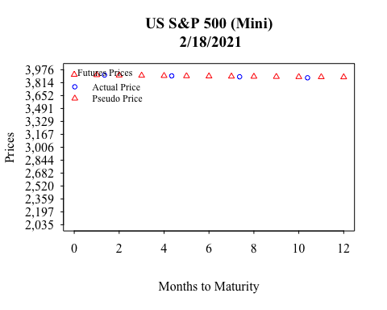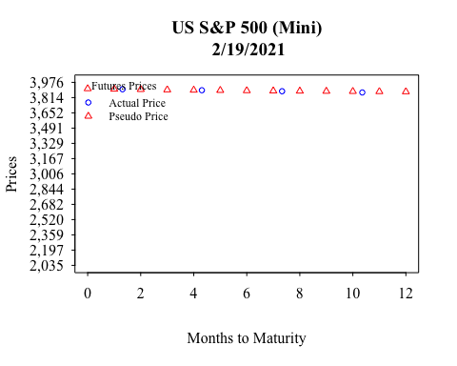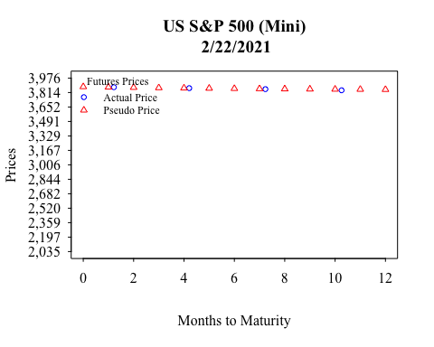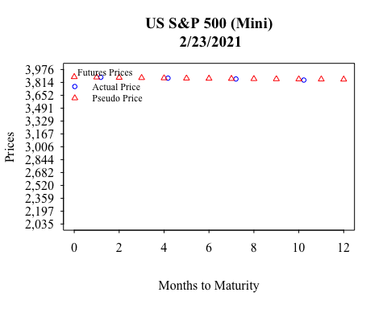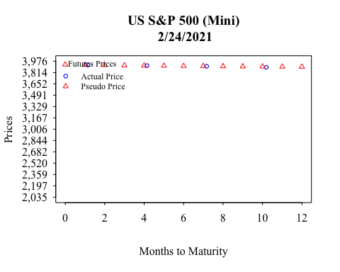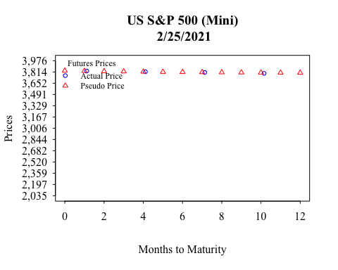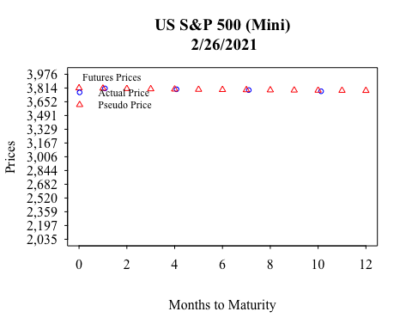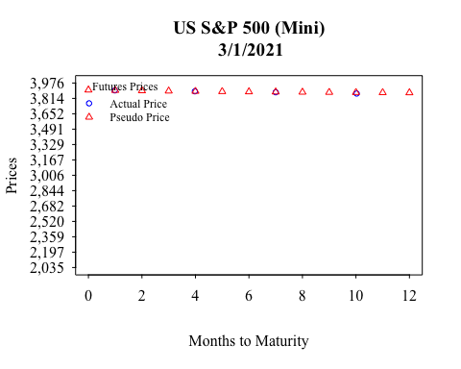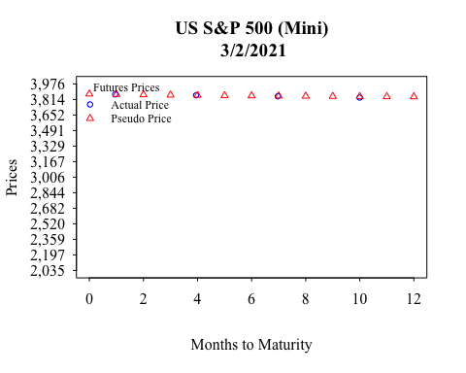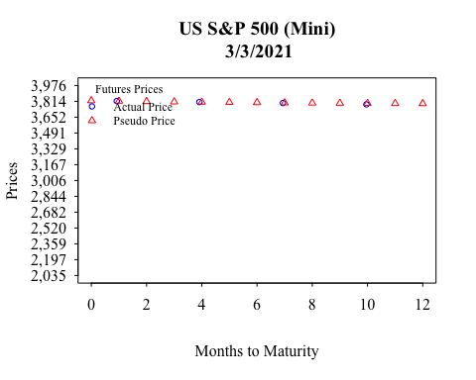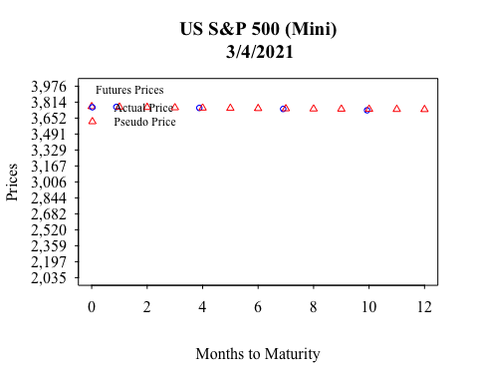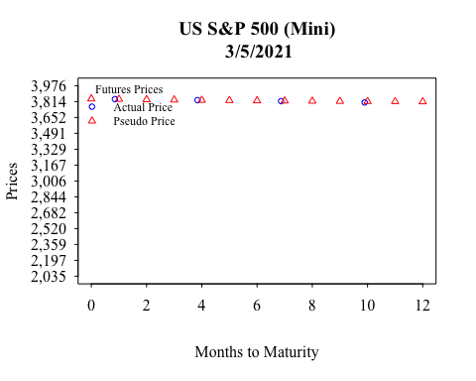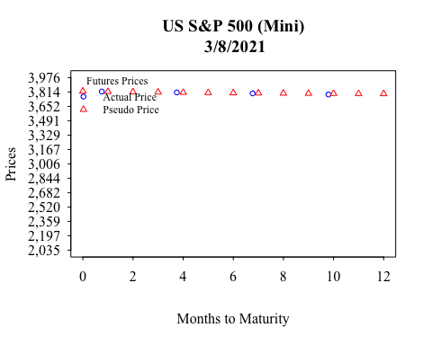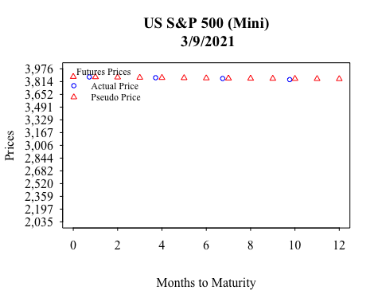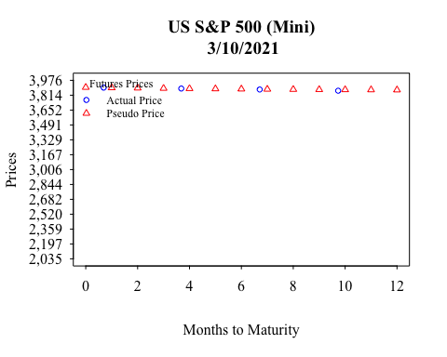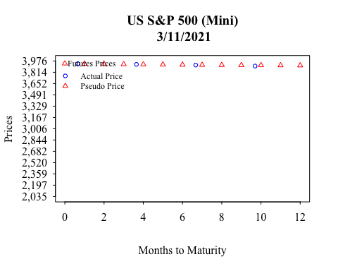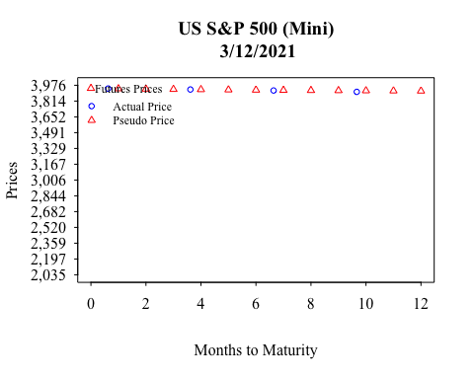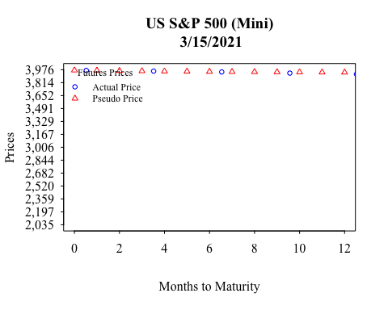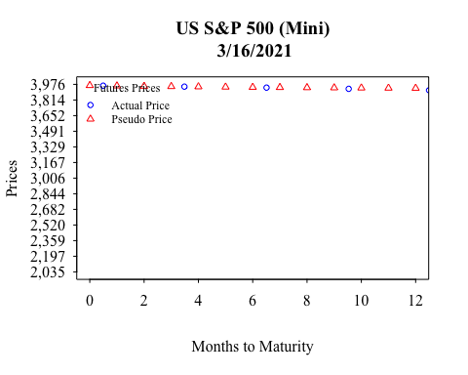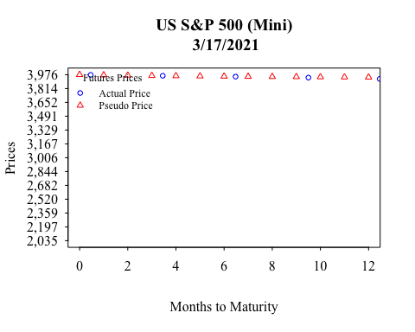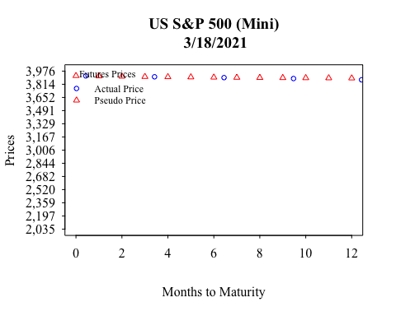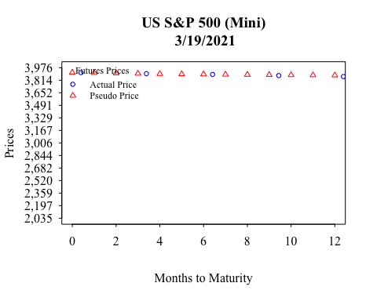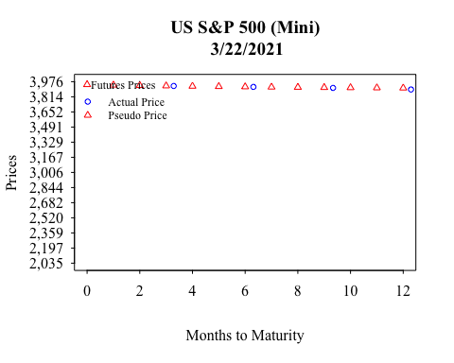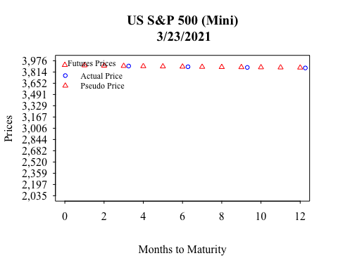

## > NULL  
## NULL

# See A1.6 R Generic Plot Example.R with Generic Plots.R to move legend  
# outside of plot